Ten Simple Things to know
about MONEY

(or what I wish someone had taught me before I was 18 years old.)

Personal money management is not hard or complicated, but studies show that most Americans do a very poor job of managing their personal financial affairs. Don’t expect your friends or family to teach you. Over half of Americans struggle to pay their monthly bills, avoid saving for retirement, have no emergency funds, have little idea where their money has gone, accumulate large debt, and suffer high stress about money. Some even put their health care needs on hold because of financial concerns.

You do not want to be someone who does not know how to manage your own money. The ten ideas we will discuss today will cover the BASICs of good personal financial management and set you on a course of controlling your money, rather than it controlling you.

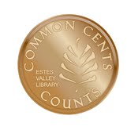
Marsha Yelick CFA (retired)
Financial Programs Consultant
myelick@estesvalleylibrary.org
970-586-8116 (Mailbox 831)

Ten Things Everyone Should Know about Money

(Learn to drive before you hit the road!)
- Earn MORE than you spend: (Keeping track is the way to go.)
In COME (paycheck)
- Out GO (expenses)
Saved Money each pay period
(10% retirement)
(20% other things – car, house, vacation)
- Pick up all things FREE:
Coupons, student discounts, concerts, lectures, libraries, workout facilities, scholarships, grants, work (with perks), Student Financial Office, FAFSA, money-savvy friends, special prices and sales, trading services (barter), tax credits, knowing the difference between wants and needs
- PRACTICE with a budget:
TO DO: Open a checking account, balance your statement, open a savings account, balance your statement, use the ATM, balance your statement, use a credit card, balance your statement, watch your accounts, invest in and secure your electronic devices, create a tentative budget, practice using a budget, check your credit score, buy a lock box, learn how much living on your own really costs.

Typical American Budget
Housing 35%
Transportation 18% (less than 50% left)
Food 12%
Insurance 12% (only 23% left)
- Understand the POWER of compound interest:
Learn about investing, begin investing in no-load, low-fee mutual funds, read a financial article once a month, talk to people who understand financial matters, educate yourself about financial matters, try on-line calculators (mycalculators.com), set a percentage goal for long-term savings contributions, search for employment with companies with 401(k) benefits
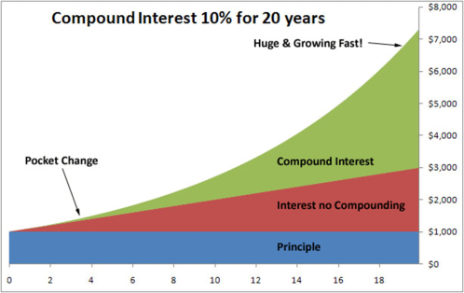

$100/mo. for 50
years at 8% = $793,172

NOTE:
FREE $$$
(Green and Red)

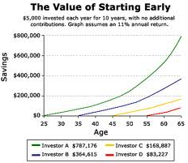
- Start saving and investing as EARLY as possible:

- Make buying decisions relative to NEED (not want):
A need is something that you have to have.
A want is something you would like to have.

- Avoid DEBT:
Charge ONLY what you can pay off at the end of each month, two cards at the most, control costs, don’t company hop, seek money resources, research and understand the implications of DEBT. Work to avoid unnecessary debt.
Debt balances are current as of Q3 2016; figures are updated quarterly by the Federal Reserve.
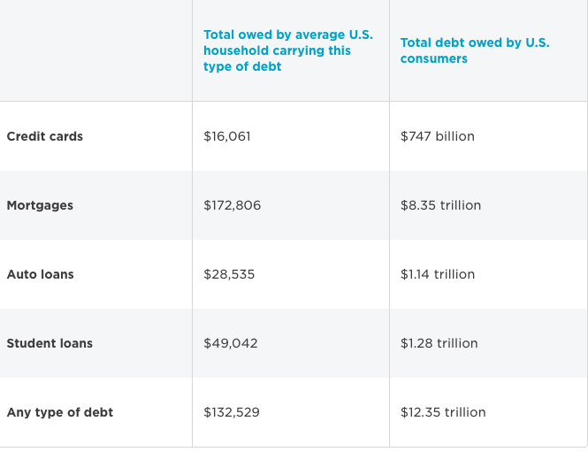

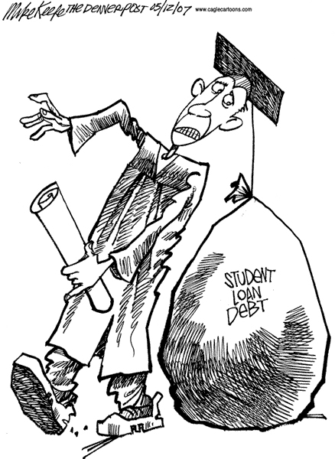

Average total of first four debt categories = $266,444. Paying $2,000/mo, and paying $170,000 of interest (at 6%), you would be debt free in 18 years!

- Make financial decisions relative to HOURS of your life you worked:
How much “LIFE” does something cost?????
Six hours @ $25/hour = $150
What does a Broncos’ Game cost?

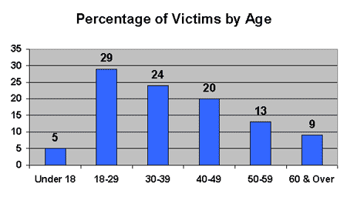
- Guard your IDENTITY:
Balance bank statements and fees, monitor credit card purchases, secure passwords, shred physical mail (especially credit card offers), create a locked place for important stuff, use secure Wi-Fi, guard personal computer and other devices with a password, trust no one, use social networking with caution, install malware protection. PROTECT YOUR SSN!

- MONEY HAPPINESS !
- Happify.com declares that additional annual income above $75,000 has no impact on creating greater happiness.
- Homeowners were found to be no happier than renters.
- Spending money on “experiences” (a vacation, a trip to the theater, a five-course dinner) gives a big and lasting boost to happiness compared to the joy of acquiring a new object.
- Giving away money creates the most happiness of all.

MONEY MATTERS!
Learn to drive before you hit the road!

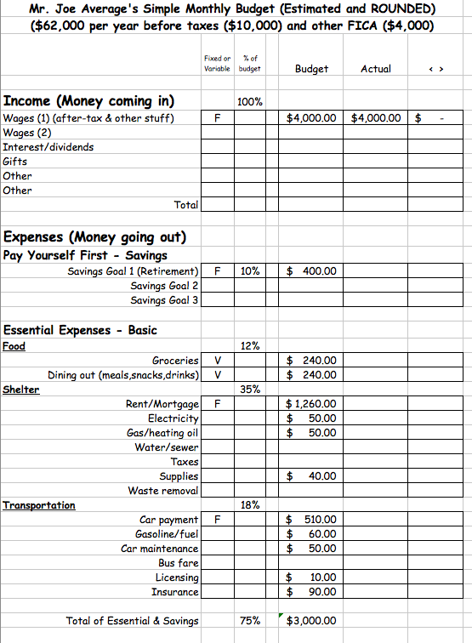
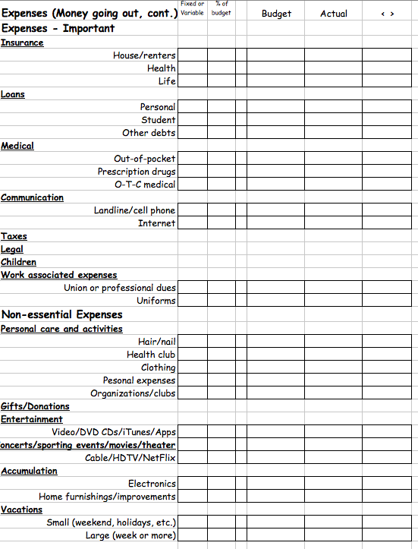
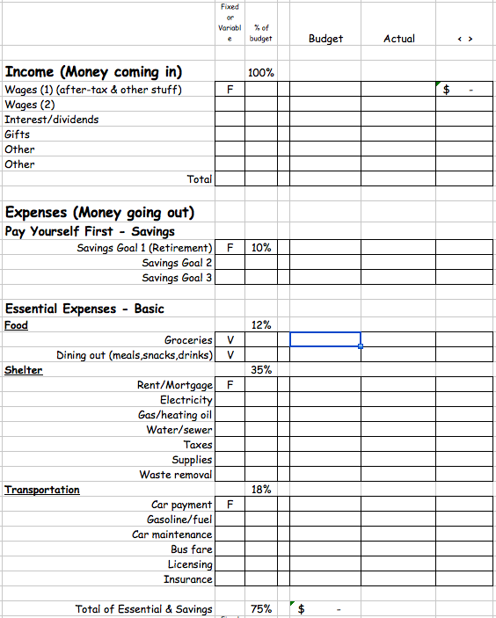
Your Sample Budget
