So you want to buy your own HOME
(What Every Prospective Homeowner Should Consider)

This seminar will explore both the basic financial knowledge needed for smart home buying AND the advantages and disadvantages of eventual home ownership. The American dream includes owning a home, but common sense should prevail when approaching the financial decisions related to shopping for a home and understanding the eventual financial burden of home ownership.

The seminar will examine who should own a home, what is affordable, hidden costs and fees, and other factors associated with homeownership. There are no right or wrong answers, but thinking about the consequences of a large financial decision is the first step toward a rational decision that will support future financial health.

The seminar is ideal for anyone considering a first-time home purchase or a change in home size or location, It might also be helpful to those who want to develop better financial skills in order to improve decision-making on other significant expenditures. Whether you are just beginning to hone your money management skills, assisting someone else, or working to improve your own financial future, this seminar will provide new incentives and tools. The goal is sound money management strategies no matter what your stage in life.

Marsha Yelick CFA (retired)
Financial Programs Consultant
myelick@estesvalleylibrary.org
970-586-8116 (Mailbox 831)

Not EVERYONE owns (or should own)
a home! (It’s a BIG, complex consideration.)
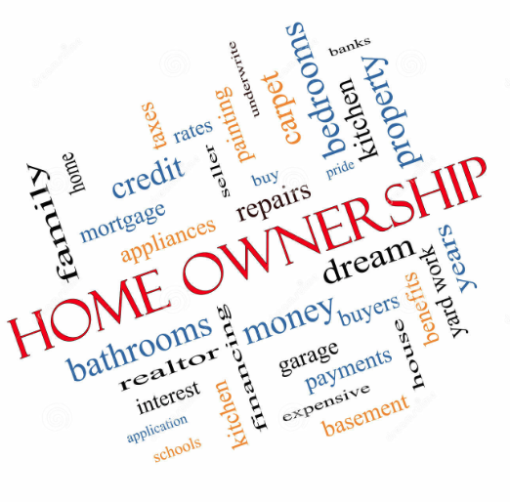

Some facts about Home Ownership

- Historic average of American home ownership is 65%
(63.4% in 2015, down from 69.2% before the 2008 crisis).
- Using FHLMC data on mortgage loans that are over six years old,
16% will experience a credit event.
- Average mortgage loan debt - $153,000 (2014)
- On average, selling a home can take 50 days and 41 days to close, and depending on the market and price – up to two years.
- The purchase price of the home is just the start –
(taxes, insurance, interest, maintenance, utilities, HOA fees…)
- There’s an opportunity cost of having money tied into one asset.
(current growth of only 3 -5 % annually nationwide)

Are You Ready to Own a Home?

Consider the following if you’re thinking of Buying a House
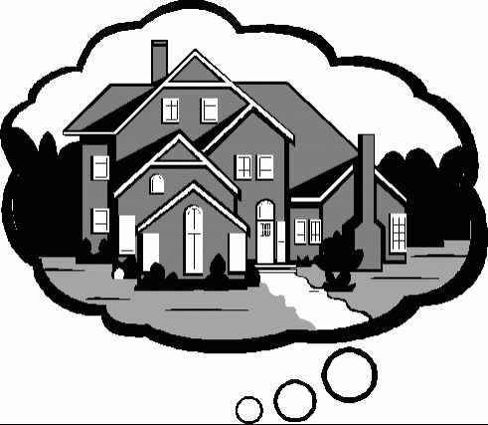
- Long-term commitment!
Are you willing to stay in one location for five to seven years?

- Upfront cost! (Hidden expenses of buying)
Do you have a down payment (minimum 3%, better at 20%) and all the other funds for closing (another 2 to 5% or up to 8%)?
(Origination fee (1%), discount points, credit report and loan application fee ($25 -400), private mortgage insurance ($0 - 2,500), initial interest, title service ($275 - 5,000), lender title insurance, property tax escrow, appraisal ($150 - 400), survey, accrued property tax, recording fees, etc.)

- Moving cost and emergency fund!
When owning a home, an emergency fund becomes even more important - enough money to live for 6-9 months without a job.

- Loan preapproval!
Requires down payment of 3 - 20%, two years steady employment, good credit score (660+), monthly income 2 to 3 times monthly mortgage payment.

- Emotional and physical commitment!
You are in charge of maintenance. You also become part of the neighborhood.

Advantages of Home Ownership
Emotional and Financial

- Privacy/security/peace of mind
- Pride of ownership
- Personalization
- Connection to community / stability
- Potential appreciation
- Tax benefits possible
- Predictable costs
- Property builds equity
- Capital gain exclusion

Disadvantages of Home Ownership
Emotional and Financial

- Long term commitment
- Reduced relocation flexibility
- Maintenance expense, time, and worry
- Upfront costs of purchase
- Monthly cost higher than rent (sometimes)
- Potential economic and/or locale deterioration
- No capital loss deduction
- Possibility of foreclosure and loss of equity
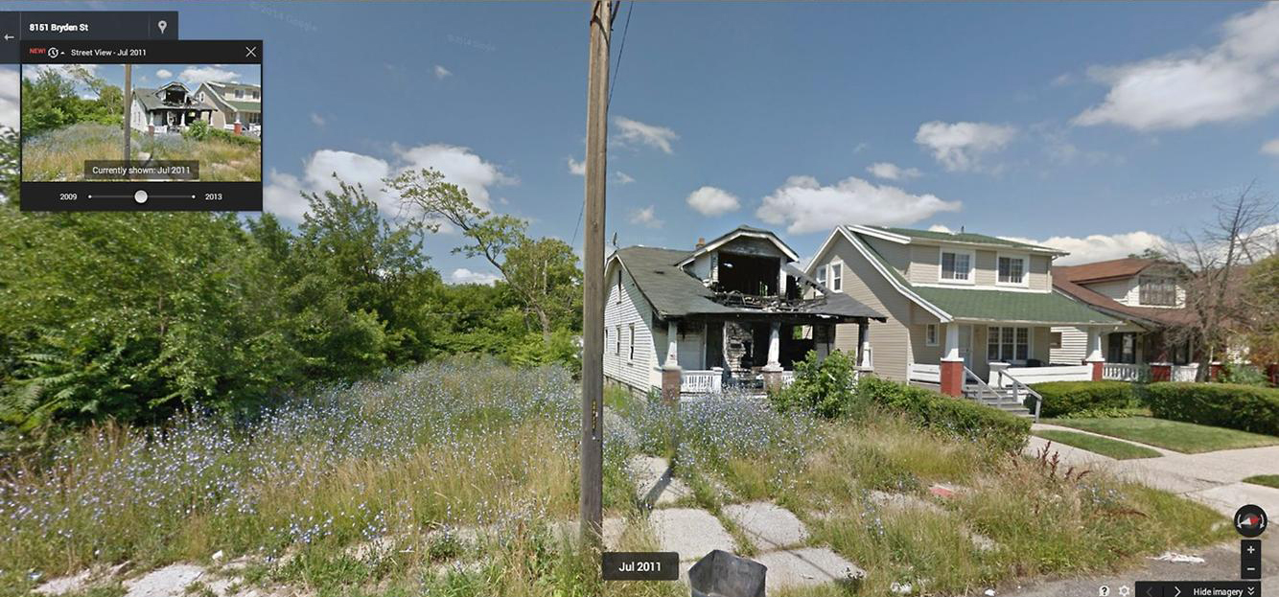
Renting vs. Owning
Homeownership is a long-term financial commitment
Comparing the financial differences between renting and buying is complex.
Use the calculators.

Example from http://myhome.freddiemac.com/buy/rent-vs-buy.html
Sally and Darren want to know if it makes better financial sense to rent or buy given their current $1,400 rent payment. How much home can they buy knowing they can afford a $1,400 monthly mortgage payment and can make a 5% down payment?
THE SCENARIOS
RENTAL SCENARIO | HOME­OWNERSHIP SCENARIO*
Monthly rent = $1,400  Monthly renter's insurance = $10  Annual rent increase = 3.6% | Purchase price = $200,000  Down payment = 5% ($10,000)  Annual property tax = $2,000  Annual homeowners insurance = $500  Annual home maintenance = $2,000  Mortgage rate = 4.5%  - These inputs will result in a monthly mortgage  payment around $1,400 when factoring in PMI
Other assumptions and costs for Sally and Darren, including: a 3% home appreciation rate, a $1,500 origination charge, $1,000 for settlement services, 3% for selling costs, a 33.8% state and federal tax rate, and a savings rate of zero.

The Outcome
(using http://calculators.freddiemac.com/response/lf-freddiemac/calc/home10)
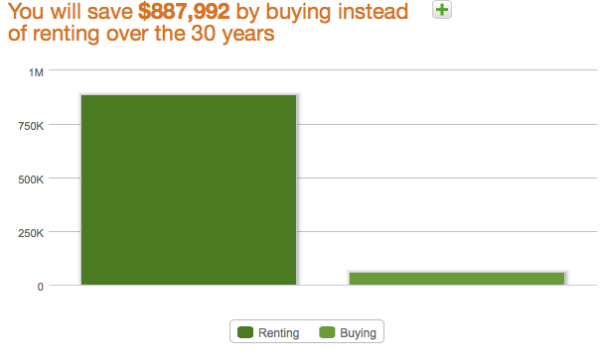
With this scenario, Sally and Darren will save $92,216 by buying instead of renting over a seven-year period. If they stay in their home for 15 years, they will save $273,558. Over 30 years, they’ll save $887,992.

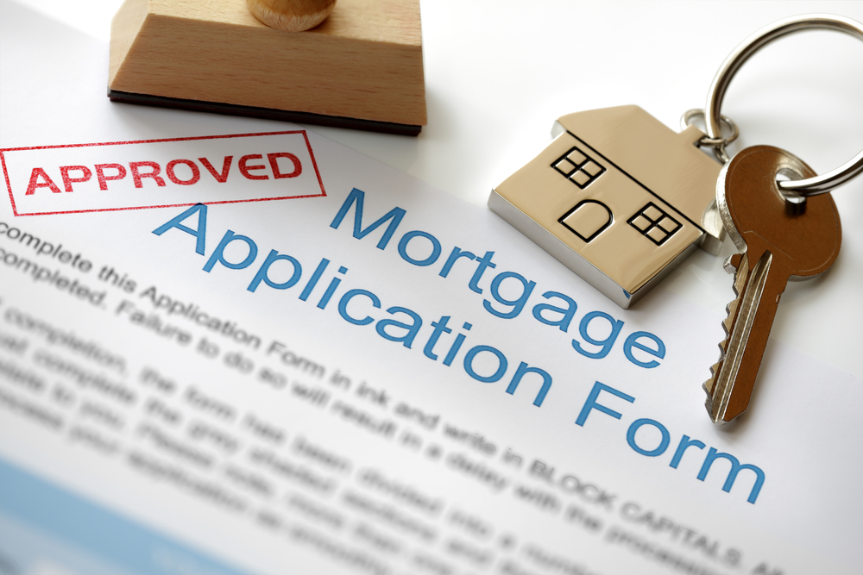
Understanding Loan Options

Loan Term
The term of your loan is how long you have to pay.
It affects your monthly principal and interest payment, your interest rate, and how much interest you will pay over the life of the loan.
Shorter Term Longer Term
Higher monthly payments Lower monthly payments
Typically lower interest rate Typically higher interest rates
Lower total cost Higher total cost
Interest Rate Type
Fixed Rate or Adjustable (ARMs)
The type of interest rate affects whether the interest rate can change, whether principal and interest payment can change, and the total interest paid.
Fixed rate Adjustable Rate
Lower risk, no surprises Higher risk, uncertainty
Higher interest rate Lower interest to start
Rate does not change Rate changes
Payments remain the same Payment changes
Loan Type
Conventional, FHA, or Special Programs
The loan type affects how much you need for a down payment, the total cost of the loan (which may include extra insurance cost), and the range of house price you can buy and how much you can borrow.

What will affect Your Choice and Your Pocketbook?
Check out the following site - and work with a housing counselor
http://www.consumerfinance.gov/owning-a-home/explore-rates/
Data varies from lender to lender and is continually changing. Your credit score, the loan type, the home price, and the down payment amount all affect the interest rate you can get. Interest is only one of the many costs you will pay when getting a mortgage. While shopping, ask about points, mortgage insurance, and closing costs. Make a final decision only after comparing lenders’ Loan Estimates that should include all the costs.

How Much House can you Afford?

The Consumer Finance Protection Bureau is there to help.
www. consumerfinance.gov

Tip 1: Only you can decide how much you are comfortable paying for a mortgage.
The average American spends 35% of their income on shelter. Reducing this outflow leaves more money for savings and emergencies. Don’t overextend!
Tip 2: Remember to factor in the closing costs and all other costs of home ownership.
Tip 3: Get trustworthy appraisals.
Tip 4: Get reliable help. People you hire to help you should be licensed or registered at
the state or federal level. Ask your loan originator about their credentials.
Tip 5: Read http://files.consumerfinance.gov/f/201312_cfpb_tipsforhomebuyers.pdf
and http://files.consumerfinance.gov/f/201312_cfpb_mortgagerules.pdf
Tip 6: Know your debt to income ratio. It should be below 43%.
To calculate your debt-to-income ratio, you add up all your monthly debt payments and divide them by your gross monthly income. Your gross monthly income is generally the amount of money you have earned before your taxes and other deductions are taken out. For example, if you pay $1500 a month for your mortgage and another $100 a month for an auto loan and $400 a month for the rest of your debts, your monthly debt payments are $2000. ($1500 + $100 + $400 = $2,000.) If your gross monthly income is $6000, then your debt-to-income ratio is 33 percent. ($2000 is 33% of $6000.)

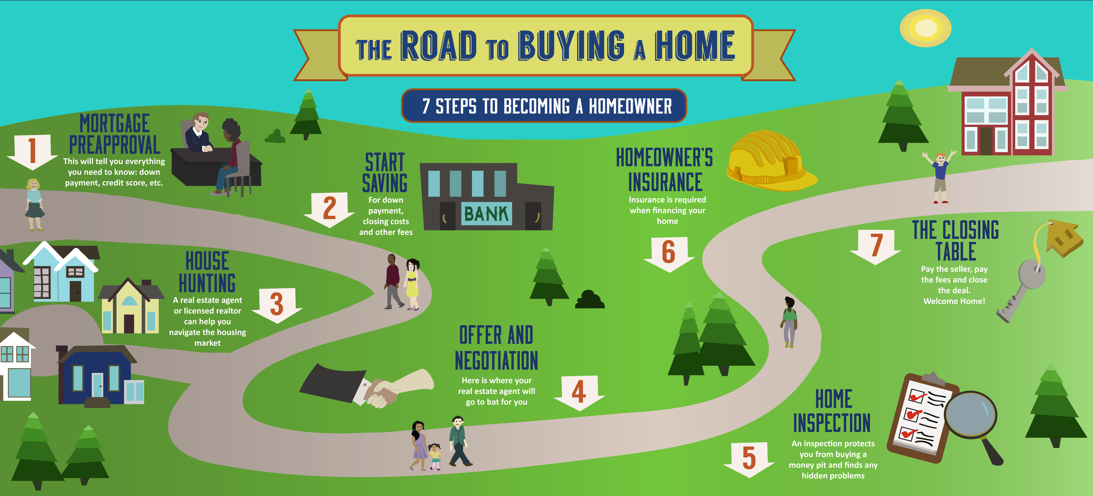

So many Resources, so little time…

For the BIGGEST purchase of your life,
take time to research and understand
ALL aspects of this transaction.

http://smartinvesting.ala.org/staff-training/on-line-self-paced-reference-course/
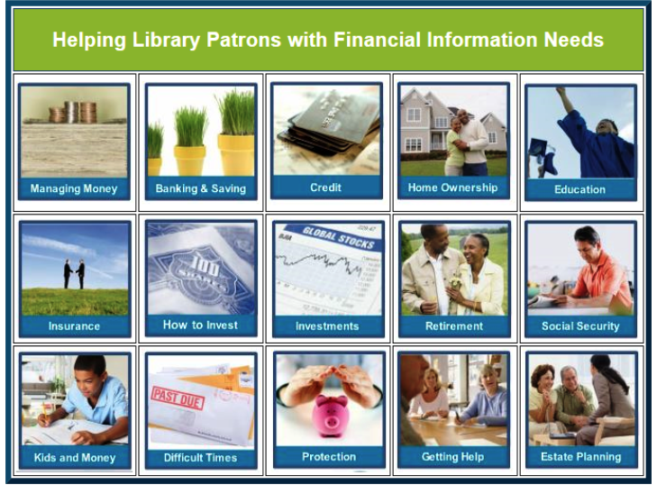

USE GOVERNMENT RESOURCES
AS MUCH AS POSSIBLE

HUD (UNITED STATES DEPARTMENT OF HOUSING AND URBAN DEVELOPMENT
https:portal.hud.gov/hudportal/documentUs/huddoc?id=DOC_12163.pdf

CONSUMER FINANCIAL PROTECTION BUREAU
http://files.consumerfinance.gov/f/201503_cfpb_your-home-loan-toolkit-web.pdf

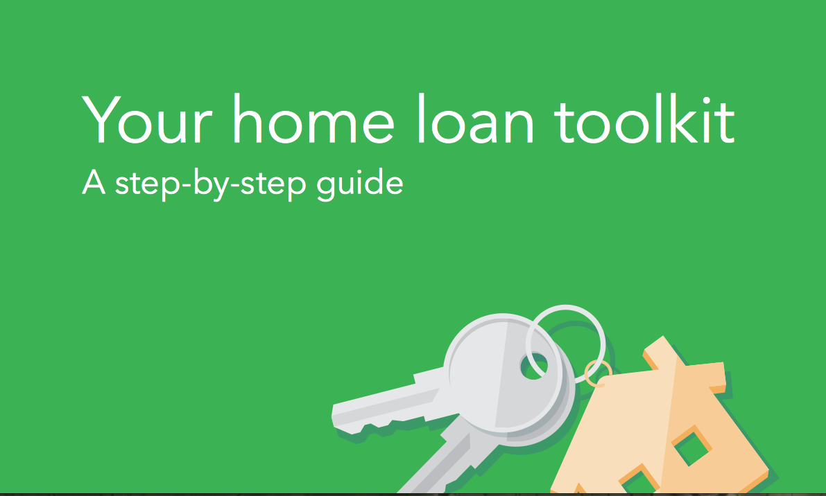
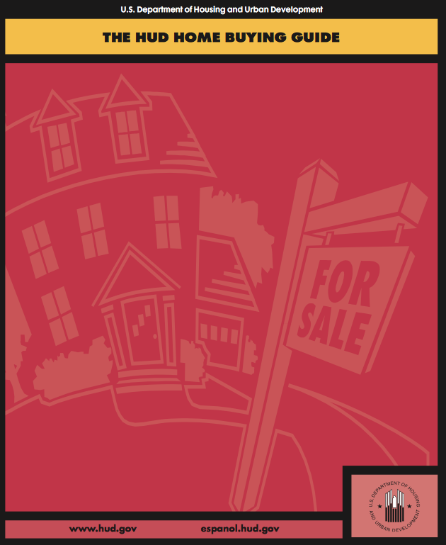

FEDERAL HOUSING ADMINISTRATION
http://www.fha.com/home_purchase
FHA loans can make your home buying dream a reality with competitive rates and a low down payment.

