


Seminar Five
Managing Money During Retirement
(for everyone who hopes to retire someday)

This seminar explores concepts and theories associated with managing money during a happy and relaxing retirement.

Participants will review the changing landscape of retirement with its growing challenges, e.g., increasing longevity, increasing medical costs, lower Social Security benefits, disappearing pensions, need for financial expertise, etc. Then the seminar will explore various plans for making money last through a secure retirement. Major discussion will be spent on methods for determining spending during retirement, allocation for remaining assets, guarding against inflation, deciding safety net needs and plans, and hints for reducing unnecessary expenses and extending limited assets while enjoying life more.

The seminar is recommended for anyone who is struggling with the retirement conundrum of managing assets so they last through a comfortable retirement. This includes those who have already entered retirement, those who are about to enter retirement, and those who are thinking about the retirement issues ahead. The seminar is also a great review of all the concepts discussed in prior seminars.
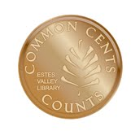
Marsha Yelick CFA (retired)
Financial Programs Consultant myelick@estesvalleylibrary.org
970-586-8116 Ext 831

If you ever needed a plan for your money,
you need it in retirement.
You earned it. You saved it.
Now it's time to keep it safe and spend it well.

MAJOR CONCEPTS for Seminar Five
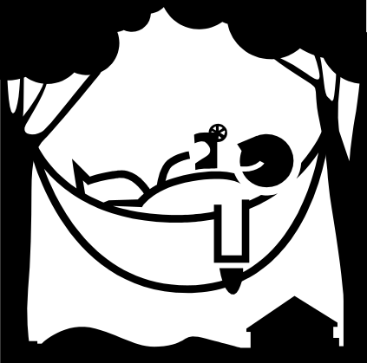
The simplest choices are the best ones.
When you retire,
you have to figure out
how to make your existing money
last for the rest of your life.

It’s never too late.
Spend only what you have!

Is the Average Retiree Prepared?

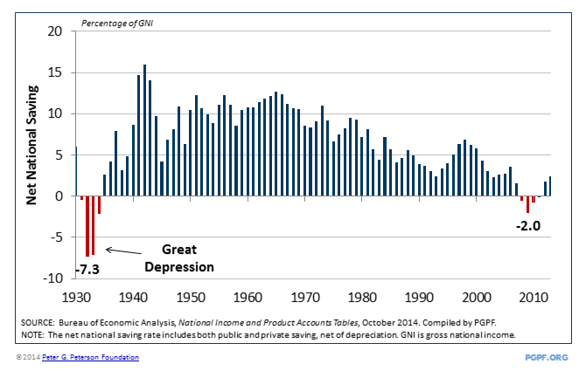

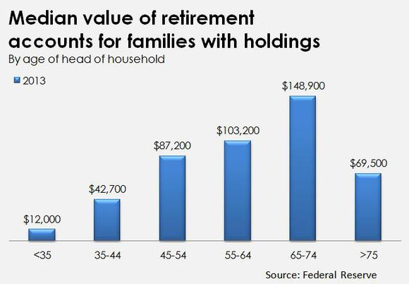
Average amount saved - $100,000???
Average savings rate for retirement–
should be 10%, but has dropped to 4%

The Boomers changed everything – and still are changing everything!
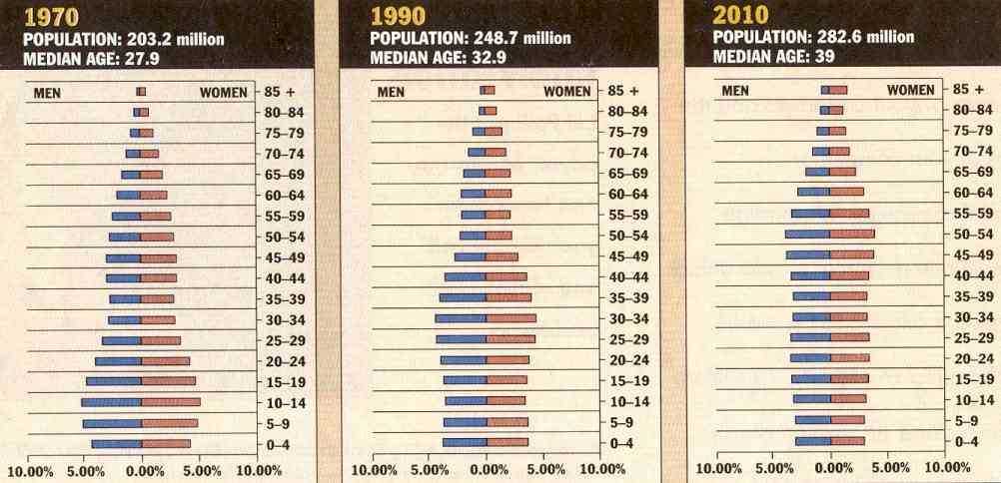

Percent of US population by age and sex, 1970, 1990 and projections for 2010
http://www.flatrock.org.nz/topics/money_politics_law/boom_moves_along.htm

How Retirees Today Differ from Retirees in the Past
Yesterday: Leisure-defined lifestyle:
Golf every day, cocktail parties, relaxation, and grand parenting
Today: Activity-defined lifestyle:
Retirement careers, “boomer energy” as in their 50’s, travel, focusing on philanthropic causes and missions, life activities that provide freedom, satisfaction, and service to others

MANY NEW and OLD Challenges = HESITATION
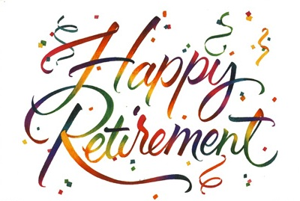
Bear market of 2008
Real Estate crash of 2008 ->
Potential for rising income tax rates
Decline of interest rates on fixed income
Possibility of inflation
Living longer
Rising medical expenses
Disappearing pensions
Social security insecurity
Volatile market swings
Debt hangover
Living far from family
Still helping kids (who need help!)

To Begin the Retirement Plan Process...

Prepare a CURRENT NET WORTH Statement
(separate the financial assets from the nonfinancial assets)
Prepare an anticipated Retirement Budget

Paper/Pencil Planning

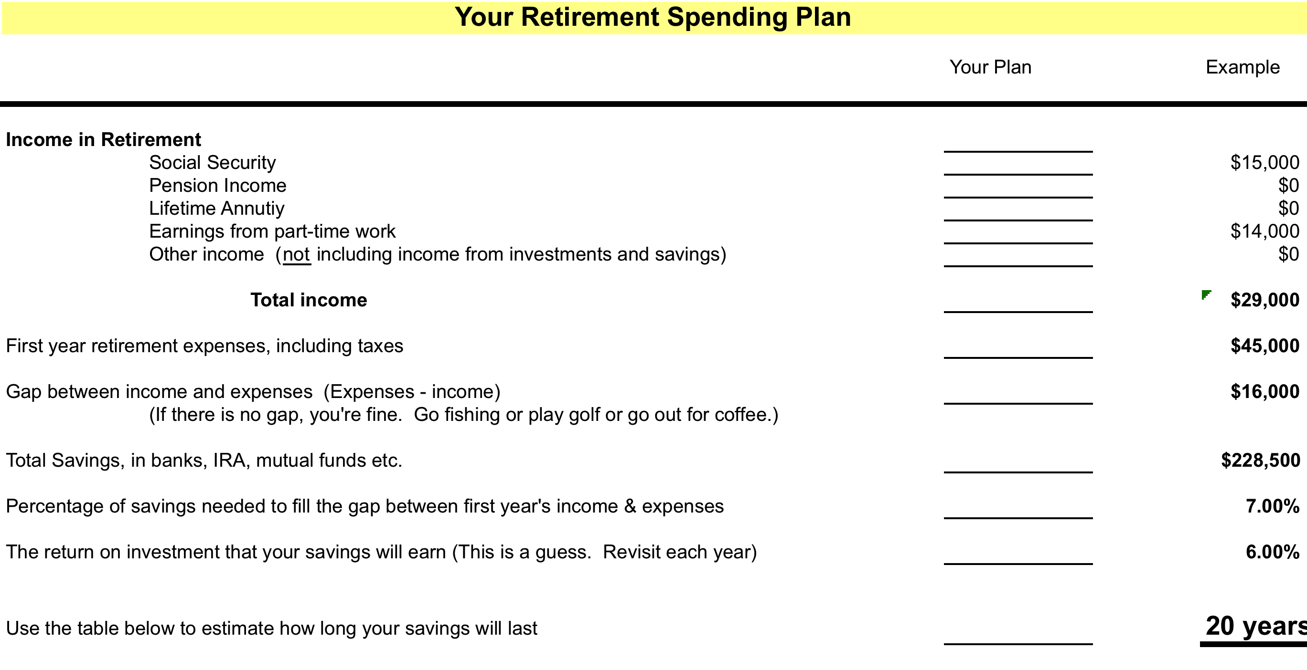

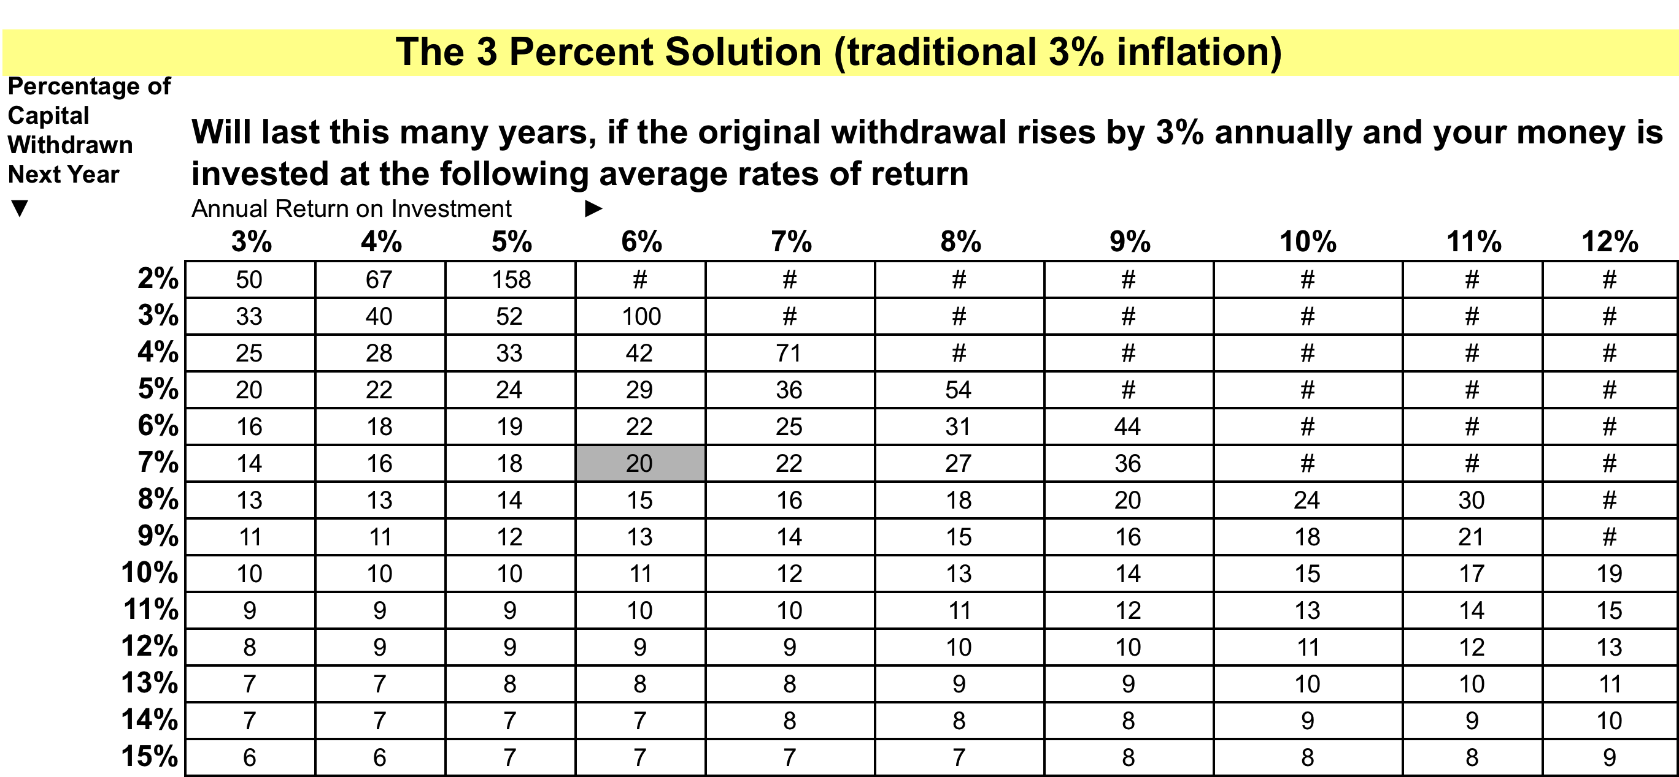

Is the 3% Solution Real?

This chart depicts the average rate of annual withdrawals that a hypothetical portfolio of 60% U.S. stocks and 40% bonds was able to sustain during a series of 30-year holding periods since 1926. The average sustainable rate for all 30-year rolling periods from 1926 to 2005 was 6.21%% when adjusted for actual consumer price inflation.
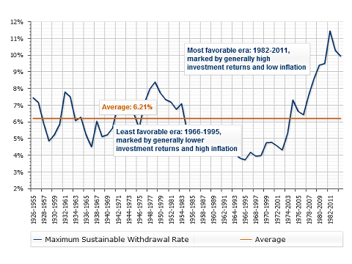
Source: Standard & Poor's.

Inflation and investment returns change dramatically at times. Since there is a risk of living beyond your average life expectancy, you may want to err on the side of caution and choose an annual withdrawal rate somewhat below 5.5%. Also, experts advise taking out less in the early years of retirement or when market returns are low, with the hope of having sufficient income for your later years.


Become familiar with
online calculators and
revisit every year.

Measure your progress!

Test various scenarios in retirement (and in the savings years preceding retirement).

- Adjust for how your portfolio has performed in the prior year (the annual total rate of return).
- Adjust for last year’s inflation (CPI) and what you anticipate (or fear) for the future.
- Adjust the starting balance of the calculation to match the year-end balance of your invested portfolio(s) from prior year.
- Adjust the withdrawal amount to meet your spending budget for the new-year (if you are in retirement).
- Adjust the number of years you think you have left (to save or to enjoy your nest egg).

Play with scenarios until you get a sense of what is right for you.

http://www.mycalculators.com (all kinds of calculations including withdrawals)

http://www.finra.org/Investors/ToolsCalculators/index.html (all kinds of calculations)

http://www.aarp.org/money/toolkit/articles/retirement_nest_egg_calculator.html (decide how much is needed for your retirement)

http://www.choosetosave.org/calculators/ (all kinds of calculations)

http://www.choosetosave.org/ballpark/index.cfm?fa=interactive (interactive estimator that highlights all the variable effecting your retirement)

Other Important Things to Remember...
- No-load mutual funds with low annual expenses are excellent for retirees.
- In your bond allocation, remember the bond ladder.
- Keep your cash reserve ready in case of large market declines.


Ask yourself – Am I Ready to Retire?
Retirement Check List
- A clear idea (on paper) of your net worth and your annual budget (Seminar One – absolutely necessary for doing withdrawal calculations)
- A Master List of all your accounts, policies, passwords, personal papers, tax records, last wishes, etc. (Seminar One – your heirs will bless you!)
- Health insurance (to carry you to 65 when Medicare is available)
- A means of regular income (pension) hopefully with cost of living increases
OR A major nest egg (Seminar Two, Three, and Four - properly allocated)
- No kids at home (or on the payroll)
- Life insurance if your are married (Reduced benefits increases need for additional funds or cash flow.)
- No debt (Good plan any time!)
- Low housing expenses (This is called down sizing.)
- Low living expenses (Simple living is not depravation, it allows your investments to grow, and enjoyment can be found in many ways.)
- A job, perhaps! (Not at the high stress / high earning level of pre-retirement, but something to keep you socially active, with the added bonus of enough money to fill the gap between retirement income and your expenses.)
- A simple and clear spending and investing plan (No doodles on a yellow pad. Consider taxes, inflation, interest rates, your investment portfolio, sources of income, different market scenarios, etc.)

Whatever the size of your nest egg, retirement will likely mean big changes in your financial life. The regularity and sources of income can easily shift, as can expenses. And financial priorities often change as you move from saving for retirement to generating income from your hard-earned retirement savings.

Managing Your IN-COME During Retirement
From SIFMA Foundation for Investor Education

- Create a draw down strategy: First and most critical so you won’t outlive your money. (Plus the strategy emphasizes or highlights what is usable income!)

- Work from a budget: Essential to adjust reality to strategy!

- Check your balances: Read your statements and understand them.

- Consolidate accounts: Easier for you and easier for your heirs.

- Gauge your pace: By budgeting and checking your accounts, you will be able to compare your pace of spending to your remaining investment nest egg.

1 -5 ABOVE ARE THE SAME THINGS YOU’VE BEEN DOING – MONITORING YOUR BUDGET TO BE SURE YOUR EXPENSES DO NOT EXCEED YOUR INCOME.

- Have sufficient liquidity to withstand market declines: rule of thumb for retirees = two years in laddered investments.

- Keep an eye on ALL inflation: Although 3.5% is historic, retirees’ expenses do not match the overall numbers (they are usually higher due to health care.

- Understand how your age and your income affects retirement benefits: for example, social security benefits can be affected by earned income until you reach full retirement age, health insurance premium cost may decrease when you reach 65 (Medicare) but then steadily increase as you age, tax exemptions and deductions may increase with age, etc.

- Keep an eye on tax liability: Not all retirement income is equal in the eyes of the IRS so try to thoughtfully examine the monies you are drawing to select the most appropriate.

- Monitor returns: Though fluctuations are to be expected, watch the general trends and revisit the calculators. In years with poor market returns, if possible, try to lower your expenses.

- Protect and grow any unused income: Reinvest whenever possible, not allowing extra income to sit idle.

Mindfully Manage Your Dollar OUT-GO

(Make those dollars S-T-R-E-T-C-H!)
In Retirement, you have time to be careful!

Apply for exemptions or utility discount programs:
One example - Senior Homestead Exemption - again available in Colorado. Ten-years in same home and over 65. Value over $500.
Ask for Discounts:
Local, senior, AAA, AARP, if you pay cash, etc. Visit Seniordiscounts.com. Track your discounts and smile at how much you have saved.
Check for fees:
Eliminate as many fees as possible (bank, brokerage, mutual funds, credit cards, club extras, annual service fees, unused services, etc.)
Comparison shop:
This applies to all items, but be sure to watch for savings on prescription drugs. Try samples, use generics, visit big box stores (and split the big quantities with other seniors), comparison shop online, investigate mail-order prescription savings, etc.
Estimates, referrals, and negotiations:
Search for reliable, well-established businesses and ask for estimates in writing so agreements are clear and comparable. If you are a good customer, negotiations are always possible.
Lower medical costs:
Stay Healthy! Also use free or reduced-rate medical and healthcare services in the community. Walking is always free and very enjoyable!
Barter:
Although it’s a technique often used by the young, consider offering your time, skill or services in exchange for a needed service or item.
Review your insurance coverage:
In retirement, you may not need as much insurance coverage. Compare coverage to cost. Consolidation of policies may bring down your total cost.
Check out what’s free:
Libraries, universities, parks, churches, city events, social groups, non-profit’s services, seminars, concerts, movies, volunteering, tax services… The list is endless.

The larger your social network, the greater chance you have of hearing about bargains, and identifying activities that are low-cost, educational, and FUN!




Larger Changes to Consider
(If there’s really not enough income)
http://www.livecheap.com/credit/14-retirement/354-7-smart-downsizing-measures-for-retirement

Move to an ultra-low cost location:
This does not mean leaving the city where you live. You could just move to a small condo or a compact residence. You can also consider other locations outside the United States. Any downsizing will produce money to invest, PLUS it should also decrease your monthly living expense. You’ll be in the know with a tiny house!
Get rid of your STUFF!
Time spent just cleaning out the “collection of a life time” can produce monetary results. Think garage sales, E-bay, Craig’s list, etc. Not only will your house be more enjoyable, but also your children will thank you for cleaning out what they might refer to as junk.
Get a Job:
Not the high stress job of years past, but something you enjoy doing part-time. Even an extra $5,000 - $10,000 will make a huge impact on your retirement nest egg, allowing it to grow.
Lose one of your expensive cars:
There’s money being absorbed in your garage. Not only the price of the car, but the maintenance, gas, and insurance eat into your income. Consider ride sharing, WALKING, and public transportation.
Eliminate or decrease expensive vacations:
Since you live in a state that is a premier resort destination, invite friends and family here and have them take you out to dinner.
Consider Moving in Together:
One of the lessons re-learned during the Great Recession was the sharing of shelter. Be creative in finding house partners. (NOTE: Not all parents and children can reside together.)
Frequent all FREE things:
Become active (and maybe even volunteer) at the Senior Center and the Library. A new social circle will be good for your mental health. Check the newspapers for events that are free to the public.
Join the Peace Corp:
This will “DO GOOD” AND eliminate all your living expenses. (It does include foreign travel, just in case you’ve eliminated your expensive vacations and still want to travel.)
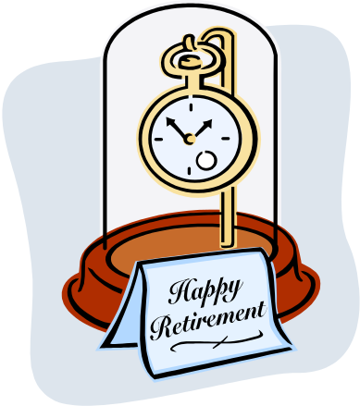
BE A
HAPPY
MONEY-WISE
SENIOR

