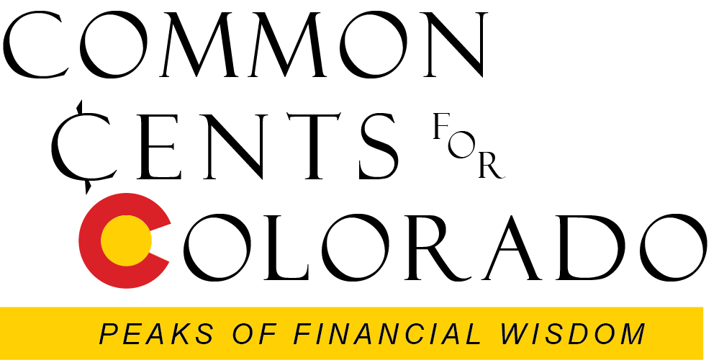

Seminar Four
Common Investment Types

This seminar explores three widely available core financial investment categories: stocks, bonds, and cash equivalents.

Participants will review the definition of each category, then go on to examine how the security types trades, their advantages and disadvantages, and acquisition strategies. Asset allocation models appropriate for various life stages will be discussed. Various buying methods for each class will be reviewed, with a thorough discussion of mutual funds and ETFs that now dominate individual investing.

The seminar would be ideal for anyone who wants a better understanding of the investment choices available in the complex financial markets. The goal will be for each participant to establish a personal allocation model that is both comfortable and comprehendible, with awareness of cost and risks as well as potential return.

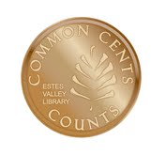

Marsha Yelick CFA (retired)
Financial Programs Consultant myelick@estesvalleylibrary.org
970-586-8116 Ext 831

The more elementary your investments,
the more you can be confident you will make and keep your money.

Major Concepts for Seminar Four
The simplest choices are the best.
The more elementary your investments, the more you can be confident you will make and keep your money.
You can understand your own investments!

"If you can’t explain it to a six-year-old, you don’t understand it yourself.” – Albert Einstein

Why do people avoid doing their own investing?
- We have no experience.
- We have no education on the topic.
- The market always changes.
- We have always been bad at math.
- We like to trust experts to do important stuff.
- We have no time.
- We have no money.
- Our “plan sponsors” will do it for us.
- Mañana…
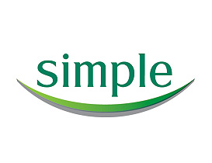

THE SIMPLE LESSON

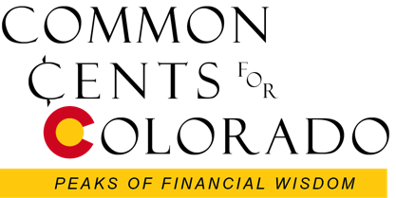
Avoid the glittering merchandise. You can rack up a superb lifetime investment record with just a handful of simple, low-cost stock-owning mutual funds and a couple of bond funds. You can protect your retirement savings merely by having an emergency reserve in cash, owning the right percentage of bonds for your age, with always having an appropriate allocation in stocks. That’s all you really need to know. Investing is easy if you buy simple things. You can do all this with low-cost mutual funds, and sleep easy at night.

Use Investment Pyramid – Mutual Funds
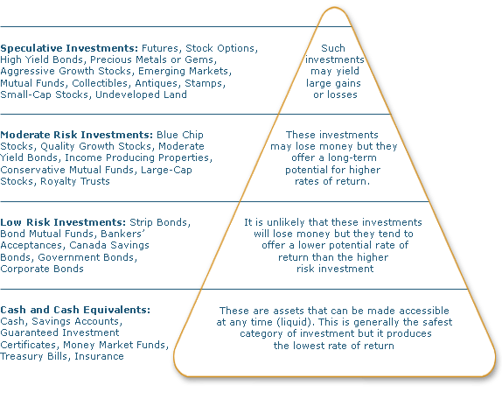
The investment pyramid arranges various investment choices according to the risk-reward relationship. The higher the investment is located in the pyramid, the higher the potential return, and the higher the risk. Since cash and cash equivalents offer the lowest risk and return, you will find them at the bottom of the pyramid. Mutual funds are included in all categories because there are many different kinds of mutual funds. Each fund has its own level of return and risk.

STOCKS

BONDS CASH

ALLOCATE ACCORDING TO YOUR AGE (RISK TOLERANCE)
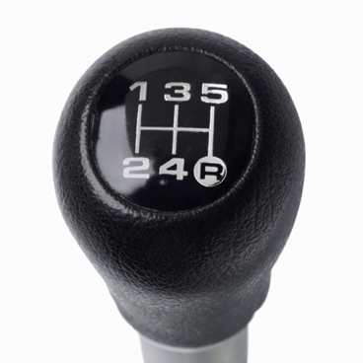
Every birthday that ends with a ZERO, (20, 30, 40, 50, 60, 70,80),
move 10% more into bonds for the money you
need for the long-term.

Cash and Cash Equivalents (for SAFETY)

Assets that are readily convertible into cash without any penalties or significant market risk, but very little return – not even enough to keep pace with inflation!
PENALTY FREE (Cash equivalent)
- Bank saving accounts
- Money market funds
  - Super safe
  - Plenty safe
  - Probably safe
- CDs (3 months or less)
MARKET VALUE ADJUSTMENT OR (small) PENALTY POSSIBLE
- Short CDs (3 to 12 months
- Short-term government bonds (less than one year)
- Treasury bills (one year or less)
- Commercial paper (usually not available to individuals unless held in mutual fund)

Cash equivalents are distinguished from other investments through their short-term existence. Cash equivalents mature within 3 months whereas short-term investments are 12 months or less, and long-term investments are any investments that mature in excess of 12 months. Another important condition a cash equivalent needs to satisfy is that the investment should have insignificant risk of change in value.

Cash reserve strategy: Your emergency cash reserve can be subdivided to minimize penalties for early withdrawal of large amounts of funds at one time and to maximize interest earned on accounts should an emergency occur. Money that would be needed within 3 months of a financial emergency is best placed in an interest-bearing checking account, passbook savings, money-market deposit account, or money market mutual fund. Funds needed 4 to 6 months after an emergency could be placed in short-term certificates of deposit (CDs) as well as 3- and 6-month Treasury bills. Money that would not be needed for 7 months to 2 years could be placed in a money market mutual fund and longer term CDs (12-, 18-, and 24-month). Money you can avoid withdrawing for 2 to 5 years during a financial emergency could be placed in Treasury notes, short-term bond funds, or 3- to 5-year CDs.
Suggested amounts for cash reserves
If you are currently employed: 6 – 9 months living expenses so you have a cushion to find new employment, or to pay for an emergency without going into debt.
If you are retired: 2 years of living expenses so you do not need to liquidate investments during bad market cycles.

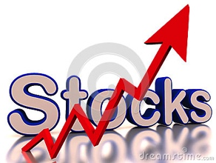
STOCK (equity) for GROWTH

Why Issued: At some point, just about every company needs to raise money. They have two choices: 1) Borrow the money, or 2) raise it from investors by selling them a stake (issuing shares of stock) in the company.
What do you own: When you own a share of stock, you are a part owner in the company with a claim (however small) on every asset and every penny in earnings. Individual stock buyers rarely think like owners, and it's not as if they actually have a say in how things are done. Nevertheless, it's that ownership structure that gives a stock its value. As a company's earnings improve, investors are willing to pay more for the stock.
How do you buy and sell: Most stocks trade in a primary market that is regulated, necessitating the need for you to purchase and sell through licensed brokers (Discount Broker - low commission, but little advice or Full Service Broker – higher commissions but service model with in-depth research and personal help available).
What do you get: Over time, stocks in general have been solid investments. That is, as the economy has grown, so too have corporate earnings, and so have stock prices. Since 1926, the average large stock has returned close to 10% a year. If you're saving for retirement, that's a pretty good deal. The two ways to make money with stocks are:
Capital Gains: Sell at a higher price than you bought (you can also sell at a lower price than you bought – which is called a capital loss!)
Dividends or other distributions: If companies are profitable, they can CHOOSE to distribute some of the earnings to shareholders.

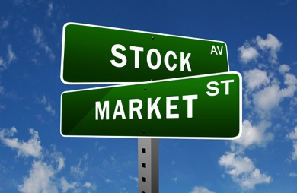
Why Own Stocks (and you MUST)?
Income and Capital Growth: Public companies may pay their shareholders dividends each year. Shares also have the capacity to increase in value, with capital growth tied to the company’s capacity to continually grow its business. Stocks have historically outperformed other types of investments with average annual returns of ~ 10%.
Highly Liquid: Shares can be sold within a matter of minutes by contacting a stockbroker or instantly if you do the transaction on-line. You will ordinarily get your money back within a few days of selling them.
Minimal Entry and Exit Fees: On-line brokers normally charge around 0.4 % of the transaction cost.
No Holding Costs: Only cost is buying and selling.
Tax Benefits: Unrealized capital gains are not liable to tax until the shares are sold. Capital losses can be offset against current and future capital gains.
Record Keeping: Monthly statements summarize transactions, tax information, and growth.

Keep pace with inflation: Over time, a diversified basket of stocks will out pace rising inflation costs.
The Risks of owning STOCK
Volatility: Share prices fluctuate daily in line with the prevailing market, which may not appeal to you (especially if you see your shares fall in value).
Risk of loss: You can lose a substantial sum if your share portfolio were to fall in value. And there is no guarantee they will recover or that you will get back your initial outlay.
No Dividend Payments: The payment of a dividend is at the discretion of the company directors.
Liquidation: There is a risk a company could become insolvent and cease trading. If this happens shareholders will rank last in terms of getting back their initial investment.
Bonds (fixed income) for Peace of Mind

Why Issued: If an institution needs to raise money but does not want to sell a stake in their company, the other choice is borrowing. Borrowing from a bank is costly, so companies issue bonds. Based upon the financial worthiness of the institution, the marketplace will determine the interest rate. A bond is a debt investment. It represents a loan made by the bondholder to the institution (corporation, government, or agency) in exchange for interest payments during a specific term plus the repayment of the principal when the bond comes due.
What do you own: A bond is a debt security. The authorized issuer owes the holders a debt and, depending on the terms of the bond, is obliged to pay interest (the coupon) and/or to repay the principal at a later date, termed maturity. A bond is a formal contract to repay borrowed money with interest at fixed intervals. As with other forms of lending, the bond holder usually has some form of lien on the property of the issuer, in case the issuer defaults on the interest payment or the return of principal at the agreed upon time. Theoretically, the bond’s value is more secure than the stock of a company.
How do you buy and sell: While some bonds trade on major exchanges, the majority of corporate bonds trade over-the-counter and individual bond trading prices are not reflected during the day. Individuals usually purchase bonds through their brokerage account. The par value of one bond is usually $1,000 and they are usually sold only in lots of five or more. Note: For individual investors, the large sums of money necessary to purchase bonds and the lack of transparency in pricing are major stumbling blocks.
What do you get: Over time, bonds have been a solid investment. The coupon interest rate set at issue is generally fair, and investors can count on the income and the return of principal. Since 1926, the average return on a diversified portfolio of bonds has been close to 5% a year. You can make money with bonds in two ways:
Interest: The interest payments from the bond normally provide you with a fixed source of income for the bond’s term. In most cases, the rate is fixed at the time the bond is issued.
Capital gains: You might also make a profit by selling a bond before maturity at a higher price than you paid for it. (Note: This is usually reserved for short-term traders.)
Why Own Bonds? The Substantial Benefits of a Safety Net

You want to earn predictable current income: The beauty of bonds is that they pay steady income. In today’s market, the income you'd get from top-quality bonds that have little risk of default is skimpy – but it still is ahead of inflation. For investors in the top tax brackets, municipal bonds may also be attractive, but the credit risk is higher than in the past. The average annual return over time for bond is ~ 5%.
You want to reduce the swings in your portfolio: The best reason to own bonds -- and perhaps the least appreciated -- is the fact that they smooth out fluctuations in the value of your portfolio. Stock prices normally rise during an economic expansion; bonds do best in a slowdown. Put the two together and they partially cancel each other out, without cutting into your return much over the long haul. That's why you want to own them when the outlook for economic growth and interest rates is uncertain, as it is today. Long-term Treasury bonds are the best counterweight to stocks precisely because they are so sensitive to changes in interest rates. Bonds may falter in a boom, when investors fear rates will rise. But when your stocks are tanking, they can ease the pain.

The Risk of Owning Bonds

Interest Rate Risk: The market value of a bond varies as the current interest rate changes. (The price variation is merely a reflection of the present value of the bond’s future cash flows, discounted relative the market interest rate.) When interest rates go up, the market value of the bond goes down. However, the market value decline, even on long bonds, has only exceeded 20% once since 1925. That’s not as volatile as stocks, and bonds still keep paying interest.
Reinvestment Risk: The risk that the proceeds from a bond will be reinvested at a lower rate than the bond originally provided. For example, imagine that an investor bought a $1,000 bond that had an annual coupon of 12%. Each year the investor receives $120 (12%*$1,000), which can be reinvested back into another bond. But over time the market rate falls to 1%. Suddenly, that $120 received from the bond can only be reinvested at 1%, instead of the 12% rate of the original bond.
Call Risk: Callable bonds have call provisions, which allow the bond issuer to purchase the bond back from the bondholders and retire the issue. This is usually done when interest rates have fallen substantially since the issue date, and calling the bond is to the bond issuer’s advantage.
Default Risk: The risk that the bond's issuer will be unable to pay the contractual interest or principal on the bond in a timely manner, or at all. Credit ratings services such as Moody's, Standard & Poor's and Fitch give credit ratings to bond issues, which helps give investors an idea of how likely it is that a payment default will occur. For example, most federal governments have very high credit ratings (AAA); they can raise taxes or print money to pay debts, making default unlikely. Companies with lower credit ratings (BB and below) have a greater probability of defaulting on bond payments.

In spite of risk, OWN (some, but not all) BONDS
Preserve Principal and Earn Interest
Maximize Income (diversification)
Smooth Out the Performance of Stock Investments
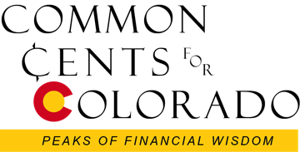
Save for a Definite Future Goal (retirement!)
Mutual Funds – for Ease and Diversity

Why Issued: Individual investors have a difficult time picking individual investments and monitoring a diversified portfolio. Enter modern mutual funds in 1924. They have become very popular beginning in the 1980s and ‘90s.
What do you own: A mutual fund pools money together from thousands of small investors and then its manager buys stocks, bonds or other types of securities. Each investor owns a pro rata share of all its investments.
How do you buy and sell: Most funds allow you to begin investing with as little as a couple hundred dollars. You purchase at the end of the day when all securities are valued at their closing prices. You may buy direct from the fund or through a broker.
What do you get: You attain a diversified portfolio and you don't have to worry about keeping track of dozens of holdings. The price for a share of an open-end fund is determined by the net asset value, or NAV, which is the total value of the securities divided by the number of shares outstanding.

Active vs. Passive Fund Management
ACTIVE MANAGEMENT: Active management was used almost exclusively before 1975. It rests on the theory that active management can pick the most attractive stocks, bonds, and time to move into or out of markets. (Sometime leveraged is introduced to enhance performance.)
PASSIVE MANAGEMENT: Passive management makes no attempt to identify the best, but instead invests in a broad sector of the market (asset class or index) and accepts the average return.
INDEXING: Indexing is a form of passive investing where portfolios mirror the securities in a known index. Best-known indexes are the Dow Jones, S&P 500 or Barclay’s Bond Indexes.
What Works Best: The results from research (from universities and privately funded research centers) are very clear: Active investment management is an appealing mirage which substantially boosts costs and decreases returns compared to properly designed passive portfolios.

Why own MUTUAL FUNDS?
Professional Management - A mutual fund is a relatively inexpensive way for a small investor to get a full-time manager to make and monitor investments.
Diversification - Owning a large number of assets reduces risk (the less any one of them can hurt your total net worth).
Economies of Scale - Because a mutual fund buys and sells large amounts of securities at a time, its transaction costs are lower than you as an individual would pay.
Liquidity - Just like an individual stock, a mutual fund allows you to request that your shares be converted into cash at any time.
Convenience/Simplicity - Buying a mutual fund is easy! Mutual fund purchases are available through almost any broker or bank, and easily purchased direct on line or by telephone. The minimum investment is usually small. Most companies also have automatic purchase plans whereby as little as $100 can be invested on a monthly basis.
The Risks of Owning Mutual Funds
Professional Management- Management is by no means infallible, and, even if the fund loses money, the manager still takes his/her cut.
Dilution - It's possible to have too much diversification. Because funds have small holdings in so many different companies, high returns from a few investments often don't make much difference on the overall return.
Taxes - When making decisions about your money, fund managers don't consider your personal tax situation. For example, when a fund manager sells a security, a capital-gain tax is triggered for the mutual fund shareholder. This can result in unanticipated tax consequences.
Liquidity: Only can sell after the market closes.

Costs - Mutual funds don't exist solely to make your life easier. The mutual fund industry is masterful at burying costs under layers of jargon. These costs are complicated, but not impossible to understand. Morningstar is a great third-party resource for researching fees.
Cost One: Loads - a percentage of the amount you're buying or selling.
- a front-load fund, meaning that you pay a certain percentage of your purchase as a commission up front
- a back-load fund, meaning you pay the commission (as a percentage) when you sell.
- a constant-load fund that takes out fees on a regular basis
- or a no-load fund, meaning you pay no commission. This is the only type of mutual fund the average investor should buy.
(It's not uncommon for a load to be as high as 5.75%, so if you invested $10,000 in one of these front-load funds, you would lose $575 immediately. Back-load funds are no less painful. Either you see the fees deducted from what you thought were your earnings or, worse yet, you may lose money on your investment and still have to cough up the back-load funds when you sell. If you buy or sell through a broker, you may also incur the cost of a commission for the trade.)
Cost Two: Expense Ratio
Before buying a mutual fund, investigate the fund's expense ratio. This is the percentage of the fund's assets that are deducted from earnings each year to cover the fund's operating expenses. Some funds have reasonable fees not exceeding 1%. Index funds can have fees as low as 0.10%. Others are 3% or more. This comes right out of your earnings, so the lower the fee, the higher your return.

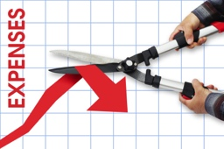
Expense ratios range from as low as 0.05% (usually for index funds) to higher than 2.00%. The average equity mutual fund charges around 1.3%-1.5%. You'll generally pay more for specialty or international funds that require more expertise from managers and have higher trading costs.

Are high fees worth it? You get what you pay for, right? WRONG!

Just about every study ever done has shown no correlation between high expense ratios and high returns. This is a fact. If you want more evidence, consider this quote from the Securities and Exchange Commission's website:
"Higher expense funds do not, on average, perform better than lower expense funds."

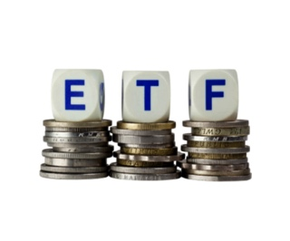

Exchange Traded Funds (ETF) – if you like to TRADE!

Why Issued: Introduced in the 1990s to replicate mutual funds but allow intraday trading, thus creating more tax efficiency for investors.
What do you own: Like a mutual fund, ETFs pool money together from thousands of small investors and then its manager buys stocks, bonds or other securities to match a designated or self-created index. Each investor owns a pro rata share of all its investments.
How do you buy and sell: ETFs trade on the exchanges, so you purchase them through a broker or online.
What do you get: Theoretically, a more tax efficient and inexpensive (low trading cost within the fund) way to own a basket of securities.
Why own ETFs?
Trading: ETFs trade like stocks. Therefore, they can be bought and sold throughout the trading day as the price fluctuates and can be bought on margin, sold short, or traded using stop orders and limit orders.
Usually fully invested: ETFs do not have to hold cash or buy and sell securities to pay fund investors when redemption is requested.
Lower annual expenses: An ETF’s annual expenses and trading costs are usually lower than non-index mutual funds.
Control of tax distributions: ETFs typically have lower annual taxable distributions because they trade less frequently than mutual funds.
Specialized Indexes: ETFs may allow you to diversify your portfolio into additional sectors of the market such as commodities.

The Risks of Owning ETFs
Dollar Cost Averaging: ETFs are not cost effective if you are Dollar Cost Averaging or making repeated purchases over time because of the commissions associated with purchasing ETFs. Commissions for ETFs are typically the same as those for purchasing stocks.
Thin trading markets: From a timing perspective, selling an EFT when you want to or need to may be difficult if the ETF is a thinly traded issue or if the market is experiencing high volatility. This is also true when selling stocks.
Untested indexes: In a survey of investment professional, the most frequently cited disadvantage of ETFs was the unknown, untested indexes used by many ETFs. A long-term risk was cited that the popularity of these vehicles might lose market favor (as in the crash of 2008) and trade below their true value.
Higher Risk: Some ETFs may not track a widely accepted index, which may result in higher costs and higher risk.

In Conclusion...

Use Mutual Funds with low expenses!
Remember the investment pyramid!

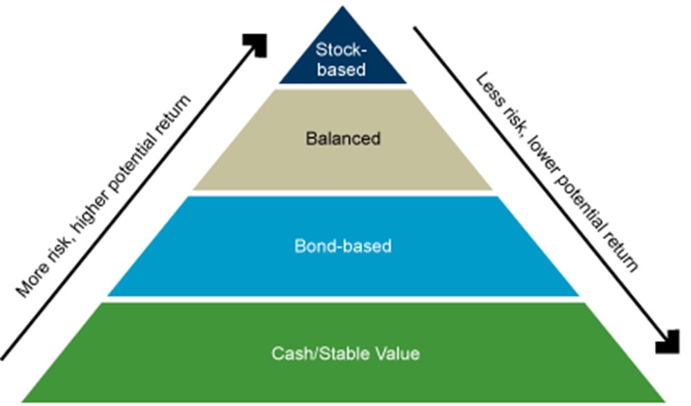

AND

ALLOCATE ACCORDING TO YOUR AGE (RISK TOLERANCE)
Every birthday that ends with a ZERO, (20, 30, 40, 50, 60, 70,80),
move 10% more into bonds for the money you
need for the long-term.

