

Seminar Two

Key Investment Concepts

(that everyone should know)

**If you’ve saved some money (even a little) and want to invest for the future, you need to understand KEY FINANCIAL PRINCIPLES that form the foundation of successful investing.**

**Participants will be introduced to eleven major (but simple) concepts and their “multiple nuisances” that should be considered (and understood) before determining an investment plan. As each concept is discussed, the application of the concept to one’s personal investment strategy will be illustrated. The seminar also includes the examination of various investment styles and growth strategies that can be applied to participants’ current situation.**

**The seminar is designed for anyone beginning or reevaluating his/her long term investing strategy, including new and more experienced investors and modest and substantial portfolios. Every young person should also learn these basics and begin the saving and investing process early in life. The goal is a sound investment portfolio strategy that you understand, that is tailored to your personal goals, that costs you little to execute, and which provides you with minimal worry.**



**Marsha Yelick CFA(retired)**

**Financial Programs Consultant**

**myelick@estesvalleylibrary.org**

**970-586-8116 Ext 831**

“When there are multiple solutions to a problem,

choose the simplest one.”

― [John C. Bogle](http://www.goodreads.com/author/show/88909.John_C_Bogle)

**MAJOR CONCEPTS for Seminar Two**

**MC900332684[1]Common sense is the secret to handing your own money well.**

**It’s not the “hottest” investment; it’s knowing how to diversify.**

**The simplest choices are best.**

**Impulse is your enemy; time is your friend.**

**Why should I understand investment concepts?**



1. You need to know your destination.
2. You need to know how long you have to reach your destination.
3. You need to know how much risk you are willing to take.
4. You need to know what to do when “circumstances” change.
5. You need to be able to determine if you are going the right direction.
6. If you have a chauffeur, you must still know all of the above!

We will be discussing ELEVEN investment terms.

**An understanding of the investment terminology is the foundation for a customized and sound investment strategy to meet your needs. There is no “one correct way” to invest, but there is knowledge that will guide you to your best investment strategy. Expect that your strategy will change over time, as you inevitably age and your money grows.**



**Term 1: RETURN**

**Return:** Investment return is what you get back on the investment you make. Ideally, the return will be positive, your initial investment or principal remains intact, and you will end up with more than you invested. How you measure the return is where it gets confusing! But it’s vitally important to know how investments are doing. Just measuring dollars is not enough. Brokerage statements usually only provide dollars in their reports.

Four common ways to measure return:

**Simple return**: Stated in dollars - the money you made.

Buy at $30, sell at $35 = simple return of $5.00

“I made $5 on that investment!”

**Total return:** Still stated in dollars – the money you made after expenses**.**

Buy at $30, pay $.75 commission, get $.50 dividend, sell at $35, pay $.75 commission.

“I made $4 on that investment!”

**Rate of return**: The percentage increase (or decrease) you made.

A more complete story that puts the return in percent (allowing comparison to other investments of different dollar amounts).

Make $4 on a $30 investment = $4 / $30 = 13.3%

“I made over 13% on that investment!”

**Annualized total rate of return:** The percentage increase (or decrease) you made put in terms of the annual holding period. **A valid measure, excellent for comparing any investment**

Make $4 on a $30 investment held over two years. $4 / $30 = 13.3% / 2 = **6.67%**

Example: At the friendly neighborhood cookout, your neighbor says he “doubled” his money on his brilliant stock investment of 6,000 shares.

****(The real story - he bought 6,000 shares of a penny stock that cost $0.10 /share ($600). He sold the shares twelve years later for $0.20/share. He paid total commissions of $50.)

Simple return: $1,200 - $600 = $600

Total return: $600- $50 = $550

Rate of return: $550/$600 = 91.67%

**Annualized return:** 91.67%/ 12 = **7.6%**



So...what is an “expected, fair” annualized rate of return?

**"Those who do not study history are doomed to repeat it."** *George Santayana*

**"I know of no way of judging of the future but by the past."** *Patrick Henry*

**“A page of history is worth a volume of logic."** [*Oliver Wendell Holmes, Jr.*](http://search.biography.com/print_record.pl?id=15942) in a 1921 decision

**"Get your facts first, and then you can distort them as much as you please."** *Mark Twain*

**“If history books were the key to riches, the Forbes 400 would consist of librarians."**  
http://www.investorhome.com/indent.gif*Warren Buffett – Berkshire Hathaway* Annual Report, 1990, p.18

**Let’s look at HISTORY**

|  |  |  |  |
| --- | --- | --- | --- |
| Historic (nominal) returns 1926-2005, source: Ibbotson Associates[[1]](http://www.bogleheads.org/wiki/Historical_and_expected_returns#cite_note-1) | | | |
| **Series** | **Geometric Mean** | **Arithmetic Mean** | **Standard Deviation** |
| Large Company Stocks | 10.4% | 12.3% | 20.2% |
| Small Company Stocks | 12.6% | 17.4% | 32.9% |
| Long-term Corporate Bonds | 5.9% | 6.2% | 8.5% |
| Long-term Government Bonds | 5.3% | 5.5% | 5.7% |
| U.S. Treasury Bills | 3.7% | 3.8% | 3.1% |
| Inflation | 3.0% | 3.1% | 4.3% |

50% stocks (10.4%) +

50% bonds (5.9%) =

8.1%

Beats inflation 8.1% - 3.0% = 5.1%



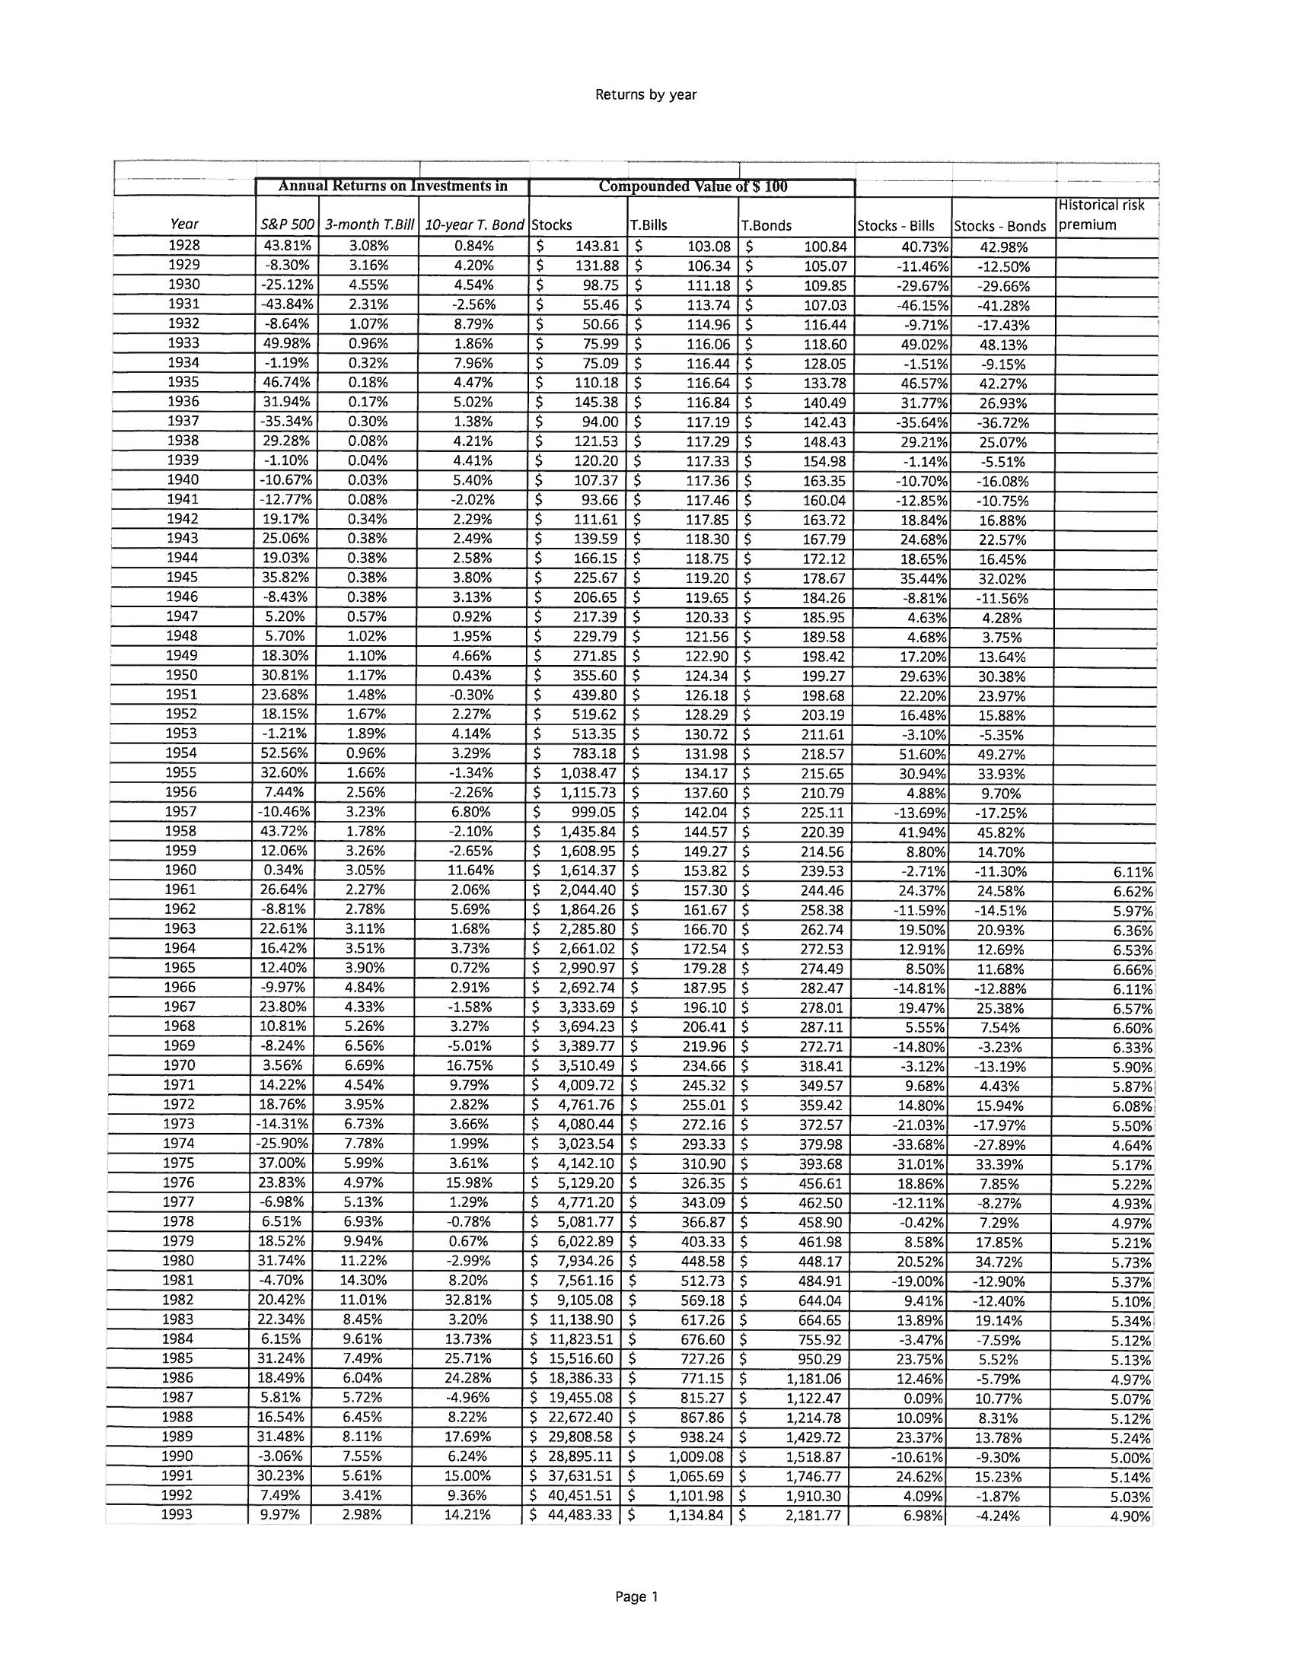

**Another View of Return (and Risk)**

**Annual Returns on Stock, T.Bonds and T.Bills: 1928 - 2014**

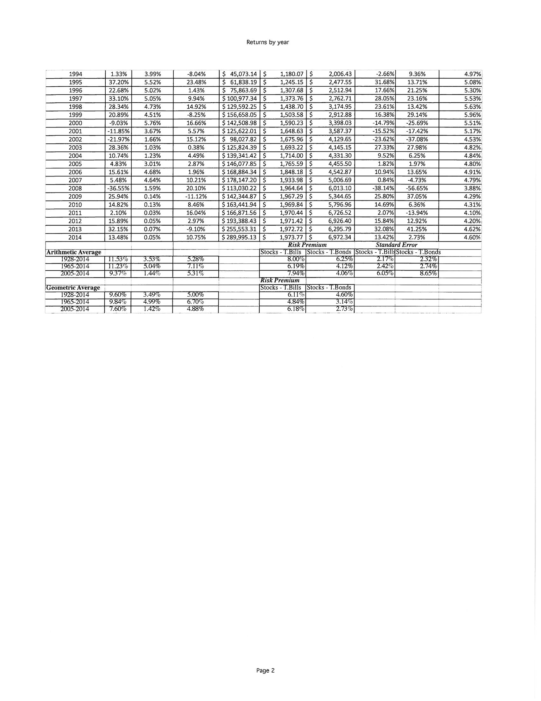

We’ve learned:

Look for (or figure out) the approximate annualized total rate of return.

A “conservative” annualize total rate of return is between 7 – 8% and

after inflation return between 4-5%.

50% stocks (9.6%) +

50% bonds (5.0%) =

7.3%

Beats inflation 7.3% - 3.0% = 4.3%

Last updated: January, 2015

Stern.nyu.edu/~adamodar/

By Aswath Damodaran

**Term 2: YIELD**

Who cares about yield? (Annualized total rate of return is still the most important – until a huge market correction! Then you will care and be glad you paid attention!

1. It is money in the hand.
2. It allows diversification.
3. It sustains price decline.

**Yield:** Yield on an investment is the amount of money you collect annually in interest (from bonds, i.e. fixed income) or dividends (from stock) calculated as a percentage of either the current price of the investment or the price you paid to buy the investment.

* Yield *sometimes* comes from equity in the form of dividends.
* Yield *almost always* come from bonds in the amount of the interest.

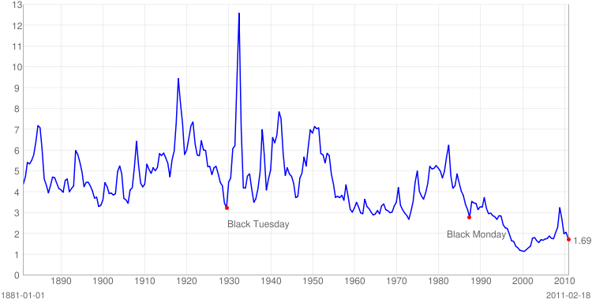What to expect in yield from “average investments”?

**STOCKS**

**Current S&P 500 Dividend Yield:** 1.92% year-end 2014 2.20% - August 24, 2015

**Mean:** 4.35%   
**Median:** 4.29%   
**Min:** 1.11% (Aug 2000)  
**Max:** 13.84% (Jun 1932)

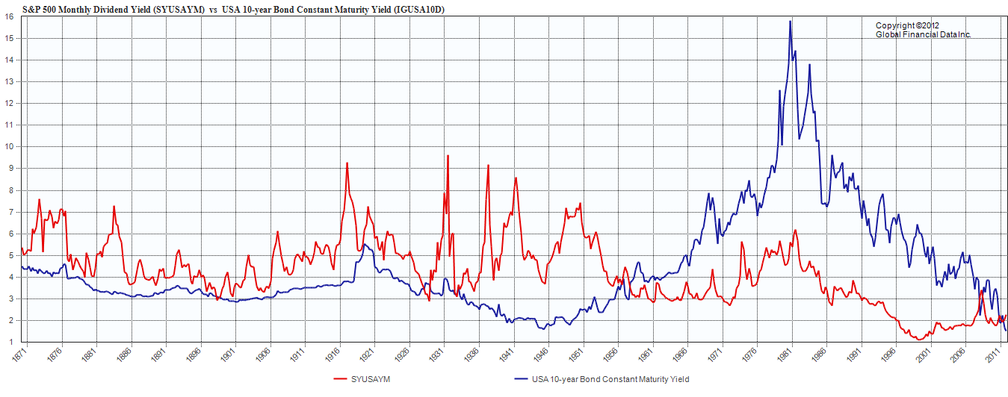BONDS

**Current 10-year Treas. Yield:** 2.21% year-end 2014 2.32% July, 2015

**(10-Yr. Treasury)**

**Mean:** 4.61%   
**Median:** 3.89%   
**Min:** 1.53% (Jul 2012)  
**Max:** 15.32% (Sept 1981)

Ralph Dillon, Global Financial data) (This was originally published at The Big Picture and is reproduced here with permission.)

**MCj03835840000[1]Term 3: RISK (RISK/RETURN)**

As with many other things, risk and reward are related. “Common Cents” tells us - **the greater the potential for gain, the greater the risk**. Although it is true that investors need to take some risk, investment risk can be managed with foresight, knowledge and good planning.

Description: MC900364268[1]

**Risk** is a term often used to imply **downside** risk,

meaning the uncertainty of a return and the potential for **financial** loss.

**NONSYSTEMATIC RISK:** The risk of an single investment.

To avoid this risk: **DIVERSIFY, DIVERSIFY, DIVERSIFY.**

**SYSTEMATIC RISK:** Risk of financial markets in general

(General risks – market segments, interest rate, inflation, recession, currency, political)

To avoid this risk: build an **AMPLE, SECURE FINANCIAL BASE**.



Highest Risk/

Highest Earnings

Lowest Risk/

Lowest Earnings



**RISK AVOIDANCE:** One of the **biggest risks** is to avoid risk altogether. If you invest very conservatively or don’t invest at all because you’re afraid of losing your principal, you become vulnerable to inflation, which will erode the value of your buying power over the long-term.

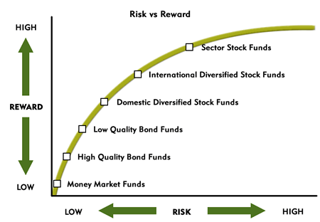

<http://www.ivyfunds.com/educ_invest_risk.aspx>



**Term 4: VOLATILITY**

**Volatility** is the “tendency” of some investments to fluctuate rather quickly in value (another form of investment risk). The more volatile an investment is, the more it can potentially lose or gain value in the short-term.



Is the relative volatility of a particular stock relative to the whole market. Beta of 1 is average.

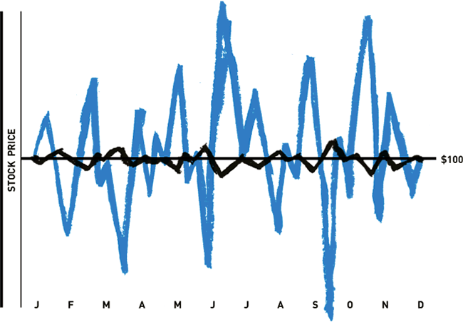**Figure 1: Historical volatility of two different stocks**

This chart shows the historical pricing of two different stocks over 12 months. They both start at $100 and end at $100. However, the blue line shows a great deal of historical volatility while the black line does not.



<http://www.optionsplaybook.com/options-introduction/what-is-volatility/#ixzz3jm0Pdxv1>

**Term 5: LIQUIDITY**

**LIQUIDITY is the ease (including speed) with which you can convert an investment into cash WITHOUT losing value.**

**- versus -**

**How much liquidity is enough?**

**WORKERS -The average time it would take to find a new job: 6-9 months**

**RETIREES -The average time it would take for financial markets to recover: 1-2 years**

**Term 6: COMPOUNDING**

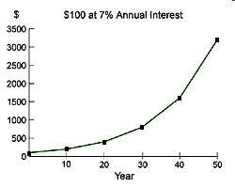

**...t**he ability of an asset to generate earnings, which are then reinvested in order to generate their own earnings. In other words, compounding refers to generating earnings from previous earnings.

The power of compounding was said to be the eighth wonder of the world - or so the story goes - by Albert Einstein.  PLEASE TEACH THIS CONCEPT TO EVERY YOUNG PERSON YOU KNOW!



**Term 7: INFLATION**

**Inflation** is the rate at which the general level of prices for goods and services is rising and, consequently, the purchasing power of currency is falling.

INVESTOPEDIA.COM

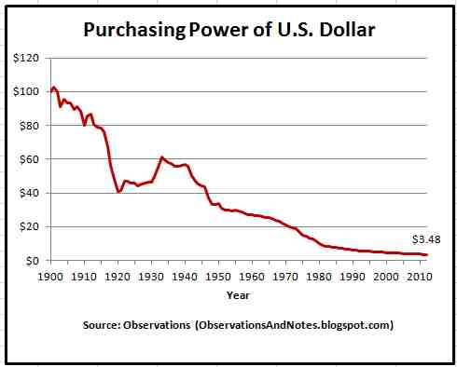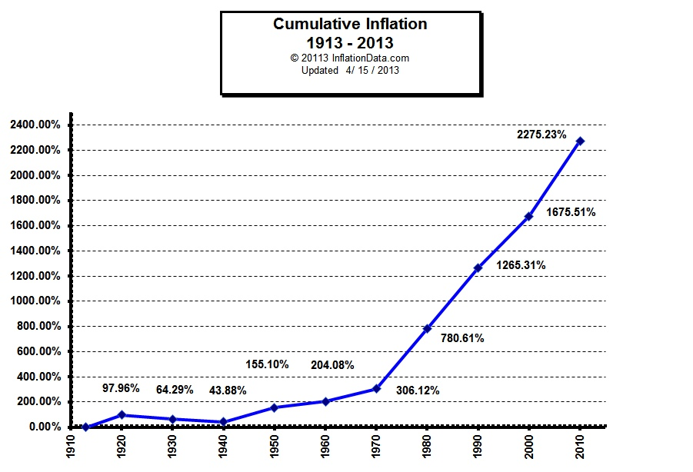**Inflation also COMPOUNDS!**

**TERM 8:DOLLAR COST AVERAGING**

…an investment strategy of [investing](http://en.wikipedia.org/wiki/Investing) equal monetary amounts regularly and periodically over specific time periods (such as $100 monthly) in a particular investment or portfolio. By doing so, more shares are purchased when prices are low and fewer shares are purchased when prices are high. The point of this is to lower the total average *cost per share* of the investment, giving the investor a lower overall cost for the shares purchased over time.

<http://en.wikipedia.org/wiki/Dollar_cost_averaging>

**Over an extended period of time, the average cost paid per share should be lower than the average share price.** See the chart below for an example.

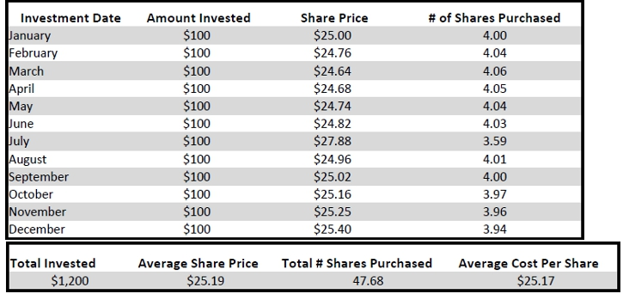

<http://www.smart401k.com/Content/retail/resource-center/retirement-investing-basics/dollar-cost-averaging>

**Term 9: TAX-DEFERRED SAVINGS**

Paying unnecessary funds to Uncle Sam is not conducive to nest egg growth!

|  |  |  |  |
| --- | --- | --- | --- |
| **Year** | **Total Contributions** | **IRA Value** | **Savings Account Value** |
| **1** | **$3,000** | **$3,000** | **$3,000** |
| **2** | **$6,000** | **$6,180** | **$6,126** |
| **3** | **$9,000** | **$9,551** | **$9,387** |
| **4** | **$12,000** | **$13,124** | **$12,792** |
| **5** | **$15,000** | **$16,911** | **$16,345** |
| **6** | **$18,000** | **$20,926** | **$20,051** |
| **7** | **$21,000** | **$25,182** | **$23,917** |
| **8** | **$24,000** | **$29,692** | **$27,951** |
| **9** | **$27,000** | **$34,474** | **$32,158** |
| **10** | **$30,000** | **$39,542** | **$36,547** |
| **15** | **$45,000** | **$69,828** | **$61,507** |
| **20** | **$60,000** | **$110,357** | **$92,344** |
| **30** | **$90,000** | **$237,175** | **$177,514** |
| **Taxes Due** |  | **- $41,209** |  |
| **Net After Tax** |  | **$195,966** | **$177,514** |

MC900149345[1]

**Term 10: FEES – All investments cost money!**

**Fees-** the amount of money you pay to buy, sell, and hold investments or to have them managed for you. Keeping fees low can increase average returns by 25% of more (return of 8% rather than 6%). Compounded over 30 years of saving, that’s a huge difference. So...

**Use NO-LOAD funds**. Load funds have an upfront fee (between 2% - 8%).

**Find LOW annual fees:** Look for funds in Quartile 1, with annual expense less that 0.6%.

**(Surprisingly, the lowest cost funds, on average, have the best performance over time!)**

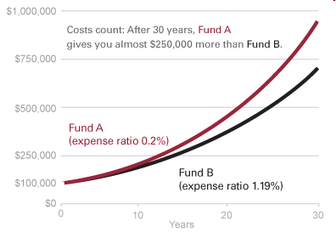

(from Vanguard Investment Counseling & Research)

**Term 11: ALLOCATION (DIVERSIFICATION)**

**Allocation**

No decision will have a greater impact on investment return than portfolio allocation.

Allocation is an investment strategy that aims to balance risk and reward by apportioning a portfolio’s assets according to an individual’s goals, risk tolerance and investment horizon. The three main asset classes – stock, bonds, and cash – have different levels of risk and return, so each will behave differently over time. [www.investopedia.com](http://www.investopedia.com)

The tables show why asset allocation is so important. It determines an investor's future return.

|  |
| --- |
| **Projected 10 year Cumulative return after inflation (REAL RETURN) (stock return 8% yearly, bond return 4.5% yearly, inflation 3% yearly**  [http://en.wikipedia.org/wiki/Asset_allocation - cite_note-13](http://en.wikipedia.org/wiki/Asset_allocation#cite_note-13) |

80% stock / 20% bond 52% **Aggressive**

70% stock / 30% bond 47%

60% stock / 40% bond 42% **Balanced**

50% stock / 50% bond 38%

40% stock / 60% bond 33% **Conservative/Income**

30% stock / 70% bond 29%

20% stock / 80% bond 24% **Conservative/Preservation**

But, one must also be able to tolerate the [bear market](http://en.wikipedia.org/wiki/Bear_market) burden. There may be periods of large paper losses in portfolios exposed to greater volatility.

**Cumulative return after inflation**

**from 2000-to-2002 bear market**

80% stock / 20% bond -34.35%

Aggressive Investor (young)

Balanced Portfolio

Conservative with Income (retired)

Conservative - Preservation

70% stock / 30% bond -25.81%

60% stock / 40% bond -19.99%

50% stock / 50% bond -13.87%

40% stock / 60% bond -7.46%

30% stock / 70% bond -0.74%

20% stock / 80% bond +6.29%



**Narrative Describing Asset Allocation Models**

***Model 1 - Preservation of Capital* (Most Conservative)**Asset allocation models designed for preservation of capital are largely for those who expect to use their cash within the next twelve months and do not wish to risk losing even a small percentage of principal value for the possibility of [capital gains](http://beginnersinvest.about.com/od/capitalgainstax/index.htm). Investors that plan on paying for [college](http://beginnersinvest.about.com/od/college1/), purchasing a house or acquiring a business are examples of those that would seek this type of allocation model. Cash and cash equivalents such as [money markets](http://beginnersinvest.about.com/cs/moneymarket/f/blmoneymarketac.htm), treasuries and [commercial paper](http://beginnersinvest.about.com/od/commercialpaper/index.htm) often compose upwards of eighty-percent of these portfolios. The biggest danger is that the [return earned](http://beginnersinvest.about.com/od/financialratio/a/aa081504.htm) may not keep pace with inflation, eroding purchasing power in real terms.

***Model 2 – Income* (Conservative)**Portfolios that are designed to generate income for their owners often consist of investment-grade, fixed income obligations of large, profitable corporations, real estate (most often in the form of [Real Estate Investment Trusts, or REITs](http://beginnersinvest.about.com/od/reit/a/aa101404.htm)), treasury notes, and, to a lesser extent, shares of [blue chip](http://beginnersinvest.about.com/od/bluechipstocks/index.htm) companies with long histories of continuous [dividend](http://beginnersinvest.about.com/od/dividendsdrips1/a/aa040904.htm) payments. The typical income-oriented investor is one that is nearing retirement. Another example would be a young widow with small children receiving a lump-sum settlement from her husband’s life insurance policy which she cannot risk losing. Although growth would be nice, the need for cash in hand for living expenses is of primary importance.

***Model 3 – Balanced* (Moderate)**Halfway between the income and growth asset allocation models is a compromise known as the balanced portfolio. For most people, the balanced portfolio is the best option not for financial reasons, but for emotional. Portfolios based on this model attempt to strike a compromise between long-term growth and current income. The ideal result is a mix of assets that generates cash as well as appreciates over time with smaller fluctuations in quoted principal value than the all-growth portfolio. Balanced portfolios tend to divide assets between medium-term investment-grade fixed income obligations and shares of common stocks in leading corporations, many of which may pay cash dividends. Real estate holdings via REITs are often a component as well. For the most part, a balanced portfolio is always vested (meaning very little is held in cash or cash equivalents unless the portfolio manager is absolutely convinced there are no attractive opportunities demonstrating an acceptable level of risk.)

***Model 4 – Growth* (Aggressive)**The growth asset allocation model is designed for those that are just beginning their careers and are interested in building long-term [wealth](http://beginnersinvest.about.com/cs/personalfinance1/a/blwealthy.htm). The assets are not required to generate current income because the owner is actively employed, living off his or her salary for required expenses. Unlike an income portfolio, the investor is likely to increase his or her position each year by depositing additional funds. In [bull markets](http://beginnersinvest.about.com/library/blbullmarket.htm), growth portfolios tend to significantly outperform their counterparts; in [bear markets](http://beginnersinvest.about.com/cs/marketanalysis/a/031701a.htm), they are the hardest hit. For the most part, up to eighty percent of a growth modeled portfolio can be invested in common stocks, a substantial portion of which may not pay [dividends](http://beginnersinvest.about.com/od/dividendsdrips1/a/aa040904.htm) or have long history of gorwoth. Portfolio managers often like to include an international equity component to expose the investor to economies other than the United States.

**Changing with the Times**

An investor that is actively engaged in an [asset allocation](http://beginnersinvest.about.com/od/assetallocation1/index.htm) strategy will find that his or her needs change as they move through the various stages of life. For that reason, some professional money managers recommend switching over a portion of your assets to a different model several years prior to major life changes. An investor that is ten years away from [retirement](http://beginnersinvest.about.com/od/retirementcenter/), for example, would find himself moving 10% of his holding into an income-oriented allocation model each year. By the time he retires, the entire portfolio will reflect his new objectives. Rebalancing may occur by changing future contributions OR by selling investments that have increased in value and buying underperforming classes.

<http://beginnersinvest.about.com>

**Check List for using Key Investment Concept**



* Pay down all credit card debt (you can’t earn 15-20% without too much RISK).
* Have adequate liquidity (to avoid selling investments at market lows).
* Start saving as early as possible (compounding).
* Use tax deferred accounts if available (next session) to save taxes.
* Know your total annual rate of return and check inflation to measure your progress. Try to include investments that produce yield as well as appreciation.
* Allocate investment according to the risk you are willing to take. (Know that bonds should make up a portion of your portfolio approximately equal to your age, for the money you need for the long-term). Don’t underestimate the affect of risk and volatility on you own ability to stick out the market lows.
* Diversify your portfolio to limit nonsystematic risk. (Mutual Funds!)
* Diversify your investments to include all parts of the bottom 2/3 of investment pyramid to limit systematic risk.
* Evaluate fees associated with investments. Don’t spend too much of your return on fees.
* Try to save something for the long term each month and from any windfall you receive. (dollar cost averaging).
* Invest in yourself – taking classes to improve financial earning power and knowledge!