

Seminar One

Goal Setting and

Financial Planning

(for everyone)

**This seminar is designed to explore BASIC money management concepts.**

**Participants will review fundamental money management tasks such as creating a personal balance sheet, building a monthly budget, and tracking everyday spending. The seminar will also examine how to clearly establish and reach financial goals. Handouts will be provided so each participant can apply learning to his/her personal situation.**

**The seminar is designed for anyone who wants to begin, restart, or reevaluate his/her relationship to money and how it can and should be managed to create a more restful and fulfilling life. The seminar is also for teens before they launch into the real world or those who may need to learn the basics before life-changing events force them to face the task of money management.**



**Marsha Yelick CFA(retired)**

**Financial Programs Consultant**

**myelick@estesvalleylibrary.org**

**970-586-8116 Ext 831**

**The finest of all human achievements**

**_ and the most difficult –**

**is merely being reasonable.**

**MAJOR CONCEPTS for Seminar One**



**Earn more than you spend.**

**LIVE WELL!**

**It’s never too late.**

**SIMPLICITITY**

**Find your financial SELF!**

**The years in which you grew up**

**The family in which you were raised**

**The bumps in the road you experienced**

**The age cycle in which you exist**

 **The habits you have integrated**

What is money?

MCj04418860000[1]

Means of exchange –

MCj04419220000[1]

MCj04418840000[1] Emotional, psychological realm

Cultural concept – Growth is GOOD

MCj04419380000[1]

* Your money or your Life!



**Financial Planning**

**Involves Three**

**DREADED,**

**but relatively easy,**

**FINANCIAL tasks**

**(You will sleep better at night!)**

1. **THE BALANCE SHEET….Figure out what you have.**
2. **THE INCOME STATEMENT… Figure out what it costs you to live as you wish to live. (Sometimes called a spending plan or a budget.)**
3. **GOAL SETTING…Figure out what you want.**



The Net Worth Statement (Balance Sheet)



****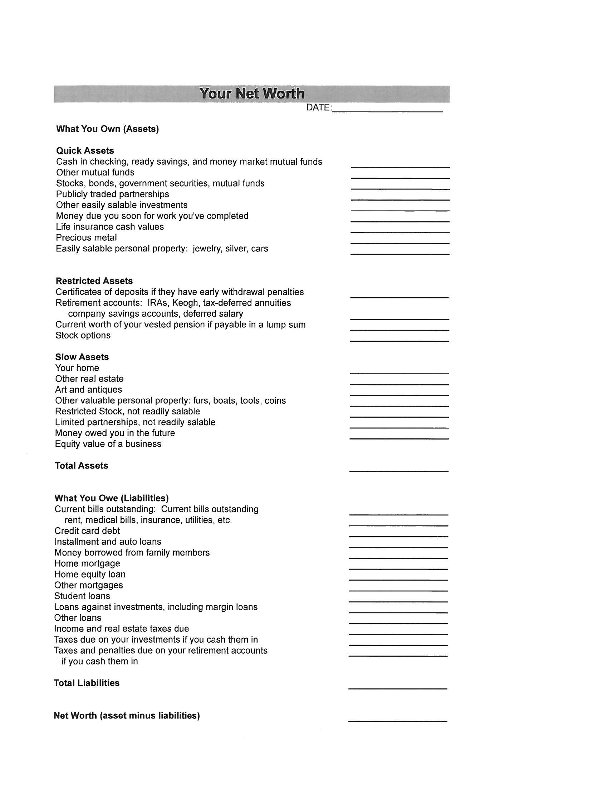

****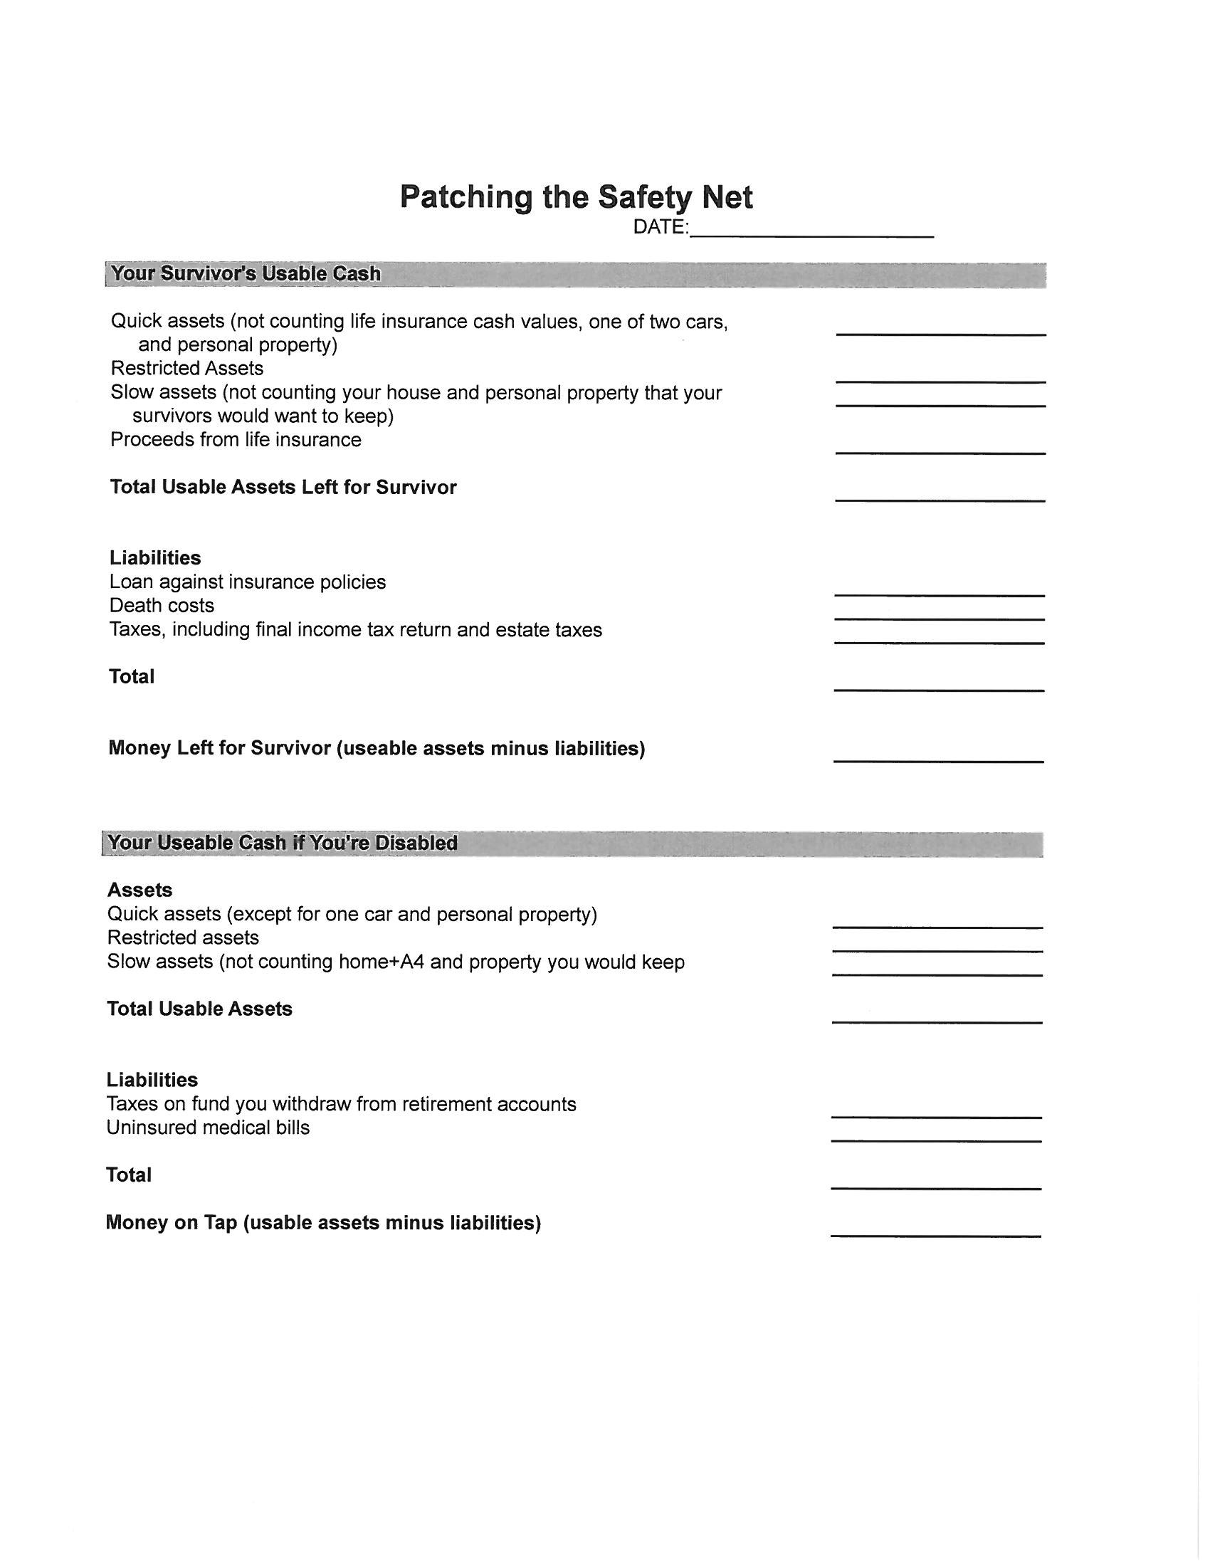

**Suggestions for THE Master List**

**(Keep in safe place AND be sure the right people know where it is)**

1. **Your insurance policies and insurance agents (Don’t forget Veteran’s information if you have been in the armed forces.)**
2. **Employee benefits and phone number of the office than handles them**
3. **Bank accounts and any particular banker that you deal with**
4. **Where to find the safe-deposit box and keys**
5. **Where you keep your will or living trust and the name of the lawyer who drew it up**
6. **Your executor or trustee**
7. **Where other trust documents are**
8. **Where all your personal papers are**
9. **Your brokers or investment advisers – names, addresses, and phone numbers**
10. **Your accountant – name, address, phone number**
11. **Where to find your securities and retirement accounts**
12. **Where your tax records are**
13. **What properties you own and where the deeds are**
14. **Your Social Security number and that of every family member**
15. **Your important computer passwords**
16. **Where you’ve hidden your home safe and what the combination is**
17. **Where you keep your emergency flight bag, if you have one (This is the box, list, container, etc. of stuff you would take with you in case of fire evacuation.)**
18. **A list of all your credit cards – account numbers and emergency telephone numbers – in case your wallet is stolen and you have to cancel them**
19. **Where your last-wishes file is**
20. **Photo copy of everything in your wallet: ID cards, driver’s license, health insurance card, and other items you carry for reference.**

Income Statement

(Budget or Spending Plan)

MC900383232[1]

**Seventeen Reasons to Have a Spending Plan**

1. To find out what you’re spending money on. Few of us know.
2. To extract more money for savings and investments.
3. To figure out how to make changes in your life, a new job, a move, a new house, etc.
4. To get out of debt.
5. To show the spouse who doesn’t pay the bills where the money goes.
6. To live within your income.
7. To prepare for big expenses such as college, a new house, a vacation, etc.
8. To retool your life after life happenings.
9. To keep money from slipping through your fingers.
10. To determine the minimum income you can live on, so you can handle what life hands you in the future.
11. To know how you’ll handle unexpected expenses.
12. To be able to buy what you really want.
13. To prepare for harder times.
14. To make the best use of the money when times are good.
15. To get the whole family pulling in the same direction
16. To put a tool in your hands that can change your life.
17. To put you new financial plan into action.

**Three Reasons Not to Have a Spending Plan**

1. You are so rich you can buy anything you want and still have plenty of money left over.
2. There aren’t any other reasons.

**A Free List of Excuses**

1. Making a spending plan takes too much time.
2. I won’t keep it up.
3. I don’t want to live in a straitjacket.
4. I hate arithmetic.
5. None of my friends does it.
6. I budget in my head.
7. I’m too tired, too young, too old, too busy, too poor, or not poor enough.
8. My husband, wife, daughter, parakeet won’t cooperate.
9. It won’t work, can’t work, and would drive me crazy if it really did work.
10. I’m too dumb, too smart, too short, too tall, too fat, and can’t give up smoking.



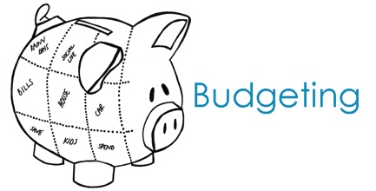**The Real Stuff of Budgets (and some hints to Help)**

**1. Budgets are a necessary evil.**

They're the only practical way to get a grip on your spending - and to make sure your money is being used the way you want it to be used.

**2. Creating a budget generally requires three steps**

* Identify how you're spending your money now.
* Evaluate your current spending and set goals that take into account your long-term financial objectives.
* Track your spending to make sure it stays within those guidelines.

1. **Use software if you are computer inclined.**

If you use a personal-finance program such as Quicken or Microsoft Money, the built-in budget-making tools can create your budget for you.

1. **Don't drive yourself crazy!**

One drawback of monitoring your spending is that it encourages overzealous attention to detail. Once you determine which categories of spending can and should be cut (or expanded), concentrate on those categories and worry less about other aspects of your spending.

1. **Watch out for cash leakage.**

If withdrawals from the ATM machine evaporate from your pocket without apparent explanation, it's time to keep better records. In general, if you find yourself returning to the ATM more than once a week, you need to examine where that cash is going. Otherwise, give yourself the freedom to spend some cash freely. It’s like an allowance.

1. **Spending beyond your limits is dangerous.**

But if you do, you've got plenty of company. Government figures show that many households with total income of $50,000 or less are spending more than they bring in. This doesn't make you a candidate for bankruptcy - but it's a sign you need to make some serious spending cuts.

1. **Beware of luxuries dressed up as necessities.**

If your income doesn't cover your costs, then some of your spending is probably for luxuries - even if you've been considering them to be filling a real need.

1. **Limit yourself.**

Aim to spend no more than 90% of your income. That way, you'll have the other 10% left to save for your big-picture items.

1. **Don't count on windfalls.**

When projecting the amount of money you can live on, don't include dollars that you can't be sure you'll receive, such as year-end bonuses, tax refunds or investment gains.

1. **Beware of spending creep.**

As your annual income climbs from raises, promotions and smart investing, don't start spending for luxuries until you're sure that you're staying ahead of inflation. It's better to use those income increases as an excuse to save more.



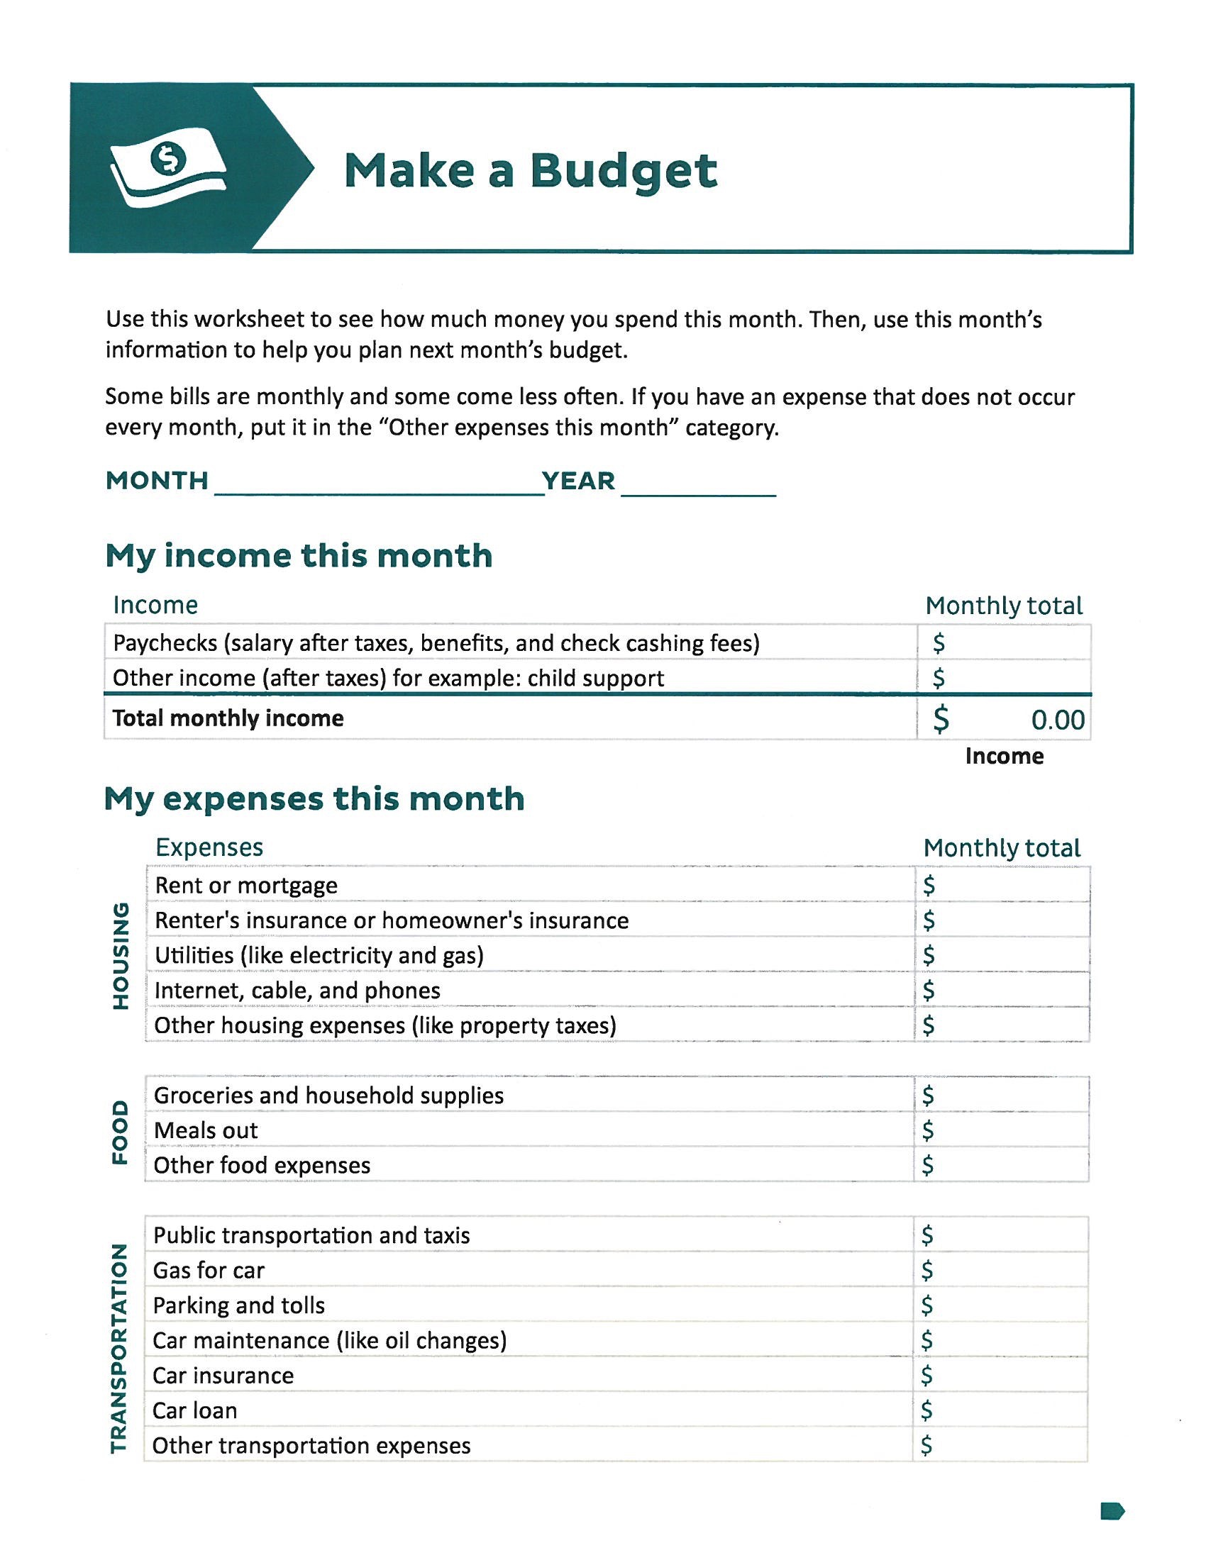

**PAY YOURSELF FIRST “PYF”**



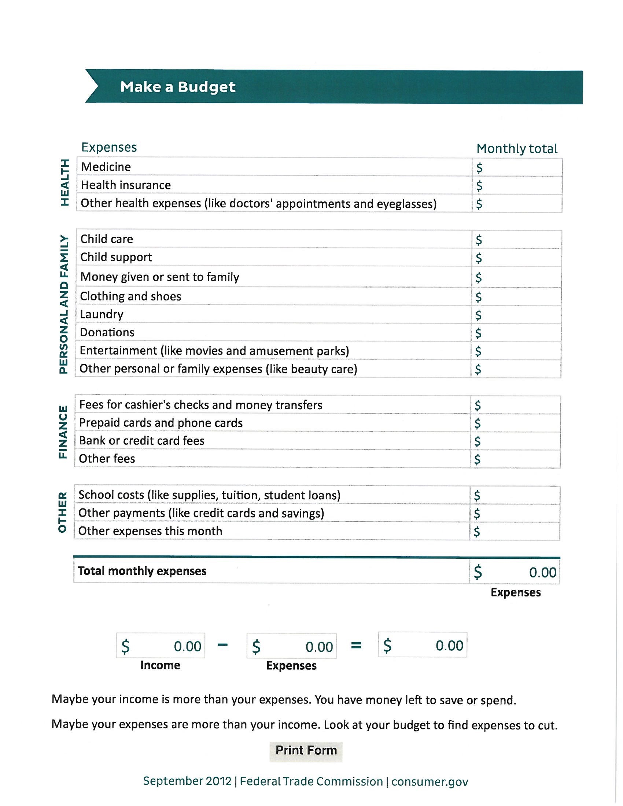



Compare Income and Expenses

**Income and Expenses Per Month (or average)**

Write down you total monthly income $______________________

Write down your total monthly expenses $______________________

Subtract expenses from income $______________________

(hope that it is not negative!)

Set Priorities and Make Changes

|  |  |
| --- | --- |
| After comparing your income and expenses, if you find you have income left over (this means money left after you already set aside at least 10% for saving for retirement), you have met the goal.  If you put the money left over, put it into additional savings toward one of your goals, you’re on your way to controlling you money and getting what you want out of life.  But – if your expense were more than your income, yikes! This can happen to anyone occasionally, but if it happens often, your budget is “out of balance,” and you’re said to have a **negative cash flow.”** To get back in the driver’s seat, you can do one of three things:   1. Increase your income 2. Cut back on some expenses 3. A combination of both. | Ideas for cutting back expenses or plugging the leaks. (Eliminate extra services, reduce unnecessary spending, etc.)  Ways to increase income. (Sell unwanted items, find a second job, etc.)  _________________________________ |



**When looking for ways to CUT expenses...**

**think of these three questions.**

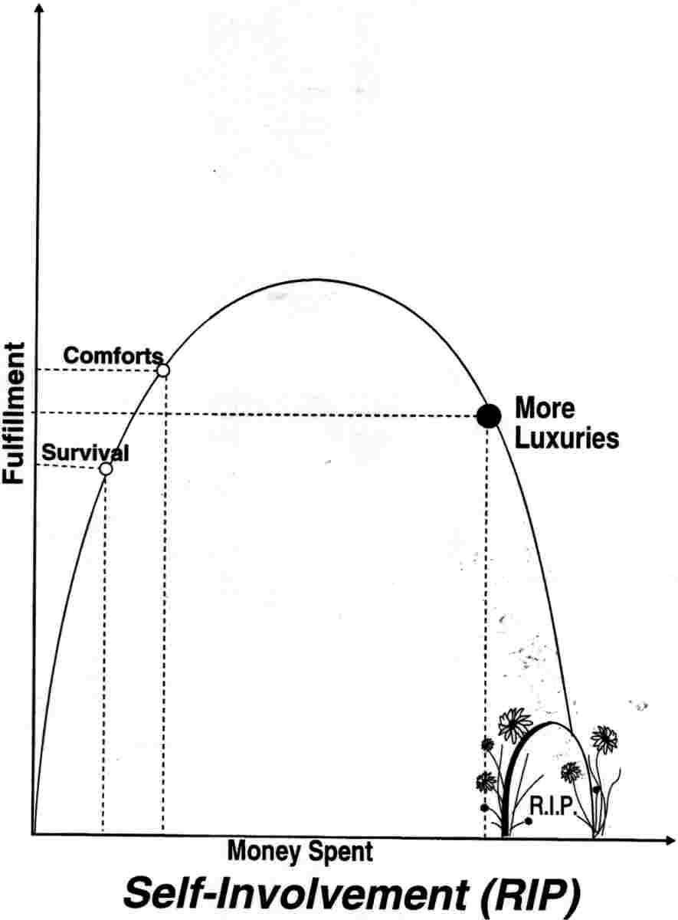

How much is ENOUGH?



What truly gives me JOY?

MC900292322[1]

****How much of my LIFE does this cost?

Setting Goals and Priorities

**Short term goals:**  Usually a goal to be achieved within the next few years. Be careful to not impact longer saving goals. Make sure money is secure and accessible. ***Examples:*** a car, a down payment on a home, a vacation, education, getting married, starting a business, paying off credit cards, student loans or other debt. ***Invest in:*** savings accounts, CDs, money market accounts, US Treasury bill, short term bonds.

**Mid-term goals**: Usually a goal to be achieved in about ten years. Try to accurately assess the cost and revisit the changing cost each year. Carefully balance investment growth with financial security, moving to stable investments as you approach the goal. ***Examples:*** college education for children, purchasing a larger home or second home, buying a boat, traveling to a special destination, changing careers or locations. ***Invest in***: stock mutual funds investing in established companies, exchange traded funds investing in established companies, US Treasury notes, high credit quality bonds or bond fund, zero-coupon bonds with appropriate maturity dates.

**Long-term goals**: Usually a goal to be achieved in twenty OR MORE years. It’s never too early (or too late) to begin planning for major financial goals. Carefully balance investment growth with financial security, moving to stable investments as you approach the goal. ***Examples***: a comfortable retirement, an early retirement to allow time for other interests, travel and hobbies, continuing to support your children, financial security for long-term health care, providing an inheritance, creating a legacy. **Invest in:** stock mutual funds that invest in growing companies, exchange traded fund tracking diversified indexes, long term bonds, zero-coupon bonds with appropriate maturity dates.

|  |  |  |  |  |  |
| --- | --- | --- | --- | --- | --- |
| **Goal** | **Short/Mid/or Long** | **Time Frame** | **$ on hand already** | **$ Needed / Month** | **Rate of Return Needed** |
| **Example: Trip next year** | **Short** | **1year** | **$2,000** | **$100** | **-** |
|  |  |  |  |  |  |
| **Example: College for child** | **Mid** | **10 years** | **$20,000** | **$542** | **5%** |
|  |  |  |  |  |  |
|  |  |  |  |  |  |
|  |  |  |  |  |  |
| **Example: Retirement** | **Long** | **25 years** | **$60,000** | **$1,115** | **5%** |

**Recommended internet site for retirement planning:** [**www.choosetosave.org**](http://www.choosetosave.org) **Go to their *Ball ParkE$timate* to some various scenarios for your retirement savings. The site helps you with all the variables that might be a part of your special situation. I assumed a 40 year old with a salary of $50,000 who wanted to replace 80% of his pre-retirement income (including Social Security but no pension) with an inflation rate of 3%.**

**Also visit some of the calculators that are featured on mycalculators.com. I used their college calculator for a four-year $25,000/year college education with inflation at 3.8%, current savings of $20,000.**

