**Money Tips from a PIZZA!**

**OR…**

**What Every Teen Needs to Know**

**about Money**

**before Leaving Home**

1. **Pick up all things FREE:**

**PIZZA, coupons, student discounts, concerts, lectures, libraries, workout facilities, scholarships, grants, work (with perks), Student Financial Office, FAFSA. money savvy friends, special prices and sales, trading services (barter) tax credits, knowing the difference between wants and needs**

1. **PRACTICE for six months before your leave home:**

**Open a checking account, balance your statement, open a savings account, balance your statement, use the ATM, balance your statement, use a credit card, balance your statement, watch your accounts, invest in and secure your electronic devices, create a tentative budget, practice using a budget, check your credit score, buy a lock box, learn how much college (living) will cost**

1. **Avoid DEBT:**

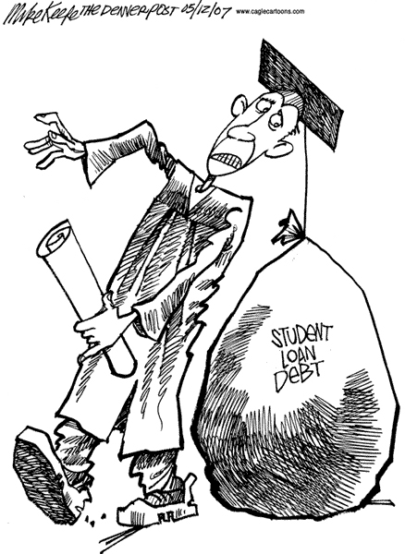 **Charge ONLY what you can pay off at the end of each month, two cards at the most, control costs, don’t company hop, seek money resources, research and understand the implications of student loans (they must be paid back), work to avoid unnecessary debt**



1. 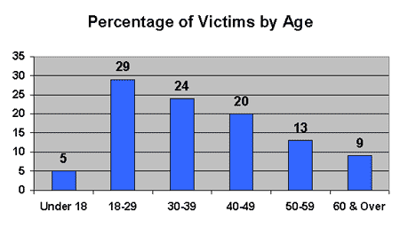**Guard your IDENTITY:**

**Balance bank statements and fees, monitor credit card purchases, secure passwords, shred physical mail (especially credit card offers), create a locked place for important stuff, use secure wifis, guard personal computer and other devices with a password, trust no one, use social networking with caution, install malware. PROTECT YOUR SSN!**

1. **Start saving and investing as EARLY as possible**

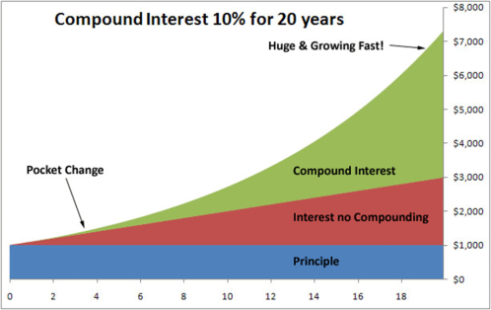**Understand the power of compound interest, learn about investing, begin investing in no-load, low-fee mutual funds, read a financial article once a month, talk to people who understand financial matters, educate yourself about financial matters, try on-line calculators (mycalculators.com), set a percentage goal for long-term savings contributions, search for employment with companies with 401(k) benefits**

**$100/mo. for 50 years at 8% = $793,172**

**MONEY MATTERS!**

**Don’t leave home without the skill to manage it!**