Money Matters
Part 2

Taking care of your money is important because money truly does matter. After all, you work hard for the money you have. It is not unlimited. And, having enough money to provide for your basic needs allows you to pursue things you want, take care of those you love, and experience peace of mind and a good night’s rest

But in our complex and fast-paced world, knowing all you need to know in order to make sound money decisions is not an easy task. What you learned from your parents or were taught in school (if it was even offered) has probably changed in the last decade.

This short two-part course is designed to review the basic money management concepts necessary to navigate in today’s financial world. Part I covers financial goal setting, banking, checking, savings, and fees avoidance. Part II deals with debt management, building good credit, saving money and planning for the future. Some of the material may be new; some may be information you learned before and practice everyday. Whatever the case, the course will provide a brief review of concepts that can save time, money, and future problems.

Participants are encouraged to complete the exercises and participate in discussion in order to discover ideas and practices that may enrich their ability to manage money. The class is about creating some positive vibration that will radiate through your financial life, making life more pleasant and allowing you to be both happy and productive.
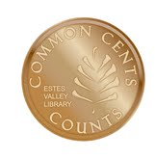
Marsha Yelick CFA (retired)
Financial Programs Consultant
myelick@estesvalleylibrary.org
970-586-8116 Ext 831

Participant Responsibilities
1. Please notify the instructor if you have a disability that may affect your learning and participation. We will make every effort to accommodate you and ensure that you are given what you need to be successful in this course.
2. Quizzes and exercises are not graded and are designed to help solidify the discussed concepts.
3. Money Matters is designed to build knowledge. It is best, but not required, to take the courses in sequence.
4. Basic classroom courtesy is expected, i.e., arriving on time, electronic devices turned off, respectful listening to the instructor and other participants, and thoughtful questions and responses.
5. You are welcome to attend a session again to brush up.
6. You are welcome to stand up at the back of the room if it helps your concentration (or your back).
7. You are always welcome to make an appointment to meet one-on-one with the instructor if you have additional questions or concerns.

Crossroads Participants
- Be sure to sign your name for attendance credit.
- Missing more than 30 minutes of a class means you will need to re-take.
- Return all your handouts to your notebook. It will be returned to your case manager. You will receive a certificate and any of the material you wish to retain for your files.
- Continue to work on the ideas you have learned. Working one-on-one with your case manager is encouraged.

Recognizing the Signs of TOO MUCH DEBT 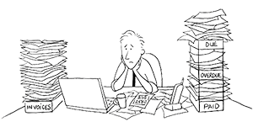
- Using credit cards to pay for basic living expenses.
- Using overdraft protection on your checking account to pay monthly bills.
- Using savings to pay bills.
- Using one credit card to pay another.
- Delaying one bill (or “floating”) to pay another overdue bill.
- Paying only the minimum due on credit card accounts.
- Using payday loans.
- Being over the limit on one or more lines of credit.
- Delaying medical and dental visits because you don’t have enough cash to pay for them.

Exercise
Check any of the following that apply to your situation.

20% of more of your income goes toward debt pay down (excluding your mortgage).
You have to borrow money each month to pay off debts.
You don’t know how much money you actually owe.
Each month you pay only the minimum amount on each bill.
You pay some bills late each month and sometimes miss payments.
Creditors call you to get you to pay your bills.
You have been denied credit in the past three years.
You have used retirement savings or credit cards to pay normal bills.
You write postdated checks.
You have taken extra jobs to keep up with your bills.

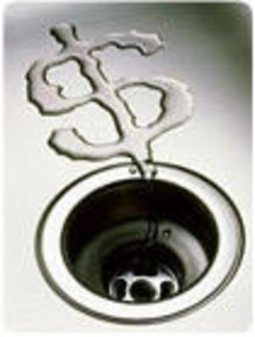
Income Statement
(Budget or Spending Plan)
Seventeen Reasons to Have a Spending Plan
- To find out what you’re spending money on. Few of us know.
- To extract more money for savings and investments.
- To figure out how to make changes in your life (a new job, a move, a house).
- To get out of debt.
- To show the spouse who doesn’t pay the bills where the money goes.
- To live within your income.
- To prepare for big expenses such as college, a new house, a vacation, etc.
- To retool your life after life happenings.
- To keep money from slipping through your fingers.
- To determine the minimum income you can live on, so you can handle what life hands you in the future.
- To know how you’ll handle unexpected expenses.
- To be able to buy what you really want.
- To prepare for harder times.
- To make the best use of the money when times are good.
- To get the whole family pulling in the same direction.
- To put a tool in your hands that can change your life.
- To put your new financial plan into action.

Three Reasons Not to Have a Spending Plan
- You are so rich you can buy anything and still have plenty of money left over.
- There aren’t any other reasons.

A Free List of Excuses
- Making a spending plan takes too much time.
- I won’t keep it up.
- I don’t want to live in a straitjacket.
- I hate arithmetic.
- None of my friends does it.
- I budget in my head.
- I’m too tired, too young, too old, too busy, too poor, or not poor enough.
- My husband, wife, daughter, parakeet won’t cooperate.
- It won’t work, can’t work, and would drive me crazy if it really did work.
- I’m too dumb, too smart, too short, too tall, too fat, and can’t give up smoking.
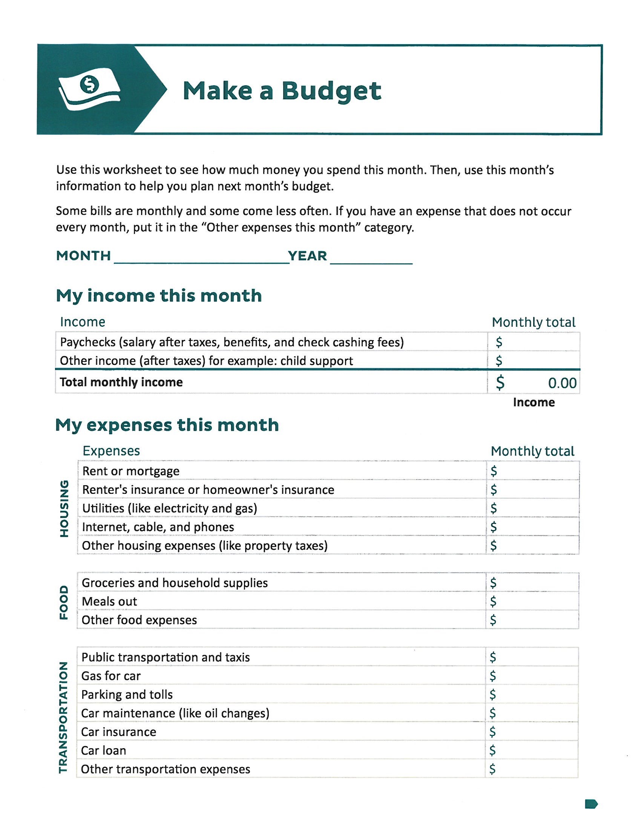
Pay Yourself First (PYF)
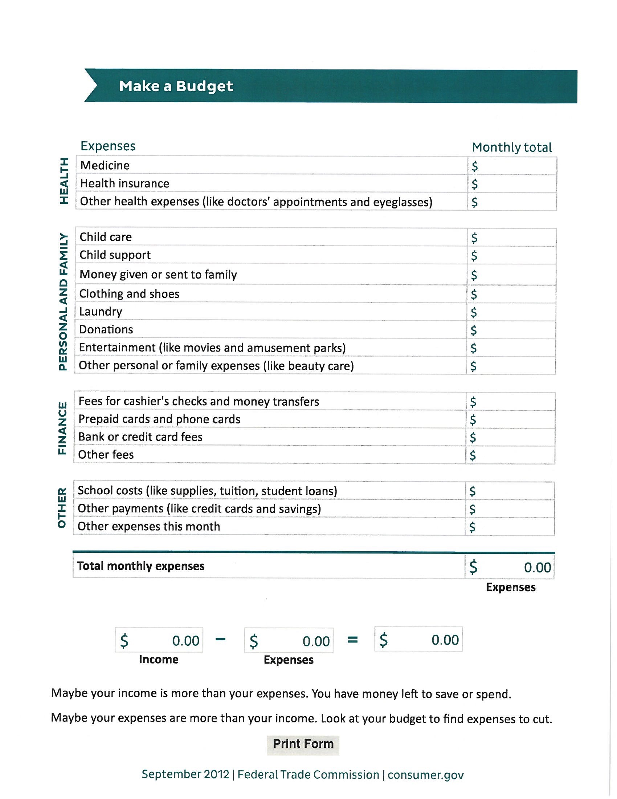

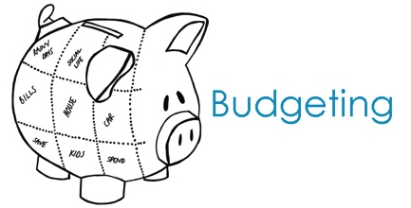
The Real Stuff of Budgets
(and some hints to help)

1. Budgets are a necessary evil.
They're the only practical way to get a grip on your spending - and to make sure your money is being used the way you want it to be used. They are less a headache than overspending!
2. Creating a budget generally requires three steps.
- Identify how you're spending your money now.
- Evaluate your current spending and set goals that take into account your long-term financial objectives.
- Track your spending to make sure it stays within those guidelines.
- Use software if you are computer inclined.
If you use a personal-finance program such as Quicken or Microsoft Money, the built-in budget-making tools can create your budget for you.
- Don't drive yourself crazy!
One drawback of monitoring your spending is that it encourages overzealous attention to detail. Once you determine which categories of spending can and should be cut (or expanded), concentrate on those categories and worry less about other aspects of your spending.
- Watch out for cash leakage.
If withdrawals from the ATM machine evaporate from your pocket without apparent explanation, it's time to keep better records. In general, if you find yourself returning to the ATM more than once a week, you need to examine where that cash is going. Otherwise, give yourself the freedom to spend some cash freely. It’s like an allowance.
- Spending beyond your limits is dangerous.
But if you do, you've got plenty of company. Government figures show that many households with total income of $50,000 or less are spending more than they bring in. This doesn't make you a candidate for bankruptcy - but it's a sign you need to make some serious spending cuts.
- Beware of luxuries dressed up as necessities.
If your income doesn't cover your costs, then some of your spending is probably for luxuries - even if you've been considering them to be filling a real need.
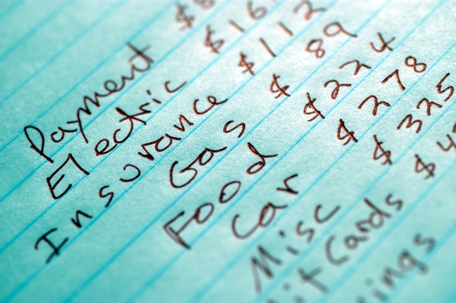
- Limit yourself.
Aim to spend no more than 90% of your income. That way, you'll have the other 10% left to save for your big-picture items.
- Don't count on windfalls.
When projecting the amount of money you can live on, don't include dollars that you can't be sure you'll receive, such as year-end bonuses, tax refunds or investment gains.
- Beware of spending creep.
As your annual income climbs from raises, promotions and smart investing, don't start spending for luxuries until you're sure that you're staying ahead of inflation. It's better to use those income increases as an excuse to save more.

Compare Income and Expenses

Income and Expenses Per Month (or average)

Write down you total monthly income $______________________

Write down your total monthly expenses $______________________

Subtract expenses from income $______________________
(hope that it is not negative!)

Set Priorities and Make Changes

After comparing your income and expenses, if you find you have income left over (this means money left after you already set aside at least 10% for saving for retirement), you have met the goal.  If you have money left over, put it into additional savings toward one of your goals, you’re on your way to controlling you money and getting what you want out of life.  But – if your expense were more than your income, yikes! This can happen to anyone occasionally, but if it happens often, your budget is “out of balance,” and you’re said to have “negative cash flow.” To get back in the driver’s seat, you can do one of three things:  - Increase your income.  - Cut back on some expenses.  - A combination of both. | Ideas for cutting back expenses or plugging the leaks. (Eliminate extra services, reduce unnecessary spending, etc.)  Ways to increase income. (Sell unwanted items, find a second job, etc.)  _________________________________

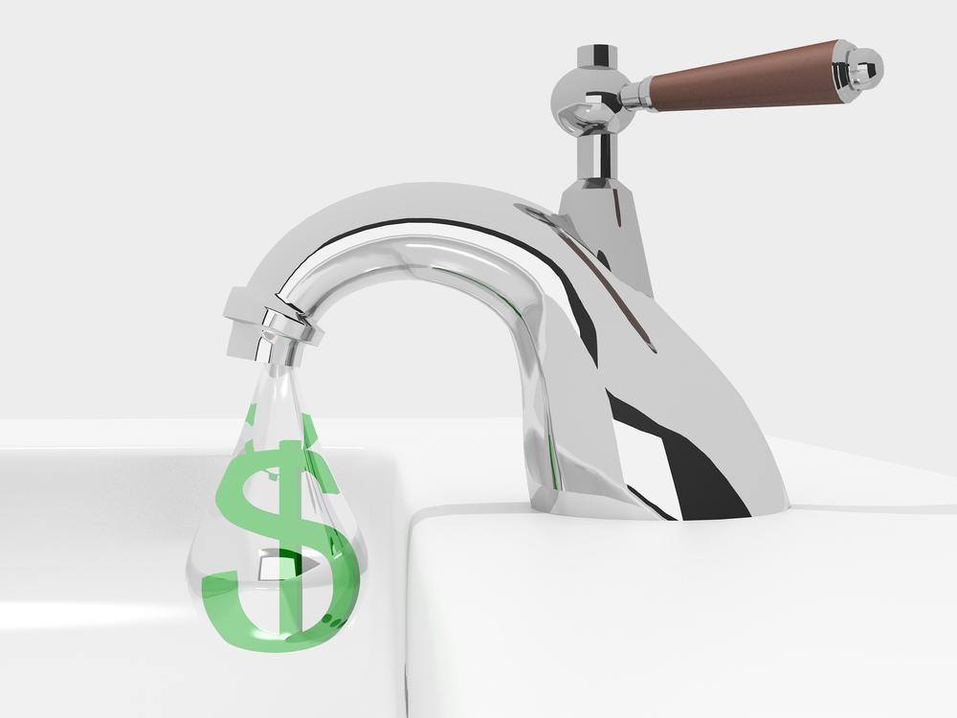
Spending Leaks Exercise
It’s important to identify where your money is going so that you can stop the spending leaks and start saving for retirement and unexpected expenses. Begin today by keeping track of where you are spending your money. Keep track for one week. Try it for four weeks. Then, do the math and find out how much you’re spending in a year! It is not deprivation! Your life will still be rich and you will have the essentials, plus more.
 |  |  | Cost Per Item | Number of Items Per Week | Cost Per Week (cost per item x number of items per week) | Cost Per Year (cost per week x 52)
 | Item
Soda, energy drinks, coffee |  |  | $ |  | $ | $
Dining out |  |  | $ |  | $ | $
Fast food |  |  | $ |  | $ | $
Vending machines |  |  | $ |  | $ | $
Habits (cigarettes, alcohol, lottery tickets) |  |  | $ |  | $ | $
Magazines, books (including downloads) |  |  | $ |  | $ | $
Downloads (cellphone ringtones, games, apps, videos) |  |  | $ |  | $ | $
DVD rental, movie downloads |  |  | $ |  | $ | $
Clothes, shoes, uniforms |  |  | $ |  | $ | $
Dry cleaning |  |  | $ |  | $ | $
Hair, nails, facials, massages |  |  | $ |  | $ | $
Toiletries |  |  | $ |  | $ | $
Movie tickets, entertainment |  |  | $ |  | $ | $
Camping trip |  |  | $ |  | $ | $
Gifts |  |  | $ |  | $ | $
Other: |  |  | $ |  | $ | $
Other: |  |  | $ |  | $ | $
Other: |  |  | $ |  | $ | $
TOTAL |  |  | $ |  | $ | $

http://www.nehemiahgateway.org/pdfs/Spending_Leaks_Worksheet.pdf
If you are in DEBT, create a plan

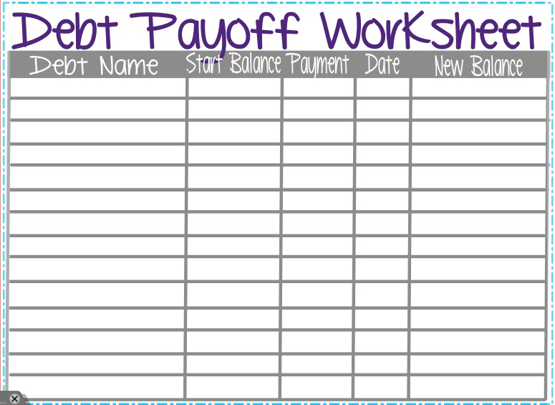
- Do not take on any new debt.
- Only charge what you can pay off at the end of the month.
- Identify all debt, creditor, amount, interest rate, minimum payment.
- Make all minimum payments
- Prioritize your extra payments (highest balance? highest interest rate? lowest balance?)
- Create a payoff plan.
- As each debt is paid off, power the extra money to the next priority.
- Stick to the plan and celebrate as you reduce your debt.

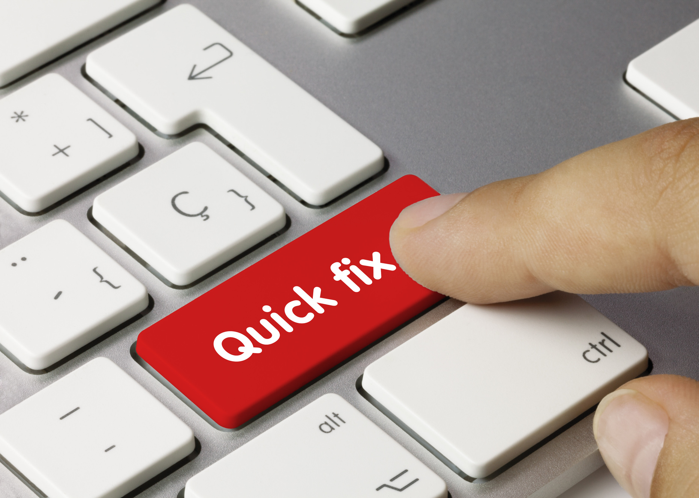
Avoid the Quick Fixes
- Pawnshop loan
- Pay day loan
- Tax refund loan
- Title loan
- Debt consolidation loans
- Rent-to-own stores

Monitor Your Credit Rating

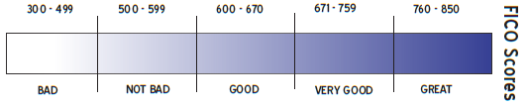
Higher rating – lower interest rate charged
Check rating annually - AnnualCreditReport.com

Avoid Common Financial Pitfalls
- Same as cash offers
- Online purchases
- Loaning to family and friends

You are worth the effort
Eliminate debt
Keep a budget
Spend less
Save more
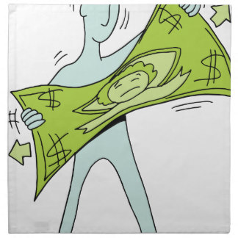
BE A SMART CONSUMER EVERYDAY!
Exercise

List 10 ideas for making your dollars go further
1._________________________________________________2. ________________________________________________
3._________________________________________________
4._________________________________________________
5._________________________________________________
6._________________________________________________
7._________________________________________________
8._________________________________________________
9._________________________________________________
10.________________________________________________

BE A SMART CONSUMER – SAVE ENERGY & MONEY
Exercise

List 10 money-saving ideas that will also conserve energy
1._________________________________________________2. ________________________________________________
3._________________________________________________
4._________________________________________________
5._________________________________________________
6._________________________________________________
7._________________________________________________
8._________________________________________________
9._________________________________________________
10.________________________________________________
AVERTING FINANCIAL CRISIS

- Live beneath you means, not on the cutting edge.
- Have an emergency fund to buffer life’s happenings.
- Begin addressing the situation as soon as possible.
- Look for assistance – churches, social service organizations, make payment arrangements.

Love and Money

SOME THINGS TO CONSIDER AND DISCUSS:
Were you taught that talking about money is impolite?
Do you feel your money is no one’s business but yours?
Are you afraid your significant other will judge you based on your money or lack thereof?
Does one person in the relationship control the money? If so, why?
Should both people know what is happening with money? Why?
What are you afraid of?
Do you equate money with power?
How can you work together to make dreams come true? What are your dreams?
What is your money personality? Are you an overspender? Are you a tightwad?

Create a will, just in case
You probably have enough to need a will.
(Bank Account, Car, House, Items you want particular people to have)
- Some items are passed on to the new owner via a will and other items (any item that has a “title” to it) must pass by naming a beneficiary. In the absence of a named beneficiary or joint tenant, an item must go through a legal process called probate.
- If you have minor children, you must name a guardian for them in a written will or the Courts will do it for you.
A will may be hand-written or typed.
- Need two disinterested witnesses (i.e., they must not be named in the will or have an interest in the will).
- Have document signed by person making will and witnesses in the presence of a Notary Public.
- Using an attorney is not required, but if you have a complex case, using an attorney may be a good idea.

POST-QUIZ -Circle the correct answer
1 | The finance charge for using a credit card is usually a higher rate than for using other forms of credit. | True | _____ | False
2 | When you write a check, it should be recorded in the check register:  - At the end of the month  - At the time the check is written  - When you receive your bank statement | A | B | C
3 | A check written for $100.45 should be written out as:  - One hundred forty-five and no/100 dollars  - One hundred and 45/100 dollars  - One hundred and no dollars | A | B | C
4 | If I always pay my bills on time, there is no reason to track my expenses. | True |  | False
5 | The safest place to keep money is  - In a bank  - In the mattress  - In my wallet or purse | A | B | C
6 | A good way to repair my credit is to:  - File for bankruptcy  - Make a plan to pay off all my debts  - Find an agency that promises to clean up my credit | A | B | C
7 | The APR (Annual Percentage Rate) for cash advances on a credit card is almost twice that of the APR on payment for regular purchases. | True |  | False
8 | It is a good idea to loan money to family members because they are most likely to pay me back with interest. | True |  | False
9 | Setting a financial goal includes which one of the following:  - Setting a realistic time frame to achieve the goal  - Opening a Go Fund Me account to ask for help  - Saving whatever money I have left over at month end | A | B | C
10 | When you have a checking account, you should reconcile transactions:  - Daily  - Weekly  - Monthly | A | B | C
11 | It is not necessary to keep a running balance of your checking account, since you can find your current balance online or at the ATM at any time. | True |  | False
12 | A low credit score will mean you will pay lower interest rates on borrowed money. | True |  | False
13 | I can become self-sufficient if I borrow the money I need to keep my bills current. | True |  | False
14 | To save a down payment of $2,500 for a car with $1,300 already saved and saving of $150 each month, how long will it take to save the down payment?  - 6 months  - 8 months  - 10 months | A | B | C
15 | Transferring credit card debt to lower interest cards is a great way to keep on top of my debt and has no effect on my credit score. | True |  | False
16 | Your credit rating is not affected by how much you charge on your credit card, but is only affected by how timely you make your payments. | True |  | False
17 | The best way to build my credit rating is to  - Borrow money from my friend paying it back over time  - Take out a secured credit card from a bank  - Buy a car from a place that accepts bad credit | A | B | C
18 | If I cannot pay my bill, I should  - Wait until I have money and then pay it  - Send in a partial payment  - Negotiate with my creditor immediately | A | B | C
19 | The purpose of goal setting in financial planning is  - To provide direction for planning and action  - To limit what you can spend on entertainment  - To increase spending essentials of food and shelter | A | B | C
20 | Planning to use my tax refund is a great financial plan which will get me out of debt. | True |  | False
21 | Paying any of your bills late may make it more difficult and more expensive to take out a loan. | True |  | False
22 | If your credit card is stolen and someone uses it before you report it missing, you are only responsible for $50, no matter how much may be charged on it by others. | True |  | False
23 | You should have an emergency cash fund that covers three to six months of normal living expenses. | True |  | False
24 | Banks usually notify you (via email or telephone) if you write a check that overdraws your account. | True |  | False
25 | Social Security is calculated in such a way to provide recipients with enough money for a reasonable retirement income. | True |  | False
26 | The best thing you can do to improve your credit score is to pay your bills on time. | True |  | False
27 | The widespread financial insecurity of Americans is primarily because the saving rate of Americans is low and many borrow in order to spend more than they earn. | True |  | False
28 | Always paying my rent on time will result in getting one month of free rent. | True |  | False

