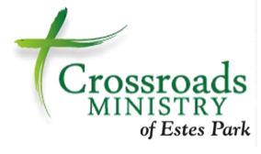

Money Matters
Part 1

Taking care of your money is important because money truly does matter. After all, you work hard for the money you have. It is not unlimited. And, having enough money to provide for your basic needs allows you to pursue the things you want, take care of those you love, and experience peace of mind and a good night’s rest

But in our complex and fast-paced world, knowing all you need to know in order to make sound money decisions is not an easy task. What you learned from your parents or were taught in school (if it was even offered) has probably changed in the last decade.

This short two-part course is designed to review the basic money management concepts necessary to navigate in today’s financial world. Part I covers financial goal setting, banking, checking, savings, fees, and taxes. Part II deals with debt management, building good credit, and saving money. Some of the material may be new; some may be information you learned before and practice everyday. Whatever the case, the course will provide a brief review of concepts that can save time, money, and future problems.

Participants are encouraged to complete the exercises and participate in discussion in order to discover ideas and practices that may enrich their ability to manage money. The class is about creating some positive vibration that will radiate through your financial life, making life more pleasant and allowing you to be both happy and productive.
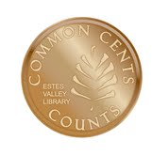
Marsha Yelick CFA(retired)
Financial Programs Consultant
myelick@estesvalleylibrary.org
970-586-8116 Ext 831

Participant Responsibilities
1. Please notify the instructor if you have a disability that may affect your learning and participation. We will make every effort to accommodate you and ensure that you are given what you need to be successful in this course.
2. Quizzes and exercises are not graded and are designed to help solidify the discussed concepts.
3. Money Matters is designed to build knowledge. It is best, but not required, to take the courses in sequence.
4. Basic classroom courtesy is expected, i.e., arriving on time, electronic devices turned off, respectful listening to the instructor and other participants, and thoughtful questions and responses.
5. You are welcome to attend a session again to brush up.
6. You are welcome to stand up at the back of the room if it helps your concentration (or your back).
7. You are always welcome to make an appointment to meet one-on-one with the instructor if you have additional questions or concerns.

Crossroads Participants
- Be sure to sign your name for attendance credit.
- Missing more than 30 minutes of a class means you will need to re-take.
- Return all your handouts to your notebook. It will be returned to your case manager. You will receive a certificate and any of the material you wish to retain for your files. (You should complete all exercises!)
- Continue to work on the ideas you have learned. Working one-on-one with your case manager is encouraged.
PRE-QUIZ -Circle the correct answer
1 | The finance charge for using a credit card is usually a higher rate than for using other forms of credit. | True | _____ | False
2 | When you write a check, it should be recorded in the check register:  - At the end of the month  - At the time the check is written  - When you receive your bank statement | A | B | C
3 | A check written for $100.45 should be written out as:  - One hundred forty-five and no/100 dollars  - One hundred and 45/100 dollars  - One hundred and no dollars | A | B | C
4 | If I always pay my bills on time, there is no reason to track my expenses. | True |  | False
5 | The safest place to keep money is  - In a bank  - In the mattress  - In my wallet or purse | A | B | C
6 | A good way to repair my credit is to:  - File for bankruptcy  - Make a plan to pay off all my debts  - Find an agency that promises to clean up my credit | A | B | C
7 | The APR (Annual Percentage Rate) for cash advances on a credit card is almost twice that of the APR on payment for regular purchases. | True |  | False
8 | It is a good idea to loan money to family members because they are most likely to pay me back with interest. | True |  | False
9 | Setting a financial goal includes which one of the following:  - Setting a realistic time frame to achieve the goal  - Opening a Go Fund Me account to ask for help  - Saving whatever money I have left over at month end | A | B | C
10 | When you have a checking account, you should reconcile transactions:  - Daily  - Weekly  - Monthly | A | B | C
11 | It is not necessary to keep a running balance of your checking account, since you can find your current balance online or at the ATM at any time. | True |  | False
12 | A low credit score will mean you will pay lower interest rates on borrowed money. | True |  | False
13 | I can become self-sufficient if I borrow the money I need to keep my bills current. | True |  | False
14 | To save a down payment of $2,500 for a car with $1,300 already saved and saving of $150 each month, how long will it take to save the down payment?  - 6 months  - 8 months  - 10 months | A | B | C
15 | Transferring credit card debt to lower interest cards is a great way to keep on top of my debt and has no effect on my credit score. | True |  | False
16 | Your credit rating is not affected by how much you charge on your credit card, but is only affected by how timely you make your payments. | True |  | False
17 | The best way to build my credit rating is to  - Borrow money from my friend paying it back over time  - Take out a secured credit card from a bank  - Buy a car from a place that accepts bad credit | A | B | C
18 | If I cannot pay my bill, I should  - Wait until I have money and then pay it  - Send in a partial payment  - Negotiate with my creditor immediately | A | B | C
19 | The purpose of goal setting in financial planning is  - To provide direction for planning and action  - To limit what you can spend on entertainment  - To increase spending essentials of food and shelter | A | B | C
20 | Planning to use my tax refund is a great financial plan which will get me out of debt. | True |  | False
21 | Paying any of your bills late may make it more difficult and more expensive to take out a loan. | True |  | False
22 | If your credit card is stolen and someone uses it before you report it missing, you are only responsible for $50, no matter how much may be charged on it by others. | True |  | False
23 | You should have an emergency cash fund that covers three to six months of normal living expenses. | True |  | False
24 | Banks usually notify you (via email or telephone) if you write a check that overdraws your account. | True |  | False
25 | Social Security is calculated in such a way to provide recipients with enough money for a reasonable retirement income. | True |  | False
26 | The best thing you can do to improve your credit score is to pay your bills on time. | True |  | False
27 | The widespread financial insecurity of Americans is primarily because the saving rate of Americans is low and many borrow in order to spend more than they earn. | True |  | False
28 | Always paying my rent on time will result in getting one month of free rent. | True |  | False

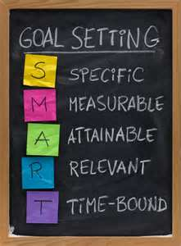
Setting S.M.A.R.T Goals Worksheet
Financial goals are things you want to do or buy that cost money - such as pay off debt, save for a down payment on a car, move to a better location, save for a home, education, or retirement.

Goals should be: S.M.A.R.T:
Specific: I want to save $5 a week, not I want to save money.
Measurable: I want to save $10 a week is measurable, I want to save money is not.
Achievable: Saving $5 a week is more achievable than saving $500 if you’re short.
Realistic: Pay down my debt in 12 months more realistic than winning the lottery.
Time-bound: Pay off debt in 18 months is more specific than pay off my debts.

Exercise: Fill in the table below to create our S.M.A.R.T goals.

Achievement Date Amount of Goal Needed Weekly Savings
Short term (achieve in 1 -3 months)
My Goal is __________________________________________________

________________ $_________________ $_______________

Medium Term (achieve in 3 - 12 months)
My Goal is ___________________________________________________

________________ $_________________ $_______________

Long Term (achieve in more than one year)
My Goal is ____________________________________________________

________________ $_________________ $_______________

Protect Your Hard-Earned Money
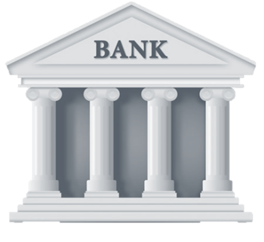
The safest place for your money
- Protect from theft
- Protect from disasters
- Protect from visitors
- Provide for record keeping
- Make transactions “mindful”

Considerations for choosing a bank, credit union, etc.
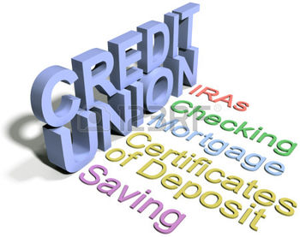
- Location
- Service
- Fees
- Recommendations
- FDIC insurance

Consider Range of Services: Checking, savings, IRA, CDs, Credit Cards, Debit Cards, etc.

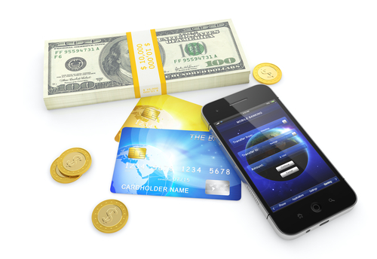
You STILL have work to do!
Deposit income
Pay bills
Record transactions
Balance and Reconcile
Choose various methods for all above
Select and manage credit/debit cards

Banking Paperwork
Make a Deposit:
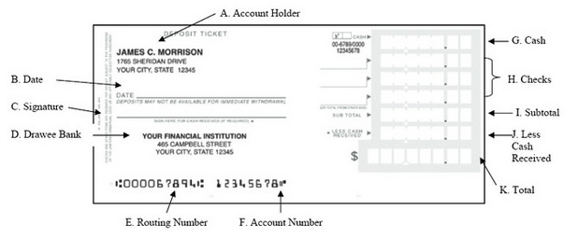
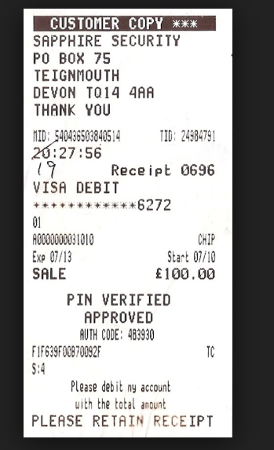
Endorse deposit Checks: Use a Debit Card
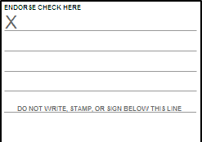

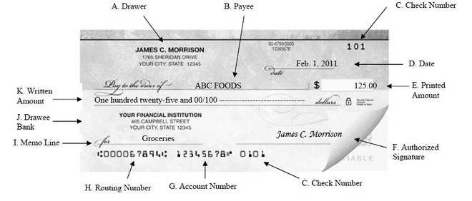
Write checks correctly:

Bank Checkbook Register Exercise

Record checks and deposit in the Check Register:
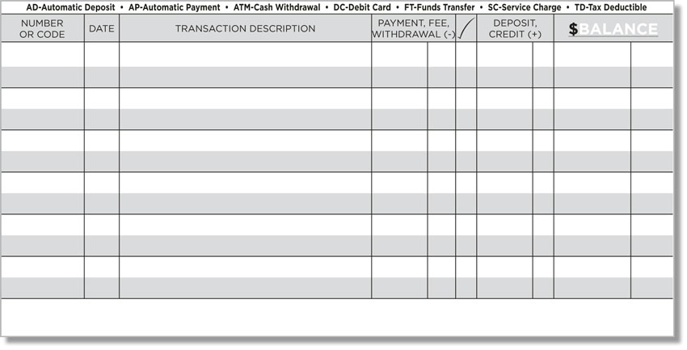

- Your beginning balance for the month is $514.25
- On 7/1 you get paid $1,239.36
- On 7/1 you pay your rent to Joe Landlord, check #101 for $700.00
- On 7/4 you use the ATM at Elk Something Place to get $50.00. You can’t get to your own ATM, so you incur a $4.00 charge at the ATM.
- On 7/5 you write a check #102 to Town of Estes Park to pay your electricity bill. The amount is $92.65
- On 7/7 you use your debit card at Safeway to buy groceries for $57.36
- On 7/15 Fred’s Bank auto-withdraws your car payment of $213.85

Bank Reconciliation Exercise

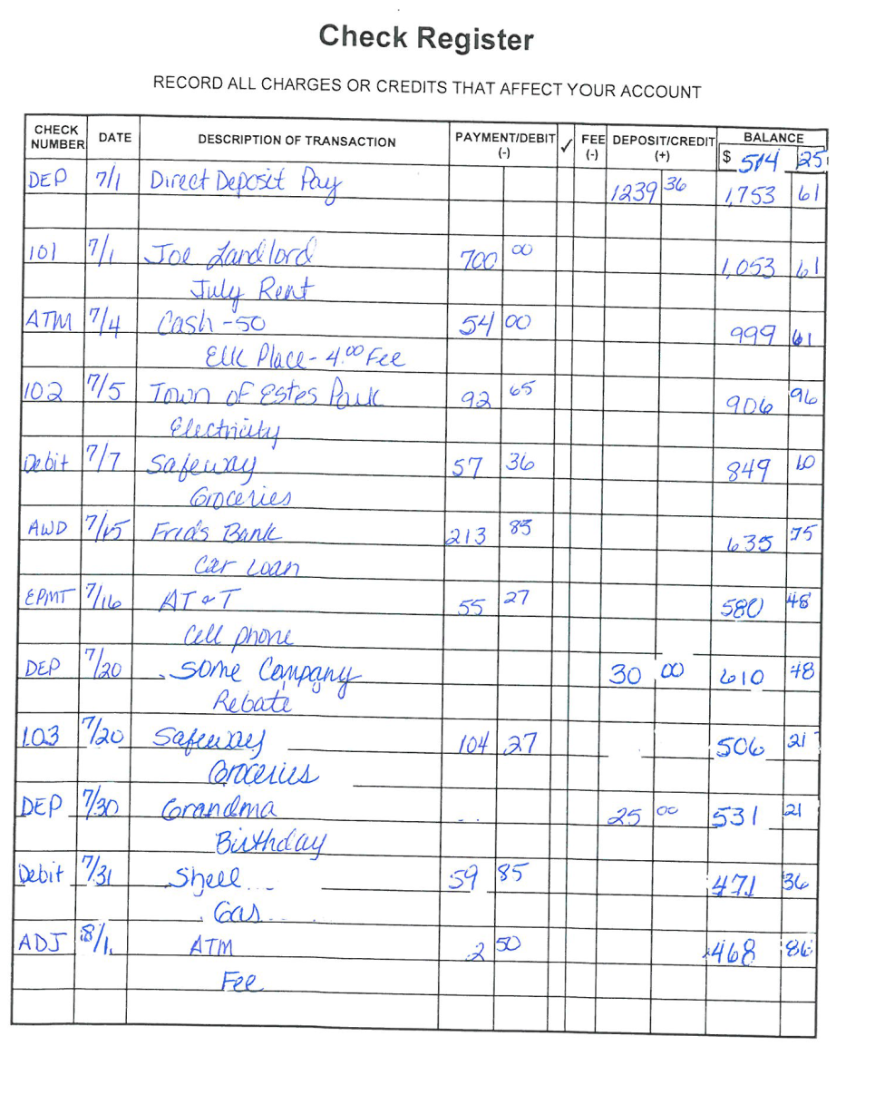

Balancing Your Checkbook - Exercise

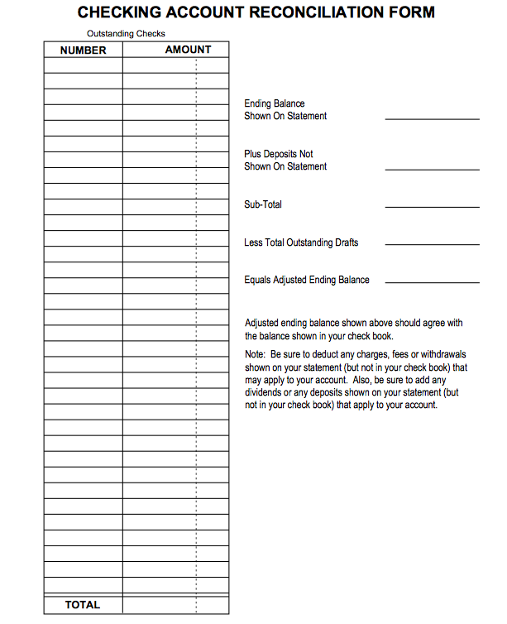
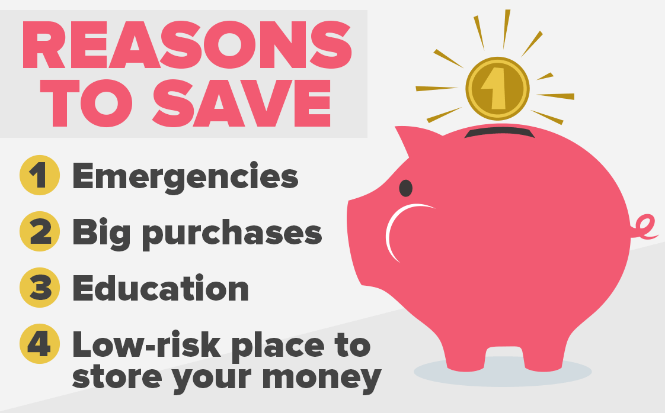
Savings Accounts
(First steps to achieving Goals)
- Saving for the future is essential.
- Provide for emergencies (and life always has unexpected emergencies)
- Experts recommend 3 – 6 months living expenses.
- Dave Ramsey says at least $1,000.
- Saving for big ticket items – you need a “store house.”
- Money is safe – FDIC insured and will not vary in value.
- Money is easily accessible. (If your savings account is in the same place as your checking account, money movement is very easy.)
- Money is out-of-sight, less easy to spend recklessly.
- Allows for regular contributions, even electronically.
- Sets a great example for your family.

If banks are not an option…
- Do not carry large sums and make yourself a target for a crime.
- Consider a strong, locked storage container, well hidden.
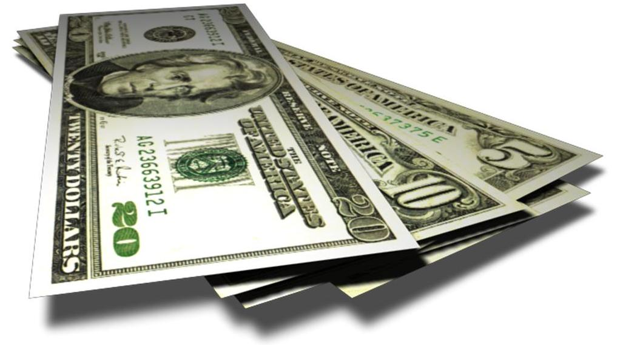
- Never send cash through the mail.
- Use money orders to pay bills. You have a receipt.
- Avoid high fees when cashing your checks.
- When cashing checks, find retail stores and organizations that have the lowest fees.
- When cashing checks, choose a safe time of day and a populated location.
- Reconsider the ease and convenience of safe banking.
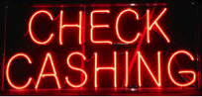

Wiring Money Abroad
- The more access both parties have to banking, the cheaper and easier the transaction.
- Shop for the lowest cost that meets your needs.
- Cost increases if money is to travel quickly.
- Fees include exchange rate conversion fee (guaranteed or estimated), banking fees (for wires), and fee for receipt (received in cash or into an account).
- Sending in dollars and letting recipient exchange may be cheaper.
- Higher amounts have lower fees / dollar sent. Explore tiers of charges.
- Follow-up on all transactions to be sure they are completed as promised.

Taxes
- There are many myths about taxes. Don’t believe them!
- Getting a big refund is NOT the best idea. It means you paid in too much during the year and you are just getting back your money.
- Free tax preparation available at the Library (970-586-8116 –AARP) and on line at FreeFile (under $62,000) https://www.irs.gov/uac/Free-File:-Do-Your-Federal-Taxes-for-Free.
- The "PTC" rebate has been available every year in Colorado since 1971.
  - If you are the owner of record of a residence in Colorado,
  - and have income less than $12,953 (single) or $17,460 (married filing jointly),
  - and are 65 years of age or older OR a surviving spouse 58 years of age or older OR disabled, regardless of age
-- you MAY qualify for the PTC rebate. (Maximum $792)
- The Senior Homestead Property Tax Exemption is again available
  - If you are the owner of record of your residence for the past 10 consecutive years,
  - and you have occupied the residence as your primary residence for the past 10 consecutive years,
  - and you are 65 years of age or older on January 1st of the year applying,
-- you MAY qualify for an exemption of 50% of the first $200,000 actual value of your home. (Worth over $600)

