Joe Average’s Budget Story

The purpose of this story is to have seminar participants actually work on a “pretend” budget. There should be some “eye-opening” learning events as participant journey with Joe Average doing his research and planning.

Keep emphasis on simplicity, estimating, and recording all spending. The idea is that it only takes only a few minutes a day. There are even apps for that if people are so inclined.

A Budget is a tool that helps you to be in control of how you spend your money – how you spend your “life energy.” Of course, you should care and be aware of what you are doing. Remember, it’s YOUR budget, not graded, no one else sees it, and it’s the best tool to use to control your money.

PIC – Joe Average outside with beauty of mountains behind him:
Once upon a time in a far off mountain community located in beautiful Colorado, there lived JOE AVERAGE, a young man who landed a great, new job as a dental hygienist with one of the local dentists. He moved to the lovely community, found a place to live, and was well on his way to starting a great life.

PIC – Joe Average with his billfold out, questioning look:
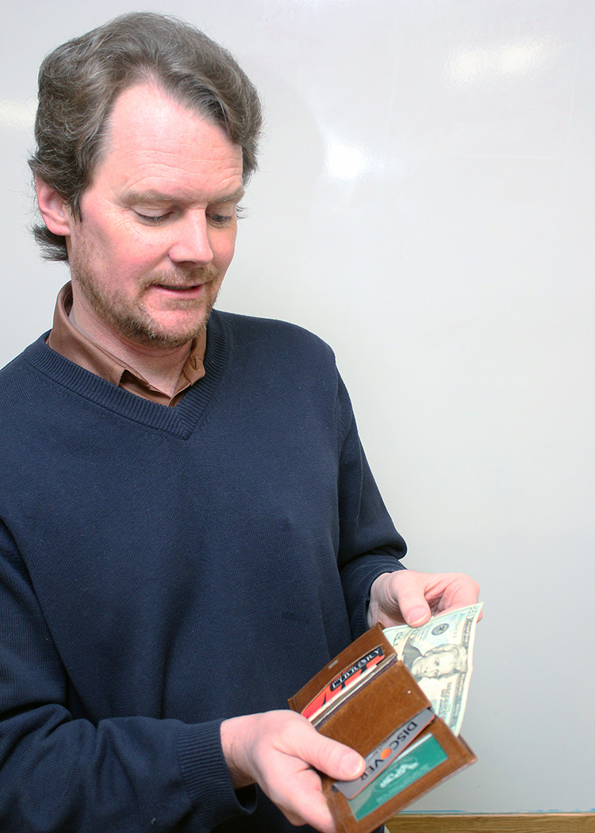
However, just moments after he arrived in town, he had a startling realization that he just might need to think a bit about his current financial situation. Mountain living, for all its beauty and great activities, is, after all – EXPENSIVE. Would he have enough to live and make his life comfortable? Would his job provide what he needed to save for a long and healthy retirement in 45 years?

PIC – Joe Average outside the library:
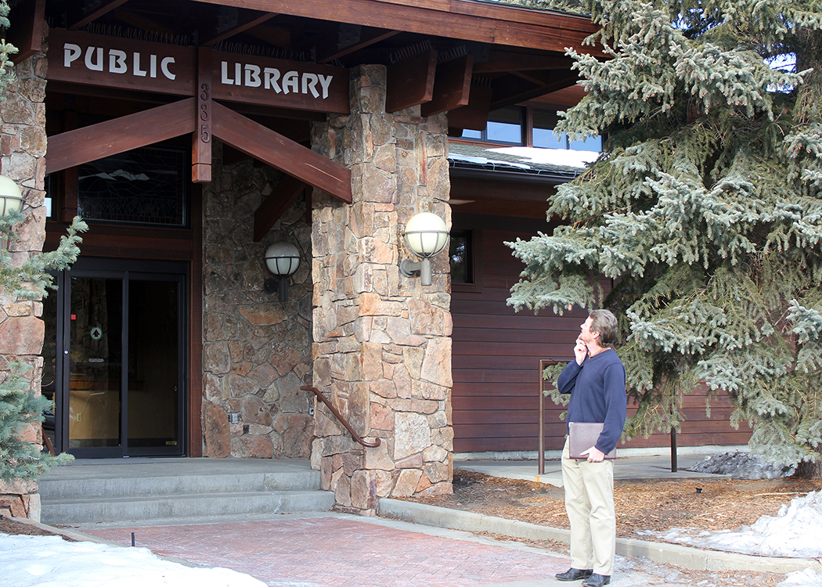
What he needed – of course – was some HELP, perhaps a tool that would help him control his spending and keep him on the right track. He didn’t learn this in school, but stopping by his local library, he knew he could find many resources to help him create that tool . The tool, of course, is THE BUDGET. It’s an old, proven tool, and even though there are lots of electronic apps Joe could use to create and keep his budget, the principles haven’t change and it’s really a very simple process. He’s definitely on the right track and he can use just simple paper and pencil.

PIC – Joe Average at table in library with books and paper, working on INCOME..
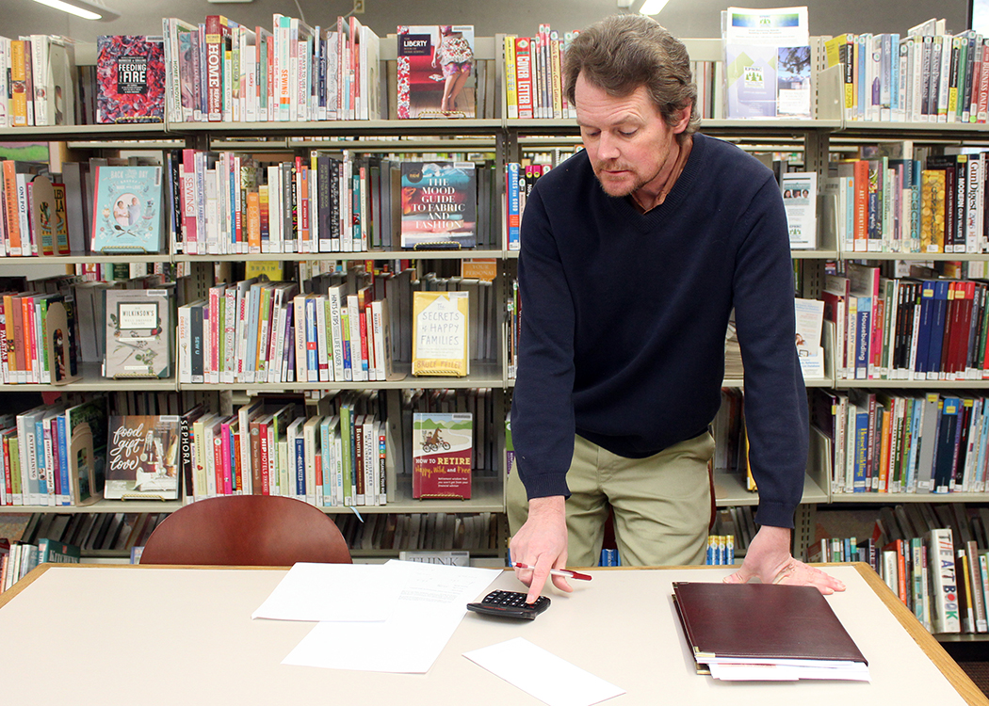
First, he looked at what he was going to be earning each month, after taxes, social security, and Medicare were taken out. Now, he is lucky to be making $62,000 per year, BUT his FICA (Social Security and Medicare) deductions will be about $4,000 annually (just using round numbers). (Federal Insurance Contribution Act is half of 12.4 + 2.9 = 15.3%). Then there will be deductions for federal and state taxes - about $10,000. Hm-m-m-m. Joe will only have about $4,000 a month to spend.

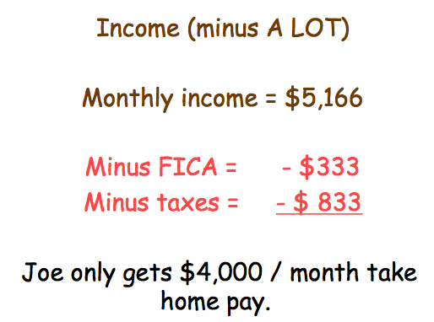
Slide of Income section: (Informal discussion can take place - how much is gone before you start.) The income is based on round numbers that easily work, but realistically, an average household (which usually has more than one income) has on average $54,000 income.

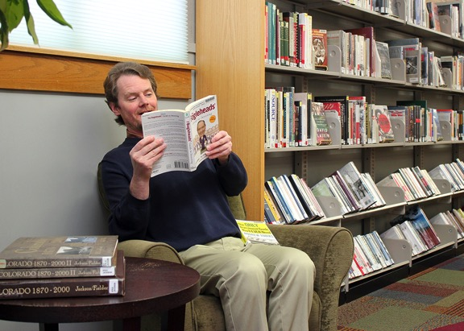
PIC – Joe Average reading a book in a chair (with overlaid screen shot of PYF):
After doing some reading, Joe learned that one of the most important rules of budgeting is to PAY YOURSELF FIRST (P-Y-F). So as he started on his expenses, he set aside the recommended minimum of 10% of his income (he used his take-home pay to figure this percentage.) He also learned that he might want to check right away with his employer to see if he could participate in a 401(k) where his savings would be tax-deferred and maybe even matched. (Be certain participants note the budget area where $400 is already filled in – 10% of $4,000.)

PIC - of the essentials: (shelter, transportation, and food): During his study session, Joe also discovered another “inconvenient” truth. There is some spending that is essential for everyone. We all need a roof over our heads, a way to get around, and something to eat. What we spend on these items is up to us, but we must provide for all these areas before other things get in the way.

PIC:Joe Average back at the table figuring his essentials:
Joe learned that after P-Y-F, the next three items of a budget are the ESSENTIALS: food, shelter, and transportation. He looked at the averages for Americans, and started his budget using these percentages. He figured he would then test to see if he really had to spend that much as he started tracking his expenses as they occurred. Possible points to discuss while looking at the numbers already completed:
Food: on average 12% of take home pay, half spent on eating out! Could this be really be true and is it necessary?
Shelter: Joe already knew his rent amount, which included some of the services a homeowner would have to cover. Rent is VERY high in Colorado. Average is 35% of take home pay, but in many communities, it can be much higher. The old recommendation was no more that 25% of income (back in the 60s and 70s).
Transportation: Average of 18% of income, lots of hidden expenses in owning a car (and parking either at home or at work isn’t even on the list).

Wow, 75% of Joe’s take home pay is already spent. What a revelation, and there’s many more “important and maybe necessary” expenses he hasn’t covered yet. Good to know before he starts spending his check.

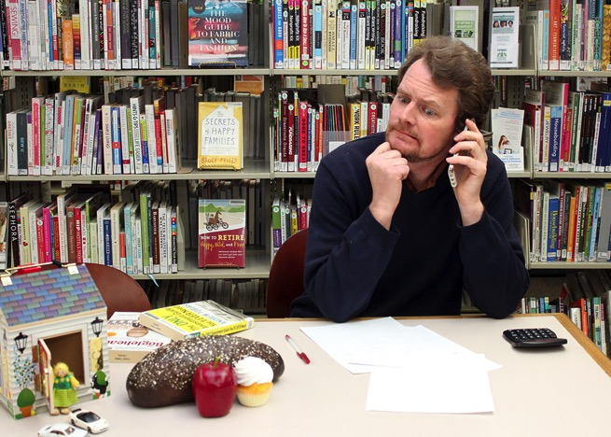
Pic: (TWO SLIDES) Joe Average back at the table with lots of papers out and using his cell phone.
So what else is important and necessary in the budget? Well, the books listed all sort of categories. Joe realized he had some of these, so he filled in amounts for the following: (Encourage participants to fill in amounts and discuss what they would fill in.) Use second slide for participant time to fill in amounts suggested below.)
Insurance – (for renters) - $25
Insurance – (for health, ACA single, bronze) $225
Student Loans - Estimated minimum payment for average $30,000 loan debt - $50 but
Joe decides to pay a little extra each month – total of $75
Out-of-pocket medical - $50
Cell phone - $50
Work expenses - $50
Internet at apt. - $25

Oh no, now there’s only $500 left for the month – that’s only 12.5% of take home pay. Well, at least the essential and the important bills can be paid. The rest of the budget will be fun – deciding what else Joe WANTS.

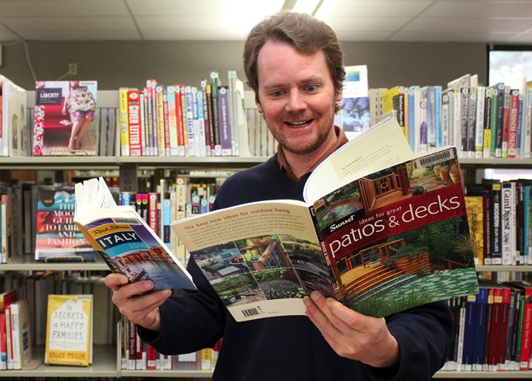
PIC: Joe Average smiling and now working on the “non-essentials”:
So what are the other things that Joe might want to purchase with his remaining funds? There’s not much leftover, but it’s enough to keep him happy. The budget, in his case, was easier than he thought. He’ll make some choices here, and then revisit each month to see how things are tracking. Maybe he’ll be able to save more money or plan for purchases in the future. This is what a budget is all about: saving for the things you really want in the future while taking care of the necessities of day-to-day living. (Encourage participants to fill in Joe’s choices.)
Haircut - $20 (only get a hair cut every six weeks)
Health club - $80 (he’ll plan to hike in the summer)
Clothing - $50 (he’ll check out the second-hand stores!)
Personal expenses - $50 (sort of a miscellaneous category)
Gifts – Donations - $15 (he will be saving for holiday gift giving and his family is small)
Entertainment - $75 (this will probably be his downfall!)
Accumulation - $100 (he needs lots of stuff for his new living quarters)
Vacations - $100 (saving this each month might allow for some travel)

The budget is made, it’s balanced. and Joe is saving for retirement and a few other things. What might be missing or what might Joe discover as he starts tracking what he actually is spending?
Possible thoughts from participants might be:
Does Joe have any pets? They are hugely expensive.
How old is Joe’s car? Should he save for a replacement?
What about his High Deductible ACA health insurance if he has a major event? Can he afford the $5,000?
Does he have any credit card debt?
Has he established an emergency fund? (at least $1,000, but recommended 6 to 9 months living expenses in case he loses his job)
What if Joe finds a girlfriend?
He should, of course, use the library as much as possible: BOOKS, DVDs, CLASSES, MOVIES, FREE WI-FI, etc.

