

A Better Approach to Holiday Spending

**If you’ve ever dreaded opening the credit card bills in January because you know you spent “way too much” during the holiday season, this is the seminar for you. A two-month spending spree at the end of the year can literally drown you in debt for six months or more and totally destroy any good intentions for saving money for important goals.**

**This seminar is designed to provide the tools you need for managing the end-of-year spending frenzy, allowing you to begin the new year with a clean slate and extra money saved for long-term goals.**

**Participants in this seminar will first examine how the average American spends his/her hard earned dollars. Then the discussion will quickly move to the monetary problems created during the end-of-year festivities. Tips for how to manage gift-giving and all the extra social activities will be identified.**

**As participants learn to manage holiday spending, they will be practicing important money management principles that result in good financial planning. A few minutes spent in this seminar, addressing how to manage the holidays, could result in a lifetime of solid financial management. This could be the best gift you can give yourself in the holiday season ahead..**



**Marsha Yelick CFA (retired)**

**Financial Programs Consultant**

**myelick@estesvalleylibrary.org**

**970-586-8116 Ext 831**

**MAJOR CONCEPTS of seminar**



**“Balancing your money is the key to having enough.”**

**― Elizabeth Warren**

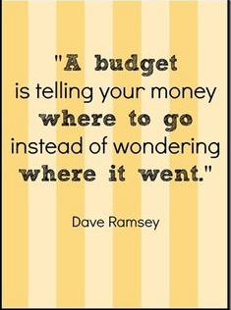



**If you practice money management principles relative to your holiday spending, you will be learning (and integrating into your habits) the money management skills needed for a lifetime of secure and intelligent financial planning. It’s not hard, you have enough, and your life will be happier and more secure.**

**Major discussion on American Consumerism**

**The emphasis on materialistic consumption began in America in the 1850’s, driven by the changing economy of the United States. Availability of credit and increased communication accelerated the trend from 1970 and beyond.**

**Consumerism:** the belief that it is good for people to spend a lot of money on goods and services; the promotion of consumers’ interests in lieu of the greater good; the theory that an increasing consumption of goods is economically desirable; and a preoccupation with and an inclination toward the buying of consumer goods.



**And so, 62% of Americans have savings of less than $1,000.**

**During the holidays…**

**the average household will spend over $700 on gifts for others and another $100 on self-gifts and non-gift items.**

**($800 invested each year for 30 years in a well-diversified investment portfolio would produce a retirement nest egg of**

**~ $65,000).**

**Ways to reduce Holiday EXCESS!**

**(Also applies to everyday financial activities.)**



1. **Follow Santa’s advice:**

**MAKE A LIST and**

**check it twice!**

1. **Limit shopping trips.**

**Average American will spend 15 hours shopping for gifts (women, 20 hours; men, 10 hours). Subconscious stimuli at the mall increases spending!**

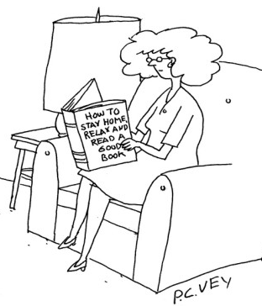

1. **Plan quality time.**

**Stay home and do the things you love to do. Enjoy the gatherings at community events that are often FREE.**



1. **Consider gift cards.**

**(After-holiday shopping can save 40% or more. Determining the amount you can spend is EASY!)**

1. **Stick to your list.**

**(Your list also includes a price limit.)**

1. 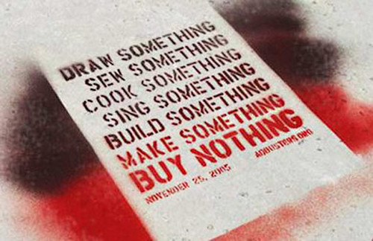**Consider making a gift.**

**(It will be more personal and meaningful. The time you spend is also your gift – more meaningful then time spent shopping.)**

1. **C:\Users\myelick\AppData\Local\Microsoft\Windows\Temporary Internet Files\Content.IE5\D3CT6WPU\MC900238965[1].wmfFind gifts that will create lasting memories.**

**(Consider giving books, experiences, events, time spent together, time spent enjoying activities)**

**C:\Users\myelick\AppData\Local\Microsoft\Windows\Temporary Internet Files\Content.IE5\1D0FRZWG\MC900160838[1].wmf**

1. **Select gifts that will be meaningful.**

**(Give a gift that you know a recipient will use or a gift in honor of the recipient that will be used by others in need.)**

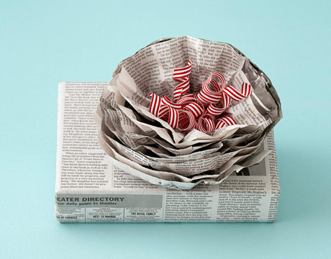**9) Wrap your gift creatively.**

**(Avoid the waste and glitter of the season and celebrate simplicity and imagination.)**

1.  **Relax and truly enjoy the holidays**

**(And enjoy the debt-free months that follow!)**

Close your eyes and remember the best gift you ever received. Realize it had NOTHING to do with money!

**P.S.**

**Now apply all these suggestions to the rest of your financial life and stop the stress of spending more than you earn.**

1) Create a budget.

2) Limit your shopping trips (and use a list).

3) Enjoy quality time at home and with friends/family.

4) Delay full-price purchases and buy on sale.

5) Stick to your budget.

6) Consider making things yourself (cooking, cleaning, planting, fixing, painting, etc.)

7. Spend money on things that truly give you pleasure and create lasting memories.

8. Only purchase items that you truly need, not items that you just want.

9. Be creative.

10. Relax and enjoy life.