Eating Well on
$6 a Day

An important item in everyone’s budget is food. You need it to live. It makes you feel good (usually). It can be healthy or unhealthy. Most important, it tastes wonderful – three times a day (or more).

Food is the third most expensive category in the average American budget, so planning carefully for food expenditures has a large impact on financial well-being The weekly financial impact of buying food is significant, and the long-term financial implications of eating a healthy diet are even more substantial.

Participants in this seminar will first examine how the average American spends food dollars. Then the discussion will quickly move to the “true” cost of food. Affordable foods that pack important nutritional value will be identified, as well as methods we can use to improve our eating habits.

The seminar will explain how you can eat delicious, satisfying meals made with simple ingredient while maintaining a budget. It’s the way our grandparents used to eat – adapted for our lifestyles and tastes in 2016. Cookbook recommendations, menu ideas, and motivational thinking will be included.

Marsha Yelick CFA(retired)
Financial Programs Consultant
myelick@estesvalleylibrary.org
970-586-8116 Ext 831

MAJOR CONCEPTS
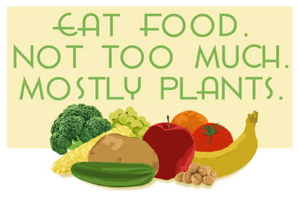
Michael Pollen

…to save money in the long run, it’s better to minimize than supersize.
Jeff Taylor,
NPR Marketplace

Major discussion on cost, value, AND quality.

The Average American – Food & Money
(the food culture in which we live)

The top three categories in the average American budget are:
35% Housing (home)
18% Transportation (car)
13% FOOD (half of this on eating out)

SOME GOOD NEWS:
Americans spend a smaller percentage of their budget on food than in the past, and a smaller percentage on food than other countries.

Average American household spends $21.57 per day on groceries.
(Average household is 2.54 persons so that’s $8.50 per person per day.) If you instead ate on $6 per day, you would save $2.50 per week per person. 2.54 people eating on $6 a day would save almost over $40 per week.
What do you spend? Keep track!

It’s about more than the money!

- Yearly sugar consumption in the last 100 years skyrocketed from 20 lbs. to 150 -170 lbs./individual.
- Consumption of sodas and fruit drinks doubled in 40 years.
- Americans consume 400 calories more per day in 2015 than in the 70s.
- American abandoned traditional fat in favor of processed vegetable oils that contain transfats and Omega-6 fatty acids.
- Soybean oil provides 7% of the average American’s calorie intake.
- Modern wheat is less nutritious than 50 years ago, and white flour is striped of the bran and the germ.
- Egg consumption decreased by over 25% since 1950.
- Food eaten away from home now constitutes over 25% of an American’s food consumption.
- Today, nationwide, roughly two out of three U.S. adults are overweight (69 percent) and one out of three is obese (36 percent)
- The standard American diet (SAD) is identified as one cause of American’s epidemic levels of obesity, hypertension, heart disease and diabetes.
- Each year, about 40 percent of all food in the United States goes uneaten. (That’s worth about $165 billion!)
- Etc. ____________________________________

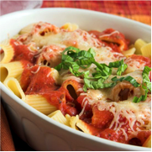
Cook at home!

- It’s faster (than fast food).
- It’s about half the cost or less.
- It could be fun to share the cooking experience with others.
- The food is not cooled off from transportation time and there are no ugly Styrofoam containers for the trash.
- It’s really delicious because you used fresh ingredients and flavored the food to your liking.
- You can taste the food because you used less salt than the commercial kitchen.
- You have great, healthy leftovers for a brown bag lunch the next day.
- Proportions are reasonable.
- You have a shared “family” experience.

Of course:
- It takes a little preplanning and thought (shopping and menu planning).
- It takes 30 minutes of preparation time.
- It might take 15 minutes to clean up.

Choose Affordable Ingredients with Great Nutrition
Like What?

12 nutritionally rich & inexpensive foods from The New Good Life: Living Better Than Ever in an Age of Less by John Robbins. “Most lists of the healthiest foods feature wild salmon and blueberries. That’s great if you’re an Alaskan bear.” For the rest of us on a budget: popcorn, quinoa, flaxseeds, nutritional yeast, sweet potatoes, split peas, lentils, sunflower seeds, oats, cabbage, carrots, tofu.

Top affordable foods of value (according to AARP,Jan. 15, 2016

CARROTS ($.25)
PLAIN LOW-FAT YOGUART $.52)
COTTAGE CHEESE ($.88)
FROZEN PEAS ($.50)
CANNED SALMON ($.75)
WHOLE TURKEY BREAST ($.55 - .75)
BLACK BEANS ($.30)
RUSSET POTATOES ($.19)
BROWN RICE ($.18)
CANNED TOMATOES ($.16)
APPLES ($.43)

Be Careful at the Grocery Store

Grocery stores sell food as a business:
“Food in the US is made to be sold, not eaten.” Jeremy Seifert
“It’s time to stop being a casualty of your grocer’s marketing strategies and to become a savvy, super-saving shopper.” Cut Your Grocery Bill in Half by Steve & Annette Economides
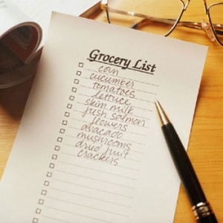
- See what’s on hand first.
- Make a list.
- Don’t shop when hungry.
- Don’t shop in a hurry or last minute.
- Buy in season.
- Use coupons and/or buy store brand.
- Bring your own bags.
Planning is the Key

Limit how often you shop.
Use up what you have.
Wait one extra day before going to the store. (Clean out the refrigerator!)
Buy ingredients with multiple uses.
Think about buying in bulk. (Be careful)
Explore alternatives (CSA, bulk purchases, etc.).
- Plan leftovers (frozen, next meal, lunches)
- Think crock pots, casseroles, and soups
- Prep ahead
- Keep grab & go foods on hand— “take-to-work lunches”
- Try a once-a-month (or -week) cooking day
- Savor meals with friends and family
- Eat slower with less distractions

Use Food WISELY (Waste not: Want not!)
- Google recipes to use it up.
- Freeze, combine, create.
- Green Food containers make it last
- Replace throwaway with reusable
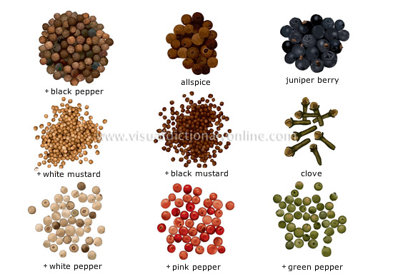
Learn to “Spice Up” Your Food

Learn to cook dried beans -
so cheap, so tasty, so good for you!

Make Your Own!
Most things in the middle aisles of the grocery store can be made at home at less than half the cost! (They taste better, too.)

Acquire cooking equipment that works. (at the thrift store, perhaps)

Restaurants are Allowed.
- Plan (limit) your restaurant meals.
- Split an entrée.
- Take home the leftovers.
- Limit meals on the go (pack a lunch)
- Drink water.
- Eat out for lunch (instead of dinner).
- Find a coupon.
- Order take-out.

And what is the Monetary Pay Off?

Save just $1/day = $365/year ($7/week) invest 20 yrs. at 5% = $38,861
Save $300 a month and invest for 30 years at 8% = $692,753

And even more…
You will feel better.
You will be healthier.
Your medical expense will decrease.
You will have more time to share with your family around the table.
You will enjoy life.

BE MONEY (AND FOOD) SMART FOR LIFE.

ADDENDUM

Spice Up Your Cooking:
Spice Families:
Italian: oregano, basil, marjoram, thyme, mint, rosemary, safe
Mexican: cumin, oregano, onion, garlic, ground chile powder, paprika, cayenne
Indian: cumin, ginger, garlic, cardamom, coriander, turmeric, red chili pepper, pepper(corns), bay leaf
Cajun: bay leaf, cayenne, garlic, black pepper, onion, oregano, thyme, basil, tarragon, paprika
Sweets/Baking: nutmeg, cinnamon, allspice, cloves, sugar, ginger
Vinegar: Lots of flavor for your buck!
The Flavor Thesaurus by Niki Segnit

Learn the great flavor of home cooked dried beans:
No salt in cooking water or salt item (NO soy sauce, stock, bullion, flavor packets).
Soaking options: More water, more time.
Methods: Crock pot for beans. Bake beans. Rice cooker. Cook without heat for last 20 mins.
Invest in a pressure cooker; it’ll save time (and money on energy bills in the long run).

Make bread, sauces, stock, dressings, snacks, etc.
Moosewood Cookbook. (Pans of water to mimic steam oven.)
Stock: save veggie scraps in freezer bag; simmer on low for several hours or in crockpot all day (longer the stronger); consider adding salt and/or dried herbs
Sauces: invest in bulk spices and bulk starters (i.e. vinegar, soy sauce, tomato paste, agave, oil, etc.); use up “ripe” veggies and fruits for sauces; freeze in canning jars!
Dressings: less oil, more vinegar (cheaper, healthier); herbs and spices; ripe fruits/veggies
Homemade energy bars, homemade trail mix, kale chips, fruits & veggies.

Invest in worthwhile equipment (try the thrift stores or re-furb sites)
Rice cooker
Pressure cooker
Slow cooker/crock pot
Good pans
Good knives
Immersion blender
Food processor

Book Recommendations

Cut Your Grocery Bill in Half- with America’s cheapest family by Steve & Annette Economides
Animal, Vegetable, Miracle by Barbara Kingsolver
The Omnivore’s Dilemma by Michael Pollen
In Defense of Food by Michael Pollen
Fast Food Nation by Eric Schlosser
Little Heathens: Hard Times and High Spirits on an Iowa Farm During the Great Depression by Mildred Armstrong Kalish

Cookbook Recommendations
The Joy of Cooking by Rombauer, Becker, Becker
Moosewood Cookbook by Mollie Katzen
The Enchanted Broccoli Forest by Mollie Katzen
The Shoshoni Cookbook by Saks & Stone
The Kitchen Goddess by Susannah Narayani Levine
Tassajara Cooking by Edward Espe Brown
The Yellow Farmhouse Cookbook by Christopher Kimball
Putting Food By by Hertzberg, Greene, Vaughan
The Flavor Thesaurus by Niki Segnit
Vegan Yum Yum by Lauren Ulm
Eat Vegan on $4 a Day by Ellen Jaffe Jones
Cancer Survivor’s Guide by Physician’s Committee for Responsible Medicine (FREE pdf version available online)

A WEEK IN SOMEONE’S KITCHEN

By Chazz | Breakfast | Lunch | Dinner | Snacks | Cooking
Sunday | pancakes | leftovers from Saturday dinner | Mexican quinoa casserole | fruits, nuts | casserole
Monday | smoothie | Mexican quinoa casserole | Penne w/white beans, wilted spinach and cauliflower | nuts | pasta, beans in crockpot during the day
Tuesday | homemade granola cereal | Penne w/white beans, wilted spinach and cauliflower | black bean soup | hummus and crackers | soup in crockpot
Wednesday | fresh “trail-mix cereal” | black bean soup | rice and veggie stir-fry | fruit | rice in rice cooker, stir-fry veggies
Thursday | smoothie | salad | Mexican quinoa casserole | hummus and crackers
Friday | smoothie | rice and veggie stir-fry | out to restaurant | cookie | bake cookies
Saturday | pancakes | leftovers from eating out | out to restaurant | cookies

A WEEK IN SOMEONE’S KITCHEN

By Diana | Breakfast | Lunch | Dinner | Snacks | Cooking
Sunday | bagel, egg | chicken & kale casserole | Ed’s Cantina | apple, pretzels | none
Monday | bagel, egg | chicken & kale casserole | salad w/ olives, nuts | quesadilla, apple | none
Tuesday | bagel, egg | Nepal’s buffet | crackers & PB | quesadilla, apple | defrosted beets, chick
Wednesday | bagel, egg | tuna, olives, greens | crackers, apple | pad thai | prep bagels, cook casserole.
Thursday | bagel, egg | chicken, rice, chard, beet casserole | tomato noodle soup, quesadilla | chai tea | baked bagels cooked soup
Friday | bagel, egg | chicken, rice casserole | tomato noodle soup | bread, tea | defrosted squash
Saturday | bagel, egg | tomato soup- added chicken | spaghetti squash pizza | dark chocolate brownie | baked brownies, pizza

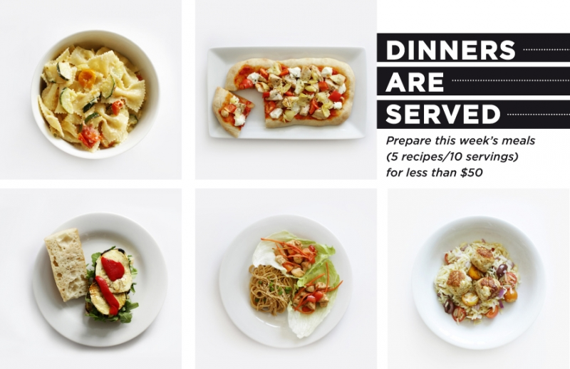
Sample From the Web
