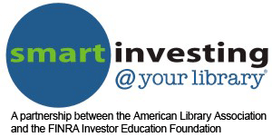

The Change
in YOUR Pocket

If you made (or are thinking about making) a New Year’s resolution about getting your financial affairs in order, this light-hearted, entertaining seminar is for you.

Participants will examine all the real-life reasons people don’t do a better job of handling money. Then we’ll list the important financial tasks that should be on everyone’s “to-do” list for the New Year. All tasks will be simple, easy-to-understand, and doable. In fact, we’ll actually accomplish a few of the task during the seminar.

Covered during the seminar will be six New Year’s Resolutions that you can adopt as your own. Each will be helpful in clarify financial goals and paths of achievement. There will be discussion of financial concepts, financial calculations, planning for retirement, saving for emergencies, and easy saving techniques.

The seminar is designed for anyone who wants to begin, restart, or reevaluate his/her relationship to money and how it can and should be managed to create a more restful and fulfilling life. The seminar is also for teens before they launch into the real world or those who may need to learn the basics before life-changing events force them to face the task of money management.
Marsha Yelick CFA(retired)
Financial Programs Consultant
myelick@estesvalleylibrary.org
970-586-8116 Ext 831

How do we make
New Year’s Resolutions
that make financial sense?

Many times resolutions are:
too difficult
take too much time,
require new learning and
are counter to our entrenched habits and attitudes.

Let’s keep our NEW FINANCIAL resolutions
EASY, QUICK, UNDERSTANDABLE, AND FULLY POSSIBLE!

Resolution # 1

I resolve to NOT make MORE money in 2016.

Reasons why this is easy, quick, possible and makes a whole lot of sense:

- Past a certain point of basic needs, money doesn’t produce happiness (or fun, or love, or power, or friends, or peace, etc.)
- Having more money doesn’t eliminate worries or problems.
- Having more money comes with a whole new set of problems and worries – and requires a ton of time and effort.
- Having more money does not make you an interesting person who is enjoyable to be around.
- Having more money does not automatically create an ability to be autonomous and do whatever you want.
- Etc. ______________________________________

☐DONE

Resolution # 2

I resolve to UNDERSTAND the importance of
COMPOUND INTEREST.
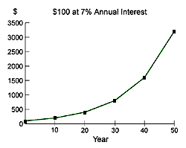

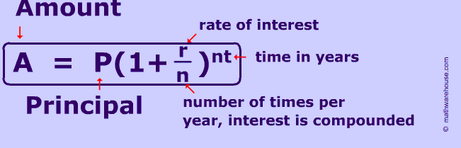

http://www.econedlink.org/interactives/tools/eel-compound-interest-calculator/EconEdLink-2-Compound-Interest-Calculator.swf

mycalculators.com

☐DONE
Resolution # 3

I resolve to THINK about
how much money I need to retire.

In RETIREMENT every $100,000 you have invested should produce on average about ~$4,000 annual income or about $333 /month. (Assumes 4% harvest rate)

SO…
$50,000 / year would be nice.
$50,000 / $4000 = 12.5
12.5 x $100,000 = $1,250,000
(All you need to do is save ~$1,000 per month for 30 years and earn average of 7%)

☐DONE (I know I should start saving!)

Resolution # 4

I resolve to SAVE
$4 a day (OR MORE).

- Save your change
- Cook at home 2 more evenings/month (avoid fast food)
- Eliminate the latté or other unconscious spending (Automatic Millionaire)
- Drink more water (less soda)
- Use the Library often
- Save on entertainment (just a little)
- Combine shopping trips (save gas)
- Plan meals based on grocery specials
- Take your lunch (once or twice a week)
- Put planned purchases on a list – wait 30 days
- Pay yourself first each month
- Avoid impulse spending (use a list)
- Repair your clothes and/or clean out the closet
- Visit http://www.thesimpledollar.com/little-steps-100-great-tips-for-saving-money-for-those-just-getting-started/
- Others…

☐DONE

Resolution # 5

I resolve to make some savings AUTOMATIC.
(Put it on AUTOPILOT!)

- Automatically deposit a fixed amount of funds at specified intervals into an investment account. (Set-up with bank or investment firm)
- Save before you get paid – 401(k) percentage withdrawal (before or after taxes).
- Use in a change jar (empty to investment account each month) for $120.

(If you don’t see the money in your checking account, you won’t spend it!)

☐DONE

Resolution # 6

I resolve to attend one more free financial class at the library in 2016.

Here are the topics and dates:

(Fill in as appropriate for your library’s schedule.)

Sign up now:

(Fill in as appropriate for your library’s ssign-up facility. You could just have a sign-up sheet available at the end of the seminar. )

